BITERS APPLICATION NOTES: Cherokee Home

As Atlantis (technology by SPD Labs) was looking into putting the solar thermal system beneath, the company was invited to participate on this project. The renowned solar architect, William McDonough especially like the product Sunslate, decision was made to participate that turned out to be a great success. Though the hybrid system had not tested yet until ten months later that prove the thermal addition could make substantial difference to the solar energy conversion efficiency especially in relatively warm climate locations like California, Arizona, Texas, Florida and most of the southern states. The efficiency could go as high as above fifty percent which could make the house net zero energy
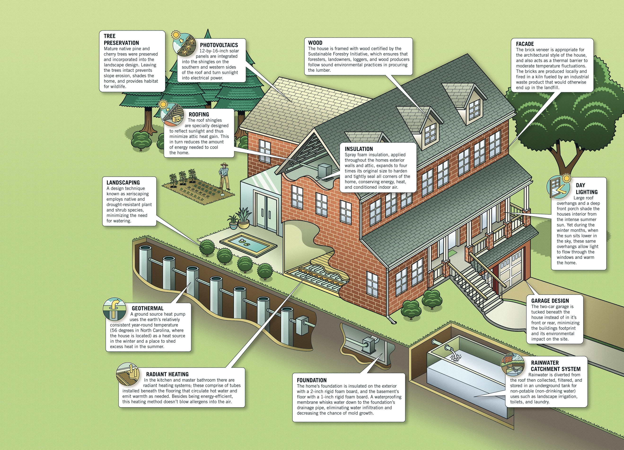

It is basically a traditional red brick home but is has the all the latest energy generation and saving technology products and systems.

- The Sunslate: Solar roof tile which generate electrical energy which reduces the electricity consumption of the building and beneath it is the solar thermal system which collect the heat the assist in domestic hot water as well as cooling off the space which resulted in saving air conditioning cost.
- Radiant floor heat: Located at the bottom of the house as shown
- Rainwater collection – the water collected from the roof will go the tank shown at the bottom of the building. As we all well know that water is precious commodity

Together, the design of this house have these items in mind:

- On the environment side, it has the ability to recycle 90 percent of organic waste.
- Consume 50 percent of less water
- Retain 95 percent of storm water collected and reuse them
- Recycle 75 percent of all demolition and construction waste.
- Provide great indoor quality of air which includes that 95 percent of all the products that does not contain or very low amount of VOC (volatile organic compounds).
- On sustainability areas: 1) Energy Star Rated windows, 2) Appliances, 3) Best type of insulators, 4) Ground source heat pump, 5) solar thermal water heater.
- It also create wildlife habitat

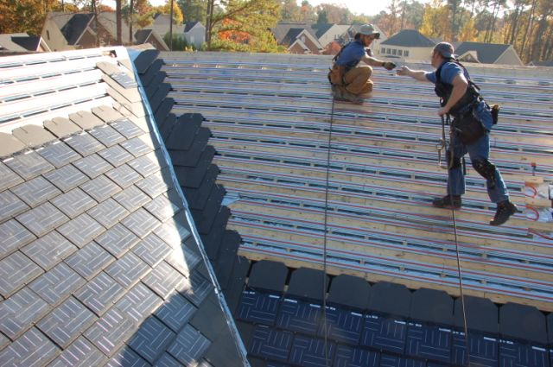
Installing the thermal and Sunslate (BITERS) on the Cherokee Home
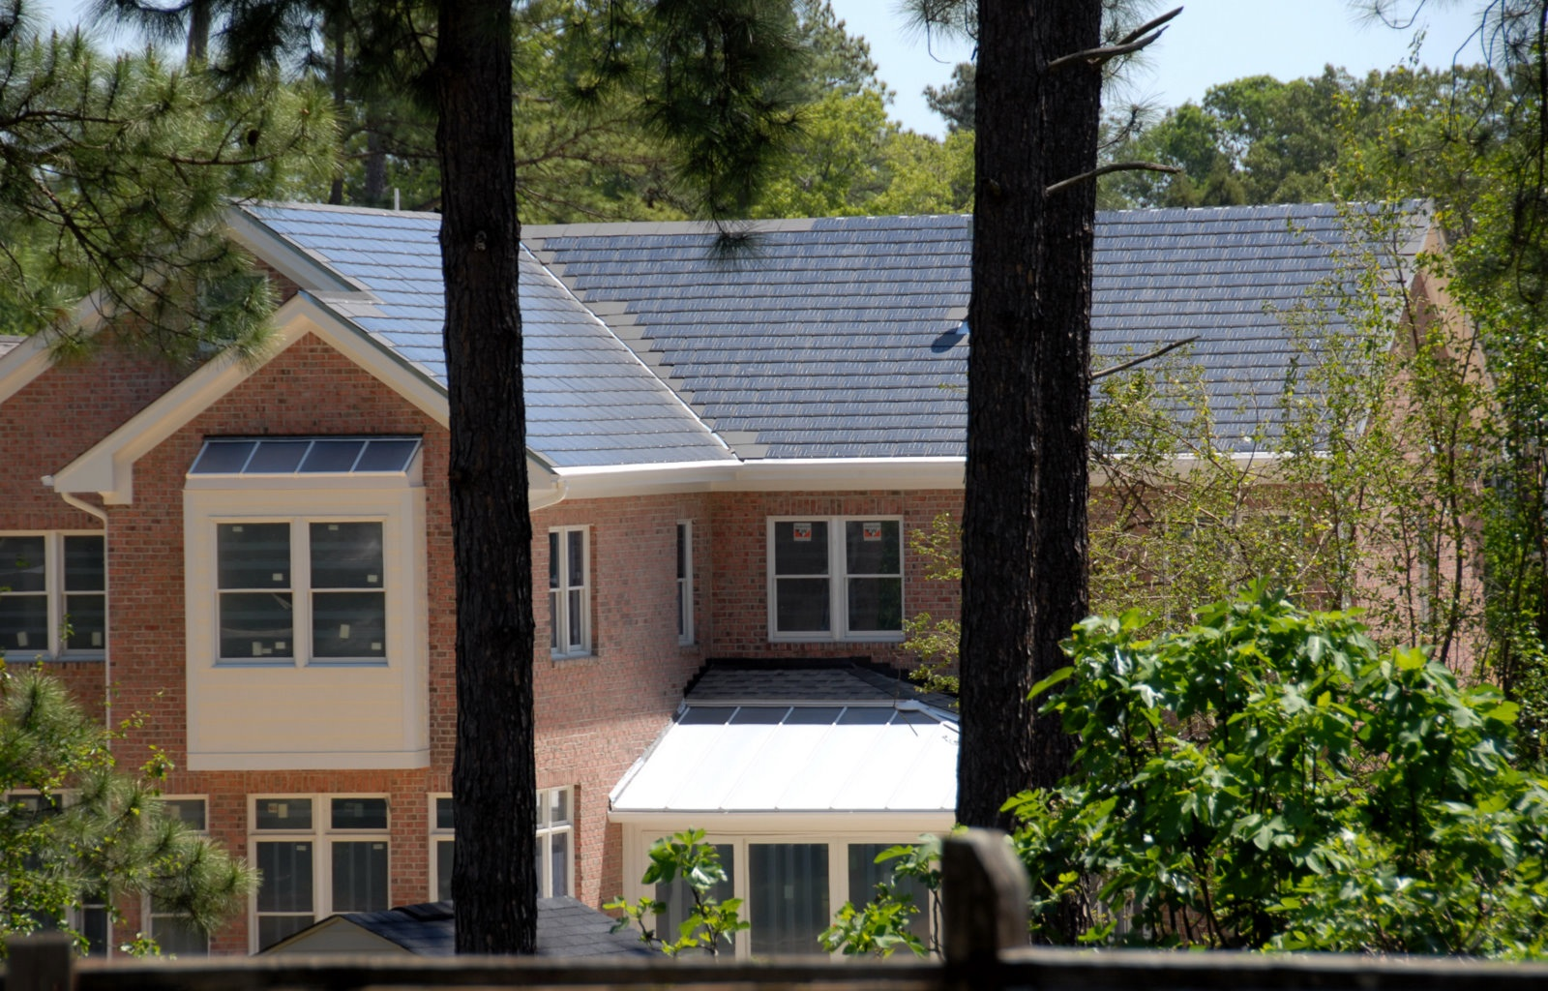
The completed back side of the Cherokee Home

Awards:
- US Department of Energy Gold Award
- National Home Builder Gold Award
- City of Raleigh over all environmental award (all categories)
- LEED platinum award (1st in South East US)
- National Wildlife Federation: Certified Wildlife Habitat for backyard
- Gold certified under the North Carolina Center of solar healthy homes
- 1st Home in the nation built in typical subdivision under NAHB Model Green Home Guidelines

Designed by William McDonough – Renowned Solar Technology Architect

This project was done back in 2006 in Raleigh North Carolina which demonstrated that the solar roof tile together with the thermal system beneath could make substantially improvements on the solar conversion efficiency that could make the house net zero energy. In light of the advancements on the recent advancement of solar cell as well as storage and generation technologies, the net zero energy house is now could be a reality and affordable to average households in the country.

The Cherokee Home had added a lot of additional features. To get the system started, one can just have the solar electric and thermal together with the storage and generation system to make the house net zero energy. All the other bells and whistles could be installed later.

