The President issued a call to action to end dependence on foreign oil. ____City of ________ would like to win the Smart Cities Challenge program to implement a Connected City that accomplishes a 45% cut in oil use, to end dependence on foreign oil by 2020.

Based on a population of 297,000, the White House paper identifies transportation costs per household at $8,999/year. The 2010 Census identified there are 2.58 people per household. Based in these numbers yearly transportation costs are ______$1.04 billion_______ for the people of ___City_____ (population of ________). By achieving the President’s call to action to end dependence on foreign oil, a 45% reduction, equates to a yearly opportunity of $467 million.

There is vast economic opportunity in our city to apply Smart City concepts to convert current costs into value. List of savings by city.

- Prime Law of Networks

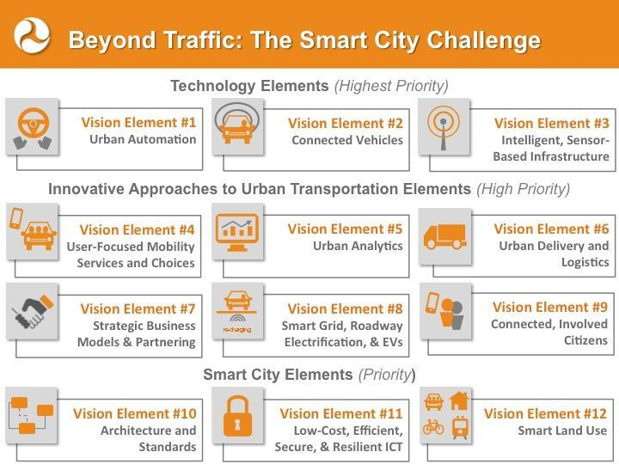
The speed with which Uber connected communities with transportation resources underscores the power of the Prime Law of Networks (Appendix A).

“Value explodes exponentially with membership, while this value explosion sucks in more members.”

____City of ________ proposal intends to leverage the Prime Law of Networks with the Vision Elements to achieve No Foreign Oil by 2020. This will also greatly aid the President’s recent Climate Change agreements in Paris.

- Vision Element #9, Connected, Involved Citizens is critically important. An involved human network is required to invent and commercialize technologies needed to solve traffic and energy issues in our cities. Facts that congestion costs $121 billion per year, accidents $840 billion per year, and our city is dependent on foreign oil underscores that current transportation networks are failing and new ones need to be invented and/or commercialized. Appendix B is Use of Funds.

First, ________The City’s_____ approach to involved citizens is illustrated in the book, The Wisdom of Crowds. This book provides many examples of how the aggregated wisdom of all of us, each acting in our own self-interest is wiser than the wisest of us at . For a very long time governments have suppressed liberty to offer the people choices. Uber illustrates what happens when new choices are offered. As people find greater the value, they communicate that value to friends and the Prime Law of Networks is engaged.

Third, it is the nature of governments to coerce compliance, to make and enforce laws. It is not the nature of governments to invent as illustrated by current traffic problems and the near century of rotary telephones under Federal monopoly.

It is the duty of the City leaders to inspire a culture of innovation and the City’s government to enforce compliance with required safety and social standards as prescribed in law.

Excellence is the process of relentlessly improving. Excellence is citizen based, not technology based.

- Vision Element #10, Architecture and Standards creates a legal framework essential to commercializing innovations. Retooling communications from analog networks to the digital Internet and cell networks provides an example. There was nearly a century of rotary telephones under the Federal communications monopoly. After that monopoly was declared unconstitutional in 1982 the architecture and standards shifted from centrally planned to being based on Performance Standards. Niche markets formed and long dormant innovations such as the Internet (1969) and radio telephones (1946) scaled to commercial viability.

____City of ________ is considering adopting the Secaucus Performance Standard Ordinance (Appendix C) that establishes architecture for sustainable mobility networks based on:
- Privately fund construction.
- Operate without government subsidies.
- Exceed safety standards of already approved transport modes.
- Exceed 120 passenger-mile/gallon energy efficiencies.
- Environmental approvals based on energy consumption less than 120 passenger-miles/gallon.
- Pay 5% of gross revenues for non-exclusive use of Rights of Way (ROW), if ROW use are required.
- Be regulated by the ASTM standards for theme parks.
  - Communities designed for pedestrian where machines networks are required to be intrinsically safe. 880Cities.org provides an excellent summary of retooling cities to accommodate eight year olds and eighty year olds.
  - Safety record thousands of times better than highways.
  - Existing insurance industry.
  - Existing enforcement industry.

Governing by Performance Standards is expected to leverage what is known into what is possible:
- Primary consideration for human travel should be given to designing our cities so they are easily walked and biked. Theme parks, the lessons of Peter Norton’s book, Fighting Traffic, The Dawn of the Motor Age in the American City, and concepts expressed at 880Cities.org emphasize the importance of starting with a sustainable concept before spending money on technology that may be counter to achieving a Smart City.
- Radically more efficient transportation networks are well understood. The 140,000 miles of freight railroads in the US average 476 ton-miles per gallon. The error in governing by Federal transportation monopoly is underscored by the fact that since The Federal-Aid Highway Act of 1956 removed efficiency as a market force, approximately 120,000 miles of very efficient freight railroads were abandoned or bankrupt.
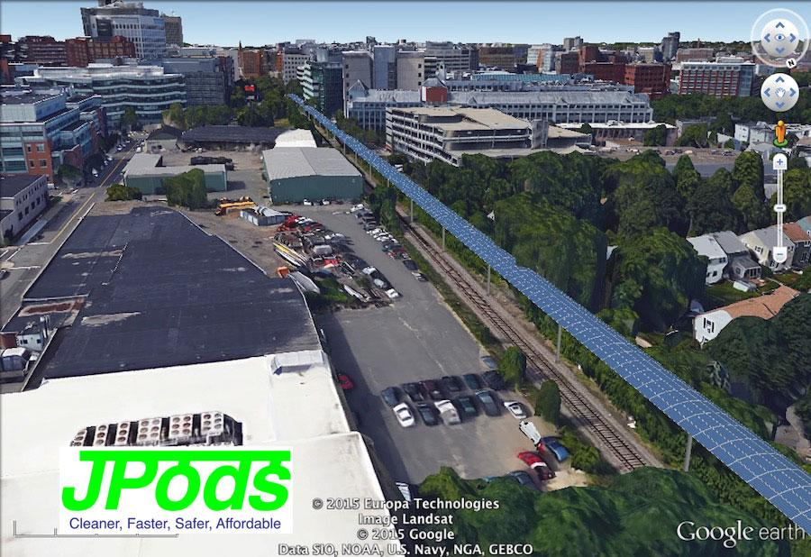
- Radically safer mobility networks are well understood. Since opening as a solution to the 1973 Oil Embargo, the Personal Rapid Transit network in Morgantown, WV has moved about 16,000 people per day without an injury. In the same period Morgantown’ PRT has been oil-free and injury-free, 1.7 million Americans died on highways.
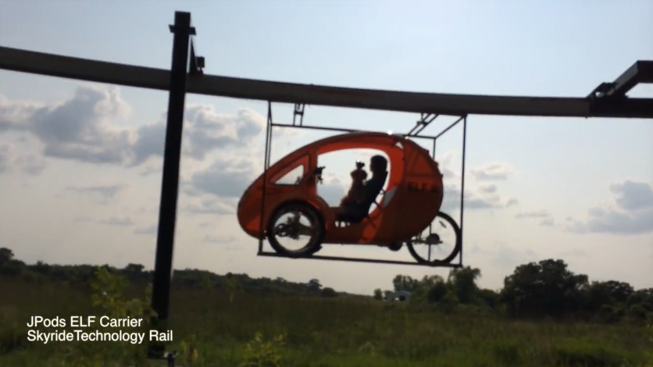
- Governing by Performance Standards is expected to result in Personal Rapid Transit (PRT) networks being built as recommended by Congressional Office of Technology Assessment (COTA) study PB-244854. This study was published in 1974 on solutions to make American cities independent of foreign oil after the 1973 Oil Embargo. Because of the short timeline to submit this proposal, JPods, solar-powered podcar networks are used to illustrate PRT. Here is a link a hearing with Boston City Council.
- As PRT networks decrease the number of oil-powered vehicles on streets, an opportunity is expect to evolve for electrical vehicles that can be locally manufactured. Here is an image of an ELF EV being carried on a rail (experimental carrier, in production they will be enclosed).
- The City estimates a large market for locally manufactured Local Use Vehicles (LUV) can be created. These can provide “last mile” solutions at a price affordable to nearly all our citizens.
- Many unplanned innovations are expected. At the time communications infrastructure shifted from Federal monopoly to Performance Standards in 1982, few envisioned innovations such as GPS, Google, iPhones, etc…. Governing by Performance Standards combines the best aspects of individual’s ability to invent, customers’ ability to sort out the best inventions, and government ability to coerce compliance with essential safety and social needs.

- Vision Element #4, User Focused Mobility Service and Choices is directly associated with Elements #9 and 10 above. More of what is failing will likely fail.

Shifting to governing by Performance Standards assures inventors liberty to invent and people liberty to aggregate wisdom by choosing between those inventions. The success of restoring liberty in communications infrastructure in 1982 can be repeated in mobility:
- Cell networks democratized communications.
- The Internet democratized access to information.
- Goal: Mobility networks are the physical manifestation of liberty, and should be ubiquitously available regardless of age, ability, or wealth. The success of the Internet can be repeated in the Physical Internet®.

- Vision Element #6, Urban Delivery and Logistics is critical to the entrepreneurship that logistical capacity be restored to our low-income neighborhoods. Buses and mass transit networks deny people in low-income neighborhoods logistical services essential to entrepreneurship and job creation. Areas with labor surpluses must have equal opportunity to create jobs and add value without having to travel out of their neighborhoods.

The current lack of grocery stores in low-income neighborhoods illustrates the inability of people living there to have goods shipped in or out.

Innovators that could create jobs in local communities are forced to move their innovations and jobs out of low-income neighborhoods. Governing by Performance Standards is expected to result in solar-powered podscar (PRT) networks being built into these communities that are capable of moving people, freight, and removing trash.

Metrics will be created to measure current and changes to equal opportunity access to logistical services.

- Vision Element #8 Smart Grid, Roadway Electrification, & EVs
Life requires energy. Oil is finite. Life and cities powered by oil are terminal. US Peak Oil was in 1970 (light blue line). Since US Peak Oil oil imports (dark blue line) and national debt (red line) have increased in tandem. Gasoline prices have ratcheted higher on average at 7.3% per year; 14.1% since China and India started buying substantial oil in 1998. We are currently in a down ratchet because of fracking, but that will deplete as all finite resources deplete. These graphs illustrate our current oil-powered networks are unsustainable. At some point in time, as nearly occurred in Sept 2008, debt will fail to buy foreign oil and there will be a rapid loss of 45% of the oil our city is accustomed to having. It is critical that sustainable mobility networks be built before the next major ratchet higher in gasoline prices or oil supply shock.

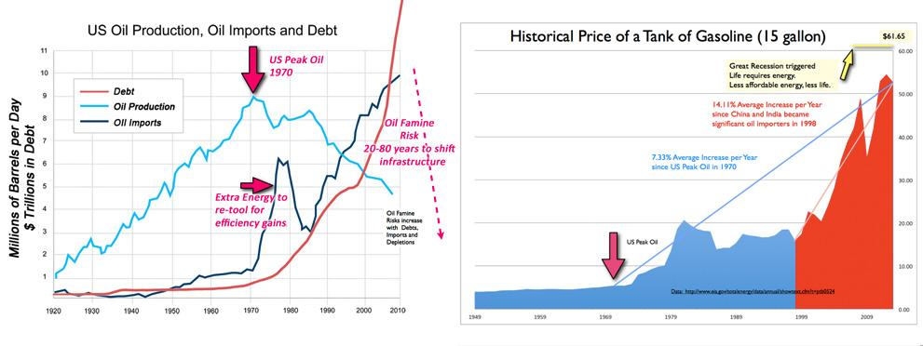

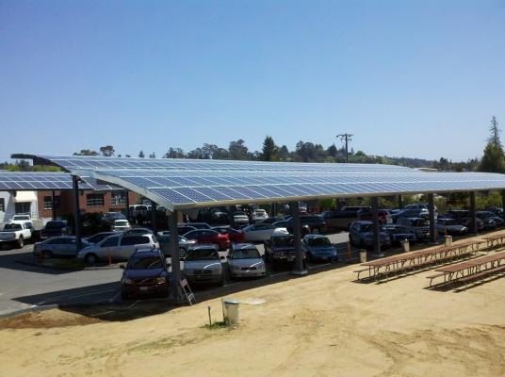
The COTA study PB-244854, on the lessons from the 1973 Oil Embargo warned of “institutional failures” as the primary barrier to implementing PRT. The loss of freight railroads and current barriers to building PRT underscores the need to shift from Federal central planning of transportation technologies to governing by Performance Standards.

Performance Standards will allow the deployment of solar-powered mobility networks and the lifeblood of America will change from oil to ingenuity. It will be practical to accomplish what Thomas Edison noted as practical in 1910:
"Sunshine is spread out thin and so is electricity. Perhaps they are the same, Sunshine is a form of energy, and the winds and the tides are manifestations of energy.”

“Do we use them? Oh, no! We burn up wood and coal, as renters burn up the front fence for fuel. We live like squatters, not as if we owned the property.

“There must surely come a time when heat and power will be stored in unlimited quantities in every community, all gathered by natural forces. Electricity ought to be as cheap as oxygen...."

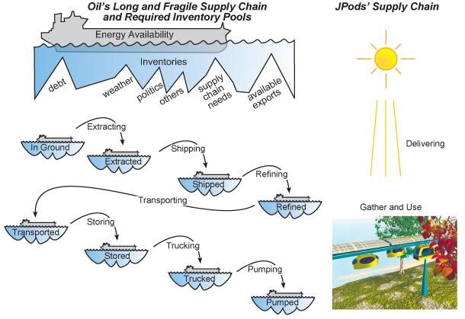
JPods networks, as an example of PRT, deploy solar collectors 4 meters wide over the rails. These gather 5 megawatt-hours per mile of rail per day. This equates to approximately 40,000 vehicle-miles of power per mile of rail per day. Unlike the long and fragile oil supply chain, JPods have a simple, reliable, and local energy source.

Energy storage is integrated into the structure of the network.
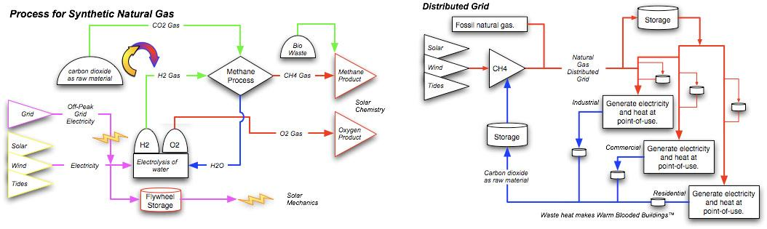

In history, transportation seems to have always been the catalyst for changing energy systems. In history, someone:
- Paddled a canoe, then built a water wheel.
- Rode a horse, then harnessed it to plow a field.
- Sailed a ship, then built a wind mill.
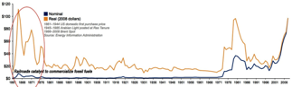
- In the 1860’s railroads were the catalyst for changing from biofuels to fossil fuels. In the 1960s a barrel of oil cost about $100 a barrel in current dollars. Railroads created a stable demand for oil and coal and cut the cost to transport. This allowed the extraction industries to scale to commercial viability.

As JPods networks deploy solar-powered mobility networks, they will be the catalyst for changing energy systems from oil to solar.

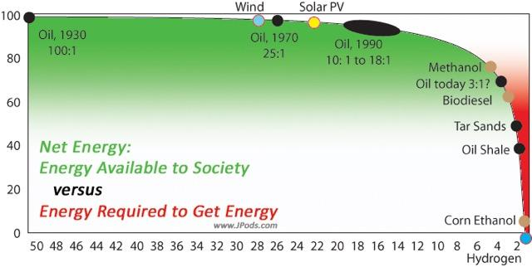
Adding to the 10x energy efficiency gain of JPods networks, applying solar energy systems add a 6x Net Energy gain over oil (20:1 versus 3:1). Here is link to understanding Energy Economics.

- Vision Element #7 Strategic Business Models and Partnerships are directly associated with defining the Rule of Law for Architecture and Standards (#10) and Connected, Involved Citizens (#9). By establishing the Rule of Law that defines a nurturing environment for innovators our city will create a culture of innovation. As Peter Drucker noted “Culture eats strategy for breakfast.”

Establishing a culture of invention will attract outside talent and emerging local talent. Implement the Rule of Law based on Performance Standards will attract capital. A commercial will form in the efforts to convert current traffic costs into value. Our city’s population is ____________. The White House estimates yearly transportation costs are $8,999 per household with 2.8 people per household. Using this data, costs that can be converted to value in our city are __________________. (St Paul 297,640 people, costs of $1.04 billion per year).

To help seed creating a commercial cluster for transportation innovation the city will reach out to:
- Statistical Process Control, Just-in-Time, Six Sigma industrial companies. These companies have been applying communications, sensors, and metrics to manufacturing processes for 50 years. Those lessons applied to manufacturing process can be applied to the mobility process.
- Transportation network innovators such as JPods, ET3, Hyperloop, Taxi2000, SkyTran, Ultra, Vectus, etc….

- Vision Element #5 Urban Analytics is a key part of Performance Standards and the Rule of Law (#10). What gets measured gets done (Appendix D). Specific metrics are:
- Performance Standard (economic work accomplished per unit of energy consumed, example passenger-miles per gallon).
- Parasitic Energy Ratio (Moving mass divided by payload mass times applications of power. “Beam me up Scotty” would be a perfect 1).
- Freight delivery costs per block (equal opportunity to logistical support).
- User complaints with metrics on resolution.
- Injuries by mode-mile

- Vision Element #12 Smart Land Use is part of the city’s Green Space Recovery. Current urban land consumed supporting highways is 44-67%. By 2020 the target is to restore 20% of this area into “Green Space”. As our city is retooled for pedestrians, bikes, PRT, and automated vehicles, land consumed by highways and parking can be radically reduced.

As PRT networks re-establish the ability to move freight in and out of low-income neighborhoods, a Smart Land Use program will be put in place to help rebuild and industry implementing sustainable transportation into areas with spare labor resources.

Because PRT networks do not have the pollution of highway networks and parking is not an issue, buildings and spaces can be more intelligently tailored to the needs of people.
By converting the mass transit system to a network instead of a series of linear routes and by decreasing the impacts of unnecessary stops on travel time pressures to have high density buildings where links cross is decreased. As a result the land values become flatter and both residential and commercial buildings can be better spread throughout the community

Technology Vision Elements
Our current transportation systems are not sustainable as indicated by pollution tilting the balance of nature into Climate Change, oil-wars since 1990, oil-dollar funded terrorist, congestion, accidents, etc.... They will have to be re-invented. Changing from failing systems to sustainable networks is a process in which technologies will be continuously created, then displaced by better technologies.

Here are the starting points in the Technology Vision Elements. Because the period to submit proposals is so short, specific companies are listed to provide technology examples. The companies and their technologies may be long-term winner such as Apple, or temporarily beneficial such as Cray and Digital Equipment.

- Vision Element #1 Urban Automation.
  - World famous efficiency expert Dr. Deming developed the foundation for the shift in manufacturing from Mass Production to Just-in-Time. Over the past 70 years this has been refined in Six Sigma and Lean Thinking applied to manufacturing processes. What has been learned in manufacturing processes can be applied to the mobility process.
  - The initial steps in Just-in-Time factory automation were to remove the sources of defects. The sources of defects in the mobility process are:
    - Burning oil to move two tons to move a person. Strive to move only the person.
    - Repetitive applications of power in congested Start-Stops.
    - Grade intermingling of pedestrians and multi-ton machines operating at relatively high rates of speed.
    - Dependence on oil energy outside of self-reliance.
  - Automation of the urban mobility process is very similar to automating controls for manufacturing processes. There are a wide number of companies in this field that will be approached to establish teaming agreements.
  - Corollary of vehicles to phones. The telephone is the correct concept, but the old analog telephone network was the wrong network. The on-demand service of the automobile is the desired device, but the highway is the wrong network. Automating smartphones connected by the old analog networks would fail. To build sustainable cities requires retooling the networks.
  - The Personal Rapid Transit (PRT) networks built in Morgantown, WV has delivered 110 million oil-free, injury-free passenger-miles since being built as a solution to the 1973 Oil Embargo. This network pays for itself about every 5 years. These types of networks will deploy as soon as the Performance Standards Law is passed.
  - JPods is used as a modern example of PRT networks. The Physical Internet®, applying distributed collaborative computer networks to moving physical packets is defined in JPods solar-powered mobility network US Patent 6,810,817. As the Physical Internet is deployed it is likely to have a corollary networks to the Internet.
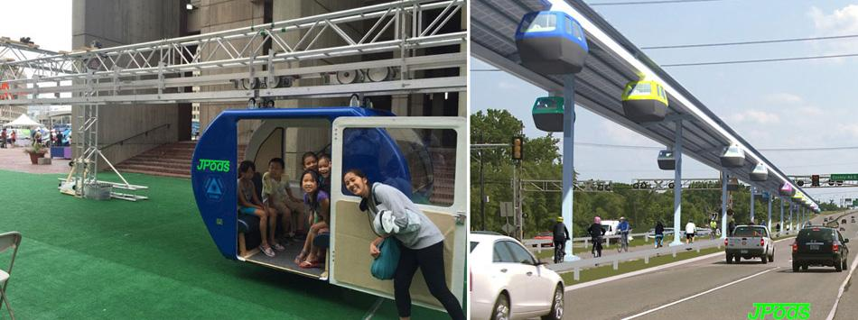
  - Robotics are becoming very affordable. The city is establishing a framework for applying robotics and autonomous vehicles as outlined in the appendix.
  - The capital costs to implement JPods networks is about 1/10th that of light rail, about $10 million per mile versus $100 million per mile. And these network can be privately financed. So the ability to expand Urban Automation beyond the financing of the Smart Cities Challenge greatly enhances efficacy. See Appendix C on the Performance Standards Law.
  - The ability to expand Urban Automation beyond the Smart Cities Challenge is aided by lesson of Just-in-Time manufacturing: “The larger the batch, the harder it is to control quality and the higher the price of errors.” The small packet size and on-demand nature of JPods networks radically reduces network congestion and increases carrying capacity. Example: Buses with 50 seats moving every 5 minutes provides 600 seats per hour (some of these buses will be crowded and other nearly empty). JPods on overhead rails moving at .5 second headways provides 28,800 seats per hour. Bikes in the same ROW as cars traveling 3 across at 1 second headways provides 10,800 trips per hour (no bike moves unless someone is making a trip). The current DOT metric of “vehicle-miles” would be rejected by Just-in-Time manufacturing for the reason it discourages the benefits of tailoring the trip to the traveler with on-demand capabilities.

- Vision Element #2 Connected Vehicles
  - Uber provides an example of the rate of network deployment and low cost that is possible by exciting an engaged public in shifting current costs into value. Just as Uber was not planned for by DOTs, new innovations will likely be disruptive and unexpected. The approach of the City is to create a regulatory framework that allows innovation to be disruptive and constraining the risks.
  - As noted in the Prime Law of Networks, Connected Vehicles must have a critical density to create an adoption cascade. The City will define specific niches within the City where there is highly repetitive transport where the payback on being connected can trigger wide adoption.
  - With the low cost of robotics, sensors, and ubiquitous nature of cell networks innovations based on existing technologies of JPods can spark a local industry creating retrofit systems for existing vehicles. For vast numbers of our citizens going $40,000 in debt to buy a new car is not feasible.
  - Innovative ways to pay to retrofit connect vehicles is a possibility.
  - New innovations and changes in vehicles are expected to radically innovate with the 2020 objective of 45% cut in oil use (to within domestic oil self-reliance).
  - The ability of PRT and other types of niche networks to carry freight may radically change the mix of vehicles and speeds at which they operate. An example of this is ELF vehicles (image of ELF being carried on a rail is in the appendix).

- Vision Element #3 Intelligent Sensor Based Infrastructure
  - Sensor based infrastructure has been extensively used in factories for decades. The City will leverage this and similar expertise from manufacturing.
  - JPods, Hyperloop, ET3, Taxi2000, Skytran and other PRT concepts are designed from the ground up to have dense implementation based on Intelligent Sensors. The City will leverage these types of sources of expertise.

- Vision Element #11 Low Cost, Efficient, Secure, Resilient ITC
  - The primary network for rapid adoption is the existing telephone network.
  - Secondary networks will be created as JPods/PRT networks are deployed with built-in backup communications.
  - As devices are invented or adapted from manufacturing process, networks will be adapted based on creating an entrepreneurial culture.

Appendix A: Prime Law of Networks

Interaction between innovators and customers in niche markets is essential to sort brilliant ideas from commercially viable ones. The fact that transportation still has the gas mileage of the Model T underscores that the Prime Law of Network needs to be applied to transportation networks as it was to communications after the Federal communications monopoly was recognized as unconstitutional in 1982.

The Prime Law of Networks is perfectly stated by Kevin Kelly in a Sept 1997 Wired article, “New Rules for the New Economy”:

“Value explodes exponentially with membership, while this value explosion sucks in more members.”

Value is illustrated by the number of connected lines.
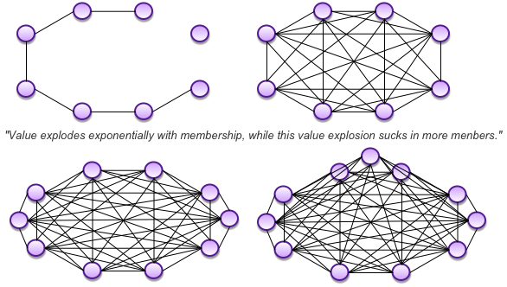

We see this Prime Law of Networks is every aspect of human behavior from children playing games to the way commercial giants create economic clusters such as Silicon Valley. More work needs to be done to polish the parameters of this Prime Law of Network. As a starting point it seems to be driven by:
- The seed of commercialization. Brilliant ideas are a dime a dozen. Brilliant ideas can be found everywhere in society from college campuses to the back on napkins. On rare occasion, someone or relatively small number of people find customers willing to pay to use an idea and a process unfolds:
  - If there is a profit, if the value customers willing pay exceeds the cost to compete, the idea begins to commercialize. To drive a paradigm shift, to get people to change habits, requires a 10x (10 times) increase in value or decrease in costs relative to current expectations.
  - If the implementers cycle increases in value faster than customer expectations grow, customers start recruiting their friends to become customers faster than customers abandon the idea for others options.
  - Competing idea both compete with the original value creator and add more customers choosing the value proposition.
  - If the rate of value expansion exceeds the rate expectation increase, a gravity well is create that sucks in ever more customers and competitors trying to delight them with value.

- Sustained commercialization requires increasing network value faster than customer expectations grow. Brilliant giants of the tech industry such as Cray and Digital Equipment are gone because they failed to increase the value faster than customer expectations; so customers turned elsewhere for value. These companies added to the gravity well that created the economic cluster of the Silicon Valley, but are no longer driving network value.

- Societies exist because of the fundamental human need to be connected to community. Exceeding the expectation of the community is what drives network adoption. ​Exceeding customer expectations is a process, not a technology. Smart thinking trumps smart devices, as brilliant devices today are rapidly tossed aside for better standards tomorrow.

- Technology is a tool that will be displaced by better tools as expectation increase:
  - The book by Alexandra Horowitz, On Looking: A Walker’s Guide to the Art of Observation provides brilliant observations of the intricate dance people engage in while walking in a city. Any application of technology may start at current levels, but will quickly have to exceed to value expectations ingrained in people's deep and intrinsic understanding of how connected communities move in our daily lives.
  - Solyndra was a brilliant idea, but lacked the ability to exceed customer expectations of value. To be effective, every tool must exceed current expectation and be displaced by better tools that exceed the growth of expectations. Commercially valuable ideas are sorted from brilliant ideas in crucible of profits, value customers are willing to pay for must exceed the cost to compete so strength is added to the process of innovations exceeding the growth of customer expectations.

- ​Start Small, Iterate Relentlessly. Network Density is a critical driver. The Wired article looking at the overview of the Internet talks of this as the Law of Connections. But at the beginning of Internet adoption is was not the vast numbers of connects, but the density of connections in specific niche markets. Total number of connection is critically important to network growth, but high density concentrated in small niche markets is essential for the seed of commercialization to germinate. You cannot solve the world's problems with traffic except by repeatedly solving someone's local congestion. By focusing on very small implementations, such as airport economic communities, the vast majority of vehicles can be connected to create the essential density for network survival. Success in niche networks can cascade as value created exceeds rated of customer expectation increases.

- Scalable: Once a seed of commercialization germinates in niche solutions, is polished in that crucible, they must still provide a 10x value increase while exceeding much broader and more skeptical customer expectations to become scaleable. Each customer that is delighted with a product will tell zero to 8 people. Each person that is disappointed with tell 8 to 22 people. Overcoming all these realities is why there are so few people like Edison, Bell, the Wright Brothers, Ford, Gates, and Jobs.

- Exponential Adoption: At some point, with luck, a tipping point will be reached as explained in the Wired article (based on Net Gain by John Hagel):

“The chart of Microsoft's cornucopia of profits is a revealing graph because it mirrors several other plots of rising stars in the Network Economy. During its first 10 years, Microsoft's profits were negligible. Its profits rose above the background noise only around 1985. But once they began to rise, they exploded.

Federal Express experienced a similar trajectory: years of minuscule profit increases, slowly ramping up to an invisible threshold, and then surging skyward in a blast sometime during the early 1980s.

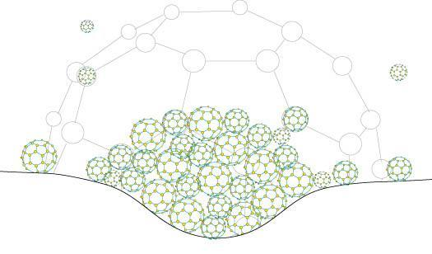
The penetration of fax machines likewise follows a tale of a 20-year overnight success. Two decades of marginal success, then, during the mid-1980s, the number of fax machines quietly crosses the point of no return – and the next thing you know, they are irreversibly everywhere.”

Value creates a gravity-well, sucking in ever more value producing efforts.

Appendix B: Use of Funds
Based on a population of _____________ with $8,999 spent on transportation per household and 2.58 people per household, there is ________________ in yearly expenses that can be converted into value. The purpose of this Use of Funds is to help trigger that conversion of costs to value. (St Paul 297,640 people, costs of $1.04 billion per year). With a 45% reduction in oil use, conversion of costs to value is ________ ($467 million of which 66% can likely be monetized ____$308 million_____ and 33% taken as customer savings. The 5% yearly fee to the city would be $15 million.
- Social Entrepreneur Center.
  - $2 million.
  - Objective: Define social mechanism to engage people to create a culture of innovation.
- City Administration of the program:
  - $1 million
  - Objective: This is a starter fund to assure proper management of the program and publishing the results to other cities. It is small because the City is responsible to implement the Performance Standard Law that will then become a source of revenue.
- Loan Guarantees for local entrepreneurs:
  - $15 million
  - $5,000 in loan guarantees based on viable business plans to create Smart Cities implementation companies in low-income neighborhoods. These are not loans but guarantees on loans.
  - The institutions issuing the loans would be responsible to vet each opportunity and are accountable for 50% of the loss. A portion of the interest from each loan would contribute to a default fund.
  - Objective: Provide capital resources not normally available in low-income neighborhoods to create local value added (non-retail) jobs.
- Loan Guarantees for local purchasing of operation sustainable mobility networks:
  - $20 million
  - Construction of networks must be capitalized privately.
  - Objective: To have workers who built networks and local interests buy and operate the operational networks so they stay focused on local needs.
  - The institutions issuing the loans and JPods would be responsible to vet each opportunity and are accountable for 50% of the loss. A portion of the interest from each loan would contribute to a default fund.
- Reserve to be applied in the most successful area:
  - $3 to $13 million (depending on Vulcan’s participation).
There is plenty of current costs that can be converted to value. Once the Performance Standard Law is passed, it seems likely business will start to emerge quickly to convert current costs to value.

Appendix C: Performance Standards Law (Secaucus Ordinance 2014-23)

The following ordinance was read for public hearing: No. 2014-23

AN ORDINANCE OF THE TOWN OF SECAUCUS, REGARDING PERFORMANCE STANDARDS FOR GRANTING RIGHT-OF-WAY ACCESS FOR TRANSPORTATION INNOVATIONS

WHEREAS, returning communication infrastructure to a free market in 1982 resulted in vast innovation, better service at lower costs and millions of jobs;

WHEREAS, privately funded freight railroads average over 400 ton-miles per gallon efficiency; and

WHEREAS, establishing performance standards based on economic work accomplished per unit of energy consumed may allow free market solutions that repeat communication infrastructure success in transportation infrastructure; and

WHEREAS, the Congressional Office of Technology Assessment Study PB- 244854(1975) identified Automated Guideways and Personal Rapid Transit (PRT) networks as a solution of the 1973 Oil Embargo and the PRT network at Morgantown, WV has delivered 100 million oil-free, injury-free passenger-miles since starting service in 1975;

NOW THEREFORE BE IT ORDAINED, non-exclusive assess to City rights-of-way may be granted to transportation systems providers meeting the following free market principles:
(1) Privately funded construction;
(2) Privately operated without government subsidies;
(3) Exceed 120 passenger-miles per gallon, or equivalent efficiency; and
(4) Exceed safety performance of transportation modes already approved for use.

AND THEREFORE BE IT FURTHER ORDAINED, regulation of free market innovations shall be based on:
(1) System design, fabrication, installation, safety, insurance, inspection practices consistent with the ASTM International, Committee F24 on Amusement Rides and Devices;
(2) Environmental approvals will be granted based on a ratio of energy consumed per passenger-mile of the innovation versus transport modes approved to operate in the rights-of-way; and
(3) All taxes and fees assessed on the transport systems providers, passengers and cargo shall be limited to 5% of gross revenues and paid to the aggregate rights-of-way holders by transportation systems providers; and

AND THEREFORE BE IT FURTHER ORDAINED, that any individual projects shall be process and considered in accordance with all relevant municipal and state regulations.

This Ordinance shall take effect immediately after final passage and publication in accordance with law. June 24, 2014

Appendix D: Metrics, what gets measured gets done.
Key Metrics:

- Performance Standard Law: The Performance Standard Law establishes a metric for regulating and granting access to Rights of Way based on Economic Work Accomplished per unit of Energy Consumed (passenger-miles per gallon in the following table).

The 140,000 miles of freight railroads in the US average 476 ton-miles per gallon. Yet cars move people on highways with efficiency less than 97 times that of freight railroads. The FTE in the following graph is the Freight Train Equivalent of how many times less efficient than Freight Trains a mode is.
Passenger rails generally operate with 77 times less efficiently than freight, or 20% better efficiency per passenger-mile than cars. Buses operate 117 times less efficiently than freight, or about 20% less efficiency per passenger-mile than cars. Since both passenger-trains and buses require taxing oil-power car drivers to provide operating subsidies the pollution and energy required to operate cars to pay those taxes should be assessed against these modes. But for simplicity, all metrics are restricted to Passenger-miles per gallon.

Mode | Load | BTU's | Watt-hrs | Watt-hrs | FTE |  | Gas mpg
Mode | Load | BTU's | pass-mile | pass-km | FTE |  | Gas mpg
ET3 | 1.57 | 216.5 | 63.5 | 63.5 | 6 |  | 528
JPods | 1.57 | 433 | 127 | 79 | 12 |  | 264.4
Performance Std | 1.57 |  | 300 | 186 | 28.5 |  | 120
Van pool | 6.1 | 1,322 | 389 | 242 | 36.6 |  | 86.6
Motorcycles | 1.2 | 1,855 | 546 | 339 | 51.3 |  | 61.7
Rail, Amtrak | 20.5 | 2,650 | 780 | 485 | 73.3 |  | 43.2
Rail, Transit (light & heavy) | 22.5 | 2,784 | 819 | 509 | 77 |  | 41.1
Rail, Commuter | 31.3 | 2,996 | 881 | 547 | 82.9 |  | 38.2
Air, domestic | 96.2 | 3,261 | 959 | 596 | 90.2 |  | 35.1
Cars | 1.57 | 3,512 | 1033 | 642 | 97.2 |  | 32.6
Personal trucks | 1.72 | 3,944 | 1160 | 721 | 109.1 |  | 29
Bus, Transit | 8.8 | 4,235 | 1246 | 774 | 117.2 |  | 27
Taxi | 1 | 14,301 | 4207 | 2614 | 395.6 |  | 8

Calculations of fuel efficiencies and DOE Energy Use

- Parasitic Energy Ratio
The enemy of efficiency is the parasitic mass of the vehicle and the repetitive applications of power is Start-Stops. The Parasitic Energy Ratio was created to provide a quick comparison of energy required by various modes of transportation. It is take as a ratio of the Kinetic Energy of the Moving Mass divided by Kinetic Energy of the Payload Mass times the number of applications of power, or Start-Stops. This is then simplified so the constants and velocity squared cancel to leave a relatively simple metric of

PER = Moving Mass (vehicle and payload) / Payload Mass * Start-Stops
“Beam me up, Scotty” would be perfect have a perfect “1”. There is no parasitic mass and only one Start-Stop.
Mode | Vehicle wt | Payload wt | Start-stops | PER
"Beam me" | 0 | 200 | 1 | 1
Bicycle | 25 | 200 | 5 | 5.6
JPods | 600 | 200 | 1 | 4
Cars | 3000 | 200 | 10 | 160
Buses | 3000 | 200 | 10 | 160
Trains | 4000 | 200 | 7 | 147

This metric may not be fair to bicycles. If there were better bike paths, bike commuters would not have to stop and start as frequently.

- Disposable Energy
Disposable Energy measures how much energy people can buy with their take-home-pay. This is a metric of the economic durability of the community. It was developed in July 2008 in an effort to warn policy-makers that rising gasoline prices were causing people to divert their mortgage payments to pay for their commutes; people have a greater need to keep their jobs than their homes. Until the recent downward spike in gasoline prices, Disposable Energy has been decreasing.
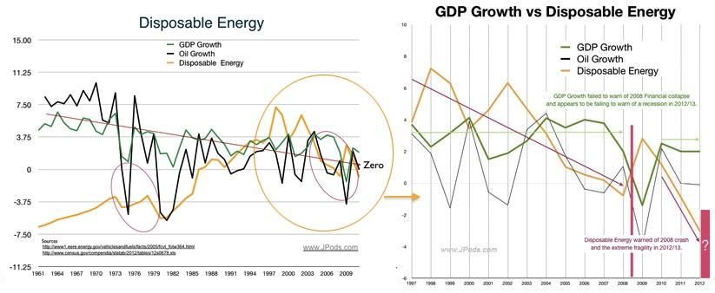

The purpose of transportation networks is to perform economic work, energy applied to moving goods and services. Modes should be evaluated based on how durable and affordable the energy to power them is to the people who depend on them.

The following graph on the left shows US Peak Oil in 1970 (light blue), rising oil imports (dark blue), and the correlation between oil imports and national debt (red). The graph on the right shows the ratcheting higher price for gasoline since US Peak Oil in 1970. Prices ratchet, but on average have increased 7.3% since 1970 and 14.1% since China and India started importing significant oil in 1998.
Oil markets are currently in a down ratchet in Jan 2016. How long this down ratchet continues is uncertain. But at some point, the 45-year upward trend will likely continue.

- Freight delivery costs per block (equal opportunity to logistical support). Map the community with costs to deliver freight.
- Create a simple app for User to register complaint linked to metrics on resolution.
- Create an interactive map with injuries by mode-mile
- Implement mapping metrics to track infrastructure components and maintenance.

