
2017
EXPRESSION OF INTEREST (EOI) for Development of Personal Rapid Transit System (PRT) for Demonstration purpose at Bengaluru
Inspiring with innovations
Actis infrastructure Pvt Ltd . India

A subsidiary initiative

JPods US LLC .United States of America

1/15 Mount Joy road. Bull temple road cross
Bengaluru-560019 .INDIA
info@actisinfra.com www.actisinfra.com
General enquiry:+91 9480 073534

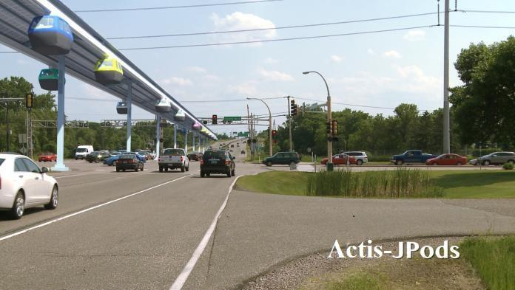
Serial no | Particulars | Page no

1. Name of the agency/Company profiles 3
2. Infrastructure planned/methodology 5
2.1.1. Bengaluru PRTS proposal 6
2.2. Revenue model with BBMP 26
3. Technology details with merits 27
Cleaner, Faster, Safer, Affordable 27
What is Personal Rapid Transit 28
Uniqueness and Competitive Advantages of JPods 29
Capacity 47
4. Experience of working with similar project 48
4.1. Software delivered
4.3. Skyride details
4.4. Within a Solar Budget, Energy Collection 51
5. Proposed initial plan and schedule 51
6. Capital plan and annual turnover 53
7. Estimated cost and maintenance 53
8. Request to Government 53
9. Additional information 53
10. Declaration 54

To:
BRUHAT BENGALURU MAHANAGARA PALIKE

(A Govt. of Karnataka Undertaking)

Executive engineer (TEC), Room no 009. Ground floor, Annexe building no.3 BBMP head office premises .Bengaluru-560002 .Email bbmpeetec@gmail.com

Respected Sir

According to the Request for Expressions of Interest (EOI) published on 15th May, 2017 for Personal Rapid Transit System (PRT) for Demonstration purpose under Design Built Finance Operate and Transfer .DBFOT for Bengaluru,
To support our Expression of Interest, we have attached the following:
- Applicant’s Organizational Contact Details
- About the organization/profile
- Infrastructure planned/methodology to be adopted
- Technology proposed along with its merits
- Process flow along with brief description of various components involved
- Experience of Working with International Projects
- Proposed Initial Plan and Schedule
- Estimated cost towards capital expenditure and maintenance
- Additional Information
- Declaration
Date:22nd May 2017 Authorised signatory

Chief Executive Officer

Applicant Organizational Contact Details
Name of Entity: | JPODS US LLC
Address： | San Jose, California. USA
Contact Person: | Mr Bill James. CEO
Telephone： | +1 612-414-4211
Email： | bill.james@jpods.com (website: www.jpods.com)
Indian Entity : | Actis Infrastructure Pvt Ltd
Address: | 1/15 Mount Joy Road Bull Temple Road cross Bengaluru. INDIA
Contact person: | Rajashekar B N .CEO
Telephone: | Mobile: +91-9845721155. general enquiry:+91-9480-073534
Email: | info@actisinfra.com (website: www.actisinfra.com)

Additional information

Place of Business | United States of America
Year of Establishment | 1999
Permanent Account No. | AAKCA1727D
Name of the representative with their mobile no to maintain liaison with concerned authority | Mr Rajashekar B N  Cell phone: 09845721155

- Name of the agency/Company Profiles

- Actis Infrastructure, India
Actis Infrastructure is a Private Limited company registered under company’s act 1956. Actis is a great growing infrastructure developer with an excellence in core development of infrastructure across the globe. In our global search for solutions to traffic, we discovered Personal Rapid Transit networks. After studying available PRT pioneers, we selected and contacted JPods. That team signed a contract in 2012 to bring cleaner, faster, safer, and more affordable mobility networks to India.
We believe that a robust infrastructure can provide the level of availability and response necessary for the global business environment. There is a world market for solutions to traffic problems. Our public transit projects are Inspiring with Innovations®
Actis Infrastructure is participating to build an efficient infrastructure. Setup can ensure a nation’s sustained economic growth. As with finding JPods, we are working to collaborate and build an alliance capable of retooling India’s infrastructure.
Actis Infrastructure is focusing our efforts on PRT Projects based on the Solar Mobility Act and private financing.
Mission Statement
Our success is based on understanding the commercial, community, and environmental aspects of every project, we have the ability to deliver challenging and innovative buildings that become the catalyst for a wider generation, making real differences to the quality of people’s lives.
We have four market focuses: 1) leading business in professional services,
2) construction services, 3) support services, and 4) infrastructure investment.
Procurement Division: Integrity in all business relationships, excellent talent, innovative solutions: This is what you can expect from Actis. We custom-tailor our approach and expertise to meet our client's' project requirements. Our engineering services include preliminary and final design, program management, and construction engineering and inspection.
Actis expects to refine its skills in the construction, engineering, and inspection services for the Personal Rapid Transit System and for building projects. Our construction personnel are committed to working with clients to control the construction schedule, budget, and Quality Control and Quality Assurance (QC/QA) within the required regulations. We will utilize and coordinate efforts to obtain certifications required to meet ASTM and other required standards/certifications. We also establish and manage safety programs and customize construction management services to address the unique requirements of various networks. The PRT deployment and operations market is in its infancy. Actis has provided leadership in creating the industry and will strive to be equally effective to assure the cost effective compliance for networks as they are built.
Our current construction engineering and inspection services include:
- Schedule and Budget Evaluations
- Construction Observation
- Value Engineering
- Constructability Reviews
- Project Scheduling and Permitting
- Quality Assurance/Quality Control
- Monitoring and Coordinating Daily Construction Activities

- JPODS US LLC, USA
Technology, enterprise management, engineering compliance will be licensed and enforced by JPods US LLC. The company was started in 1998.
Current ownership is private. The development of JPods’ baseline technology was completed in 1998 and patent #6,810,817 issued in 2004 for the use of distributed, collaborative computer networks that move physical packets, the Physical Internet®. This patent applies to the mobility process, previous applications of computer software and networks to manufacturing and sales processes. JPods’ founder also founded the ASI part of ASI-Datamyte. ASI was a pioneer in computerizing Statistical Process Controls and Just-in-Time manufacturing. In 1998, WebClerk/CommerceExpert software, also written by JPods’ founder, was listed as the “Best New High Tech Product of the Year” in the Twin Cities Business Monthly and was part of two national tours with Apple Computer.
In 1998, in a discussion with West Point classmate (founder is an infantry veteran), it became clear that oil-wars since 1991 would continue so long as America’s oil-addiction funded hostile parties with oil-dollars. With WebClerk on the back burner, efforts were made to work on ending America’s dependence on foreign oil by combining the efficiency of freight railroads with the on-demand service of the Internet. Everything well-understood in “Just-in-Time, Six Sigma” manufacturing process controls could be applied to the mobility process. Everything well-understood about the convenience and service of the on-demand nature of the Internet could be applied to the mobility process.
In 2006, a 20-foot operational demonstration was built. That unit, and a subsequent larger demonstration units, have been set up in front of Parliament in Ottawa, Canada, to San Jose, California. These fully functional demonstration units have been set up and taken down many times with thousands of people riding in them. (See page 53)
JPods builds on the success of the Personal Rapid Transit Network (PRT) in Morgantown, West Virginia, USA. Morgantown’s PRT has delivered 110 million oil-free, injury-free passenger-miles (see page 52).
JPods has applied its robotic and network software to SkyRide Technologies. The manual version of SkyRide is deployed on the Carnival Vista Cruise Ship. Carnival has ordered a second implementation (see page 54).
RouteTime™ software was written to estimate the cost, number of vehicles, station placement, capacity, and other aspects of network designs. This software may be downloaded by schools for free, so future generations can grow up planning sustainable cities. RouteTime maps and computer simulations are delivered as part of this proposal.
JPods3D™ software was written to model networks in 3D and display them in Google Earth. Again, this software may be downloaded for free by students.
As with the near century of rotary telephones under US Federal monopoly, the barrier to innovation was regulatory. Bengaluru, Secaucus (NJ-US), Medley (FL-US) are leading the world with Performance Standards-based regulations (EOI-Scope of Work). The Solar Mobility Act is also pending in the Massachusetts’ Legislature (US).

- Bengaluru Mobility Company (BMC) will be created by JPods US LLC, Actis Infrastructure, capital, industrial partners, and employee equity as a Special Purpose Vehicle to localize the focus of building and operating networks in Bengaluru in compliance with this EOI. This company will have all licenses and capital to accomplish its mission.

As a local company, it will focus solely on meeting the mobility needs of the people of Bengaluru.

- Infrastructure planned/methodology to be adopted

- Bengaluru PRTS proposal Introduction
Bengaluru is an urban continuum, suitable for a grid based transport system. The travel characteristics of the population also show prevalence of short and medium distance travel that are more amenable to a network system of travel rather than dense linear corridor creation. A new system of Personalized Rapid Transit has been jointly proposed by BMC (Bengaluru Mobility Company of JPODS, ACTIS, allies) that does away with age long ills of traditional systems. Its advantage is in effectively decongesting the existing gridlocked transport network prevalent across the state. BMC proposes to finance, design, build, operate, and transfer PRT systems in the state of Karnataka under PPP Model /Rights Of Way (ROW).

- The present proposal is for implementing a PRTS in Bengaluru city, linking the:
- Phase 1: M G Road Metro Station to The Leela Palace junction-4.0 km
- Phase 2: The Leela Palace to EPIP junction-6.0 km,
- Phase 3: Marathalli junction to EPIP 6.5km,
- Phase 4: MG Road Metro Station to Koramanagala -7 km
- Phase 5: Jaya Nagar 4th block to JP Nagar 6th phase-5.3 km

Initially, a corridor is proposed which can later be made into a network system connecting several nodes of the city.

  - PRT Corridors

The PRT system is proposed for Bangalore city from M G Road Metro Station (Trinity Circle) to the Leela Palace junction connecting via Old Airport Road.

- Indicative System Configuration

Total Route Length (km) | 4.0 km
Number of Stations | 6
Number of Pods(2017) | 130
Daily Passenger Carrying Capability | 36,000
Indicative Project Cost (INR Crores) | 188 (US$28 million)

- Overall Project Cost

The overall project cost is estimated at INR 46.9 Crores per km (US$7 million/km) for a dual-track system including interest during construction, project management consultancy, pre-operative expenses, etc. This is likely to vary depending on technology and the results of a detailed engineering analysis.

Figure 1 Route Map of Proposed PRT System
PRT Corridor: Phase-1-M G Road Metro Station (Trinity Circle) to The Leela Palace junction -4.0 km.
Times are estimated in Google Maps and JPods RouteTime. Travel times for riding and walking are measured from the Red Cross: Green is 5 minutes, Blue is 10 minutes, Yellow is 20 minutes, Red is 30 minutes.
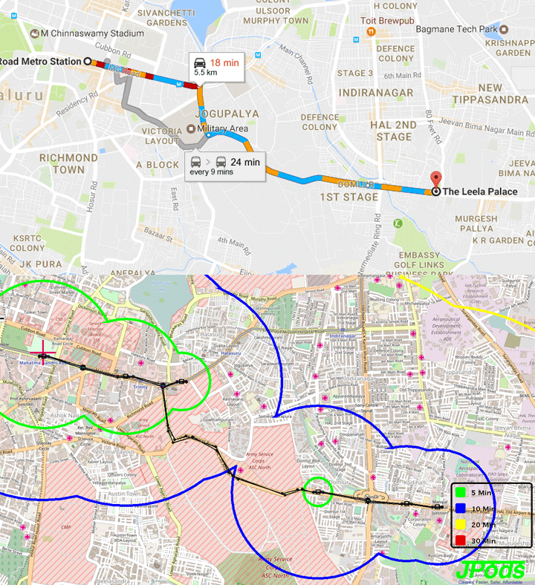

Phase: 2 –The Leela Palace to Marathalli junction - 6.0 km
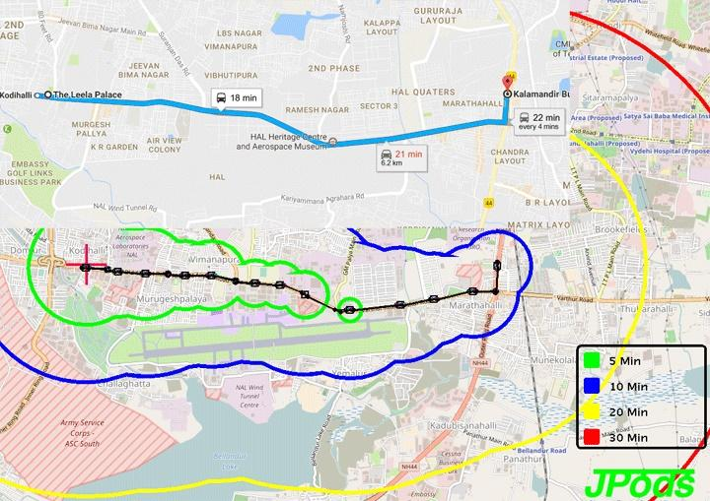

Phase-3 -Marathalli junction to EPIP - 6.5 km
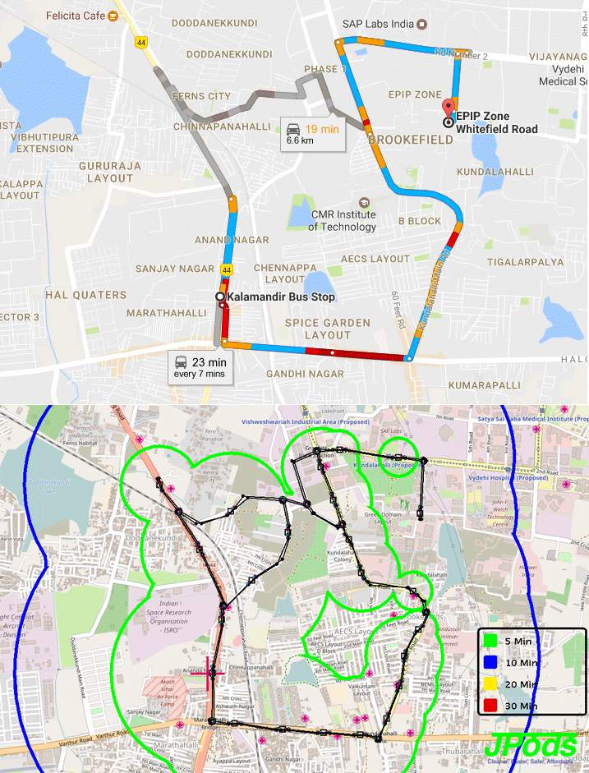

Phase-4-Trinity Circle/Metro Rail Station to Koramangala - 7.1 km
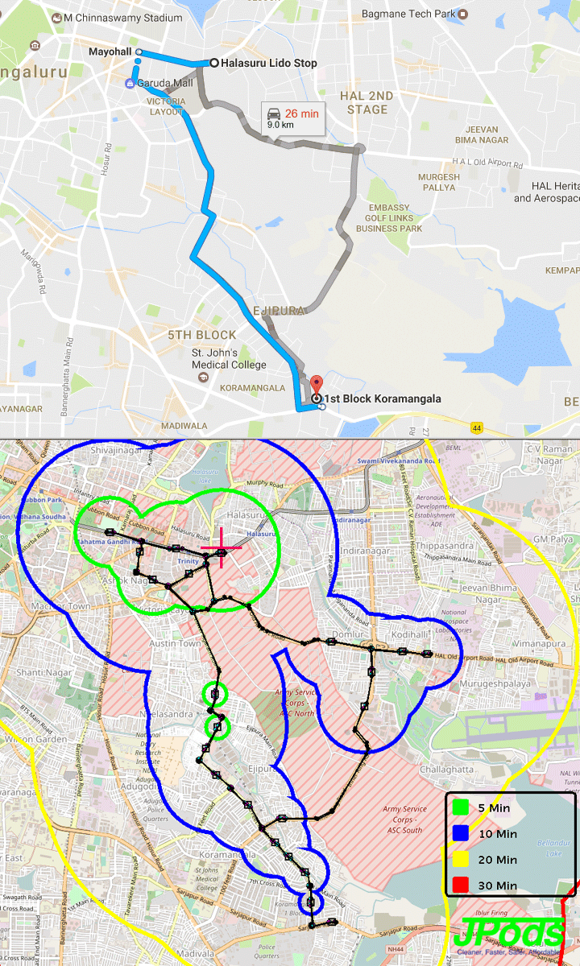

Phase-5
Jaya Nagar 4th block to JP Nagar 6th phase – 5.3 km
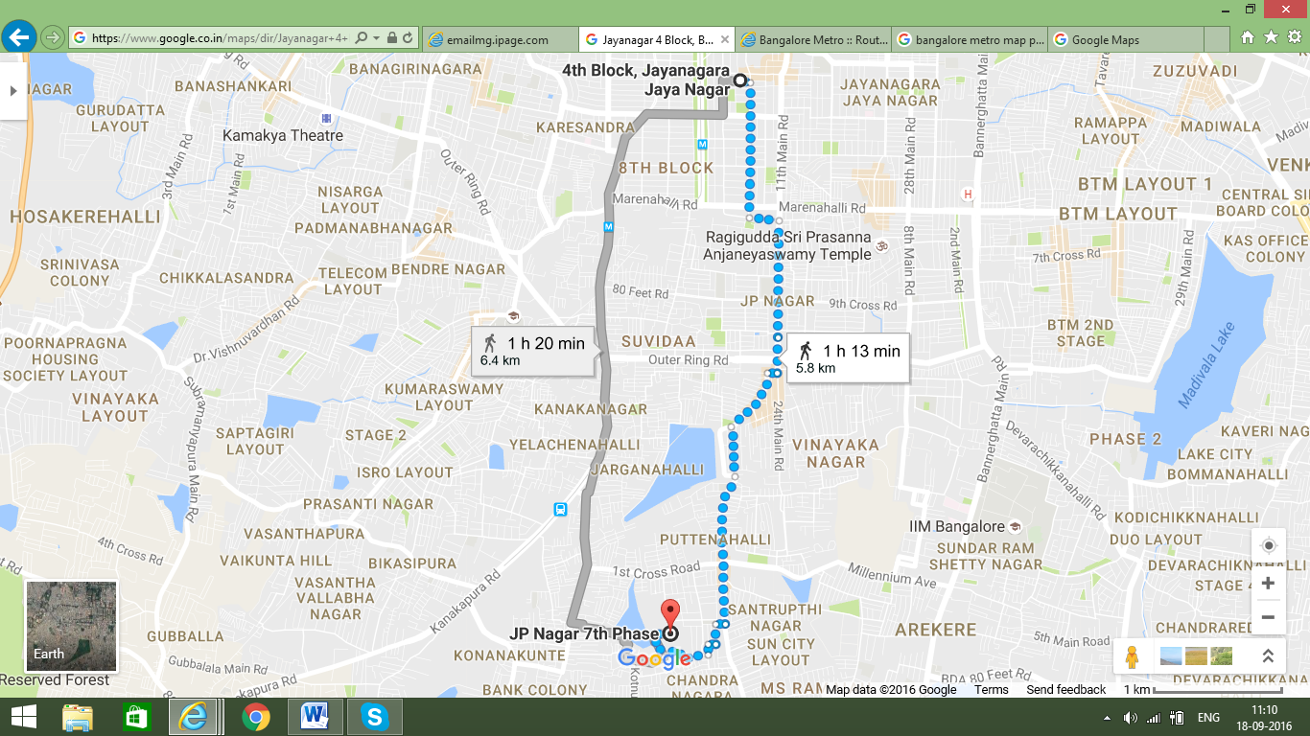

- Traffic Demand Estimates for the PRT System in Bengaluru
About 175,000 passengers ride the Bengaluru metro rail each day. JPods networks effectively provide feeder rails to the metro and connect other aspects of the economic community together.
The Solar-powered Personal Rapid Transit system has capability to support the Metro rail with feeder networks. To ease traffic congestion, JPods networks move people and cargo in cities, cleaner, safer, faster, and more affordably. There is a special niche for these networks as feeders to existing railway stations, around airports, and other densely traveled areas.
Phase-1 Proposed Route: Covering areas will be M G Road to HAL Airport Road to The Leela Palace
Stations Phase-1: M G Road Metro Station, Brigade Road to Garuda Mall, Army Public School, Commando Hospital, Domlur Layout, Old Airport Road, Leela Palace.
Phase-2 Proposed Route: The Leela Palace to Marathalli Junction
Stations Phase-2: Manipal Hospital Museum, Yamlur Circle, Marathalli Post Office, Marathalli Bridge.
Phase-3 Proposed Route: Marathalli Junction to EPIP
Stations Phase-3: Kundanahalli Gate, Ryan International School Junction, Apollo Hospital, Gopalan SEZ, Graphite Signal, EPIP signal.
Phase-4 -Proposed Route: Trinity Circle(metro station) to Koramanagala -7.1km
Stations Phase-4: Trinity Metro Rail, Lower Agaram Road, Ejipura, Srinivagilu Main Road, HSR Layout 2, Koramanagala 2.
Phase-5-Proposed Route: Jaya Nagar 4th block to JP Nagar 6th phase
Stations Phase-5: Jaya Nagar 4th block bus stop, 5th block telephone exchange, 5th block junction, Marenahalli Circle, J P Nagar, 2nd Phase-4th Phase-6th Phase extension to Brigade Millennium, Millennium Ave., Bannerghatta Gottigere.
Subject to detailing.* The detailed survey will be carried out after the proceed letter from the Government. The above calculations may vary depending upon the People per Hour
- Traffic Demand Estimates for the PRT System

Peak demands of 15,000 people per hour can be met based on building sufficient stations. Fare pricing will be adjusted to encourage people to spread their travel plans.

Capacity can be calculated based on individual networks and station placement.

- Present fare structure of Public Transport Modes

 | Table 1 Comparison of Fares city bus services and other IPT
No. | Type of Service | Minimum fare (INR) | Minimum Distance for Base fare | Incremental
No. |  | Minimum fare (INR) | Minimum Distance for Base fare | per km fare (INR)
1. | Bus | 7 | 5 km | 0.64
2. | JNNURM (AC) | 15 | 20 | 1.91
3. | Multi Axle AC Volvo bus | 70 | 20 | 1.30
4. | Metro | 20 | Not available | Not available
5. | Auto Rickshaw | 22 | 1.9 km | 10
6. | Taxi | 150.00 | 5 km | 12

- Project Proposal
The project is supposed to be costing around Rs. 50 Crores ($7 million) per kilometer. This will vary depending upon detailed specifications to be worked out during the detailed engineering design process. The fares will be set based on market conditions so that the capital to build the networks, provide maintenance of the network, and cost of operations are balanced with the customer sense of value.

The system jointly proposed by BMC (JPODS-ACTIS-Allies) as Design, Build, Finance, Operate, and Transfer for a 20-year period. The fare will be marketed based on location, time of day, and other factors. The exact fare price is vary. The fares will be competitive with the market. See paragraph 3.2.4.3. for costing data.

- Suggested Implementation

BMC (JPODS-ACTIS-Allies) is submitting this as a solicited proposal for implementation from a BBMP. A Special Purpose Vehicle, SPV, the Bengaluru Mobility Company, will be created to localize manufacturing and concentrate resources to execute the agreement without any financial commitment from the government.



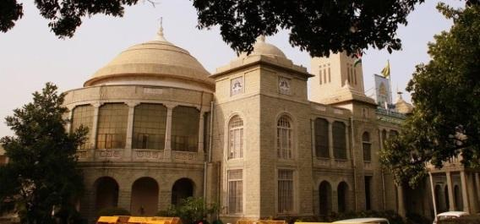
History on Bengaluru

Bangalore is draped over the Deccan Plateau at an altitude of 949 meters (3113 ft.) above sea level, which gives it possibly the best climate among all the cities in India. Legend has it that Bangalore got its name from the words "BendhaKaaLu" (which means boiled beans in the local language Kannada). King VeeraBallala of the Vijayanagara Kingdom was once lost in a forest and happened to stumble upon a lonely cottage. An old woman that lived there could offer the starving king only boiled beans "BendhakaaLu" and the place came to be known as "BendhakaaLuooru" (“ooru” in Kannada means a “city”). BendhakaaLooru later came to be known as BengaLooru in Kannada, and Bangalore in English. However, historical evidence shows that "BengaLooru" was recorded much before King Ballala's time in a 9th century temple inscription in the village of Begur. Even today, "BengaLooru" exists within the city limits in Kodigehalli area and is called as "HalebengaLooru," or "Old Bangalore.”

2.1.1. BENGALURU PRTS PROPOSAL

BENGALURU is the COSMOPOLITAN city of Karnataka state.

Bangalore District Overview
An official 2011 Census detail of Bangalore (Bengaluru), a district of Karnataka, has been released by Directorate of Census Operations in Karnataka. Enumeration of key persons was also done by census officials in Bangalore District of Karnataka.
Bangalore District Population In 2011, Bangalore had population of 9,621,551, of which male and female were 5,022,661 and 4,598,890 respectively. In a 2001 census, Bangalore had a population of 6,537,124, of which males were 3,426,599 and the remaining 3,110,525 were females. Bangalore District population constituted 15.75 percent of total Karnataka population. In a 2001 census, this figure for Bangalore District was at 12.37 percent of the Karnataka population.
Bangalore District Population Growth Rate
There was a change of 47.18 percent in the population compared to population as per 2001. In the previous census of India 2001, Bangalore District recorded an increase of 35.09 percent to its population compared to 1991.
Bangalore District Density 2011
The initial provisional data released by census India 2011, shows that density of Bangalore district for 2011 is 4,381 people per sq. km. In 2001, Bangalore district density was at 2,985 people per sq. km. Bangalore district administers 2,196 square kilometers of area.
2.1.2. Traffic demand

The assessment of traffic demand for the present study has been based on the travel characteristics identified during the traffic studies conducted by Urban Transport and Traffic Management - For Sustainable Transport Development in Bengaluru City. Based on the OD Matrix, the study revealed that the major traffic generation/attraction nodes are centered around the Railway station and the bus stands at Whitefield Railway station, Marathalli Junction, MG Road, Ballari Road, and Hebbal flyover - the link volumes have been derived for the proposed PRT system, and using growth factors, the traffic demand has been projected for the horizon years.

- Bengaluru City & Traffic
Bengaluru today is obviously one of the most sought-after cities in the country, with exceptionally rapid growth in the IT industry and a steady rise in the number of job opportunities throughout the city. With the rising population in the city, there is also a corresponding increase in the number of vehicles in the city, thus placing a huge increase in the demand on land.
What adds to the traffic pressure in Bengaluru in particular is that there is very little scope for expansion of roads, and the need to use existing roads for smooth movement of vehicles is even more pronounced. It thus becomes mandatory for the administration to ensure better parking facilities. So far, the government and the BBMP have not taken this issue seriously and now the situation is such that it needs to be addressed seriously and effectively.
- Bengaluru city Traffic at a Glance - Numbers Speak!
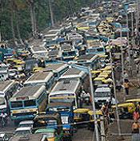
Rapid population growth because of IT and other associated industries in Bengaluru led to an increase in the vehicular population to about 1.5 million, with an annual growth rate of 7-10%.
With the increase in population and the expansion of the city, the problem of connectivity for the populace has arisen. Quite obviously, personalized modes of transport have grown at a tremendous rate, and two-wheelers along with the cars comprise almost 90% of the total registered vehicular population in the city.
Two-wheelers constitute more than 70% of the total volume, while cars comprise 15%, autos 4%, and the remaining 8% includes other vehicles such as buses, vans, and tempos.
- Impact of growth on Traffic
All or most of the roads are operating above their capacity and volume: capacity ranges from 1:2, 1:3 and 1:5.
1 | Nrupatunga Road | 3.62
2 | District Office Road | 2.51
3 | K.G. Road | 2.51
4 | Lalbagh Fort Road | 2.67
5 | Puttanna Chetty Road | 2.45
6 | Richmond Road | 2.26
7 | M.G. Road | 2.26
8 | Chord Road | 2.51
9 | Tumkur Road | 2.62
10 | Sankey Road | 1.52

Vehicle Population in Bengaluru City (up to 31-03-2016)
Two-wheeler | LMV | A/R | HTV | HGV | OTHERS | TOTAL
3841139 | 1141455 | 149944 | 108845 | 73462 | 244885 | 5559730

- BANGALORE THE “BLACK CITY” OF INDIA
Bangalore has the worst road traffic in India considering the destructive cocktail of high accidents, vehicular pollution, traffic violations, and motorisation levels.
Consider the statistics:
- Motorisation Index of 362
- Nearly 800 accidental road deaths every year, with an Accident Severity Index of 11.85
- Nearly 4500 “Official” traffic violations per day
- Majority locations indicating AQI > 75 and Noise > 90 dB
- Congestion cost of 208 million Rs/Day in terms of lost time
- Nearly 30 vehicles stolen per day
- Overcrowded buses, with average loading of only 57 passengers and with distance between bus shelters an average of 2.69 km.

- MODES of TRANSPORT
- Vehicles 60%
- Pedestrian 10%
- IPT 6%
- Safety 6%
- Public Transportation 18%

The Comprehensive Traffic and Transportation Study conducted in Bangalore in 2007 estimated the pedestrian trip share as 8.33%, with number of trips daily being 523597. This estimation looks highly conservative, as the Public Transport and IPT shares are 41.91% and 11.56% respectively. Considering very poor service of park & ride facilities available in Bangalore, the ingress and egress from the public transport share would be mainly through the walking mode, thus it should have a higher share.

- WHY IS BANGALORE TRAFFIC BAD?
- Inefficient Policing 3%
- Low Fines 1%
- Poor Traffic Management 25%
- Lack of Proper Infrastructure like Flyovers 24%
- Undisciplined Drivers 18%
- Bad Roads 29%
- Other

- Introduction of Urban Transport and Traffic Management

STRATEGIC TRANSPORT MODEL: A suggestion, given the contexts above. It would be good to think of a strategic transport model for applying to the situation pertaining to Bengaluru city.

First is the fact that the CDP does not use a model for planning and managing the transport in the city. Second, in the absence of a specific model, a generic model such as the Strategic Transport Model may be used for developing transport planning and management strategies. This model is recommended for use in transport planning and management for Bengaluru because this has been successfully used in numerous contexts, but particularly in Australia. That model was developed by the New South Wales Transport and Population Data Centre and it analyses transport and traffic patterns in a highly disaggregated form (Rickwood et al., 2007). This provides information on travel for all purposes - for example, shopping, business, education, social/recreational — and all modes. It is because of the sample requirements that the scholar has not been able to use the model and arrive at a model result. Small sample sizes will be too small to allow accurate estimates for minor modes such as cycling, or for analysis of travel patterns for specific purposes at fine geographical scale.

- Station wise matrix of passengers for PRT in the selected area 2017
No |  | Name of zone |  |  | 1 | 2 | 3 | Total
1 |  | M G road station |  |  | 2,044 | 1,363 | 6,132 | 9,539
2 |  | Marathalli junction |  |  | 825 | 206 | 1,100 | 2,131
3 |  | Silk board |  |  | 2,700 | 3,100 | 1,434 | 7,234
 |  | Total |  |  | 5,569 | 4,669 | 8,666 | 18,904

Hence the daily demand for the initial year of 2017, considering induced and diverted traffic of 12% and a growth rate of 6 %, daily demand will be in the range of 18,904 persons per day. The average of daily passengers is: 16,000.

2.1.3. Alignment

The alignment considered for provision of PRT system is a pilot-case-basis, with provisions for introducing more stations as well as expanding into a network configuration. For the purpose of this report, the basic alignment is considered from M G Road Metro Station to The Leela Palace Junction. The PRT system can be further expanded to also include outlying area in the future phases to then be integrated onto the network. The other locations to be connected in phases are BMTC bus terminal, AirPort link, and Ring Road, which could be linked to the main network in future.

2.1.4. Stations
The stations placed on the routes to optimize access to moving both people and cargo. The stations features are discussed in paragraph 3.3.3.

2.1.5. Land- (Government of Karnataka)
Land is the primary requirement for any infrastructure creation, however the PRT system brings in a radical change in the way land is used. Similar to the KPTCL cable & overhead lines, the tracks shall pass over existing roads and the supporting pillars shall be located along footpaths or medians as appropriate. Only the station and depots for maintenance may require land. Wherever possible, the stations shall also be housed within the right-of-way. Hence for the project, Government shall permit use of space over a road along or across that which the proposed system passes and may permit exemption of levy charges as may lawfully be levied in respect of the use of a road or bridge along or across that which the system is laid. Hence, no additional land acquisition is required for laying of tracks.

2.1.6. System design

The PRT system proposed for Bengaluru has been designed so as to cater to the peak demand that has been observed in the region. The average trip length has been estimated at 1.5 km. Although pods are dedicated to the trip each traveler wishes to make, pod vehicles will service many trips each hour.

2.1.7. Civil Infrastructure- Stations & Track

The layout of stations has been designed to provide general amenities such as toilets, kiosks for refreshments, tea shops, book stands, etc. These have been layered in such a way so as to avoid unnecessary rush, while at the same time promoting sales in the kiosks by rationally separating the paid areas from the unpaid zones.

PRT systems use offline stations so that all stopping traffic is diverted away from the main guideway, thereby discounting for time losses to the system due to stopping vehicles. In order to make the proposed Bengaluru PRT system truly effective, a conscious attempt has been made in the design process to keep the capital and maintenance costs of stations at a minimum. Although all stations would eventually be individually tailored to ensure optimal integration within the local context (space available, surrounding development etc.), for the purpose of station design, four (4) typical station typologies have been developed.

Stations may be located above, at, or below ground, or, due to the system’s virtually silent nature, inside buildings. Stations can be enclosed or open-air, will always provide at least a minimal covering above the berth area, and are designed to be suitable for 24-hour operation. To reach the platform level, passengers take stairs or elevator from the street level.

2.1.8. Track Alignment and Guide ways
Standard elevated guideways would be 6 to 9 meters high with ramping up and ramping down depending on locations as and wherever required as non-standard ones. As project stretch has undulating topography, the guide way elevations can change. Gradients can be at a maximum of 6%.

Guideways will normally be single or twin depending on network design configuration. Guideway supports will be of different types: single, columns as portal frame, or with cantilever support, etc. Depending upon the ROW available, underground utilities and building projections etc. The exact locations of placement of columns with various combinations would be based on detailed engineering drawings. Column spans are normally 18 meters apart. Additional protection railings may be provided along the guideways with covered mesh wherever required.

2.1.9. Maintenance Yard and Control Room

Each system requires a maintenance depot, which should accommodate about 5% of the total fleet size. The control room for the system will also be located appropriately. The maintenance depot will be equipped with a repair and maintenance unit to perform regular preventive maintenance and repairs. The control room will be equipped with display systems for both the stationary and vehicle cameras. Intercoms at stations and in vehicles all connect to the control room as well.

2.1.10. Infrastructure and Structural Requirements |  | 2/9
Stations will be located about every half kilometer depending on the demand. In Phase One, there approximately 6 stations. There will be an X-type route (Traffic Circle) with stations along old airport main road. In addition, there will be one Maintenance Yard where the maintenance and washing of pods will be undertaken. Apart from these, there will be an office space along with a Central Control Room from where all pod movements will be controlled.

Number of Pods –Requirement of pods in various years is given below. Counts will depend on demand in specific networks. Counts are provided per kilometer of rail. Actual data will vary based on needs.

 | Year | 2017 | 2021 | 2031 | 2041
 | Number of Pods | 50 pods/km | 70 pods/km | 80 pods/km | 85 pods/km

Maintenance Yards: 1 per 500 vehicles
Control rooms: 1 per 10 km of network

2.1.11. Power Requirement

The system will be connected to the grid for collaboration and backup. The network will be energy self-reliant.

2.1.12. Water Requirement

Total Water Requirement: approx 9 KLD

Broad items for water consumption:

 | Domestic Water | : 45 | Litre / Person. / day
 | Floor Washing | : 3 Litre / Sq.mt. / day
 | Public Toilet | : 15 | Litre / Person / day | JUNE 2012 | 2/9
 | Pod Washing | : 20 | Litre / Pod

Water Supply

It has been assumed that water will be available from the State Authority via nearby Sources. Supply will be taken at a single point or each consumption Station nearby, and multiple distribution points within the Consuming Station will be internally handled.

The capacity of JPods networks to carry water, sewage, garbage, and other cargos increases opportunities for recycling to improve water and waste problems.

2.1.13. Heating Ventilation and Air Conditioning (HVAC) Requirement (link to energy calculations).

Total HVAC Requirement: approx. 140 TR¹ (including 23 TR standby)
*Would be provided through Window/Split Units (equivalent to 175 KW of power load).

HVAC Load
 | UPS Room | : 50 Sq.ft / TR
 | Office and Control Room | : 100 Sq.ft / TR
 | Ticket Counter | : 1 TR per Counter

2.1.14. Cleaning System

Cleaning to take place only in off-peak hours, at yard, and using washing methods similar to commercial car wash systems.

2.1.15. Fire Fighting System

Fire Water Tanks with Pumps, Fire Hydrants, Fire Extinguishers

2.1.16. Maintenance

The system requires regular periodic maintenance; therefore, one maintenance yard has been planned. It is planned that a pod comes for periodic maintenance to the yard once every 3 days. This is estimated based on various factors including the utilization factor.

2.1.17. Provision for Security

CCTVs are planned for the stations, yard, and the entire track. Each station is provided with Flap Gate Access Systems.

2.1.18. Ticketing System

Ticketing System would be Token, Smart Cards, or Touch Screen system.

2.1.20. Structural Design Specification

The project is located in a seismic zone classified as III, as per IS 1893 (Part 1): 2002, and as such, the design and specifications are to be based accordingly to minimise the structural damages resulting from an earthquake.

Design Features
The entire track/guideway is elevated on M.S. Column resting on RCC Foundation and pedestal. The foundation location would be decided on the basis of a soil data analysis of the track alignment. The guideway would rest on MS Column, which supports the main built-up (Beam) section, as well as secondary built-up beam. The secondary beam is provided to place the precast RCC / GRP planks for the movements of Pods. In between two planks, there would be cable tray for supporting various electrical and communications cables. For safety purposes, Railing (MS) would be provided up to height of 0.9 metre on both sides.

2.1.21. Safety Certificate

JPods uses safety standards from ASTM International Technical Committee F24. These standards resulted in the innovative spirit, care for customers, and extraordinary safety record of the theme park industry.
ASTM International, formerly known as the American Society for Testing and Materials (ASTM), set the standard. We certify compliance of the design and build to that standard. The insurance company that provides the insurance confirms that we are in compliance. There are multiple checks, with risks of penalty or lawsuit, to anyone trying to avoid compliance. Personal Rapid Transit is developed under ASTM leadership.
JPod Systems Codes and Standards
The following codes and standards apply to the design and construction of the JPod chassis:

Issuing Organization | Code / Standard | Title
ASTM International | ASTM F2291 | Standard Practice for Design of Amusement Rides and Devices
National Fire Protection Association | NFPA 70 | National Electrical Code
ASCE | ANSI/ASCE/T&DI 21-05 | Automated People Mover Standards

Safety opportunities are expanded by the Rescue-Rail version of JPods networks. These networks can be deployed in emergencies to mitigate harm and speed recovery.

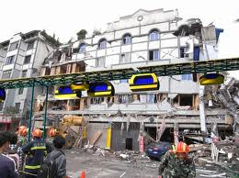

2.1.22. Staffing Plan

The system requires decentralized control rooms, operating staff, and cleaning and maintenance. Initially, PRT cabin attendants will service the stations. The staffing will grow and shrink based in system size, station number, and vehicle dissemination.

2.1.23. Fare Collection Systems

The PRT stations in all locations within the system will be integrated. The ticket management system will curtail the time spent by passengers in procuring tickets before boarding the PRT vehicle. There are a number of fare collection options that will be employed, including:

• Automatic Ticket Dispensing Machines (Such systems help in fast transactions and provide ease-of-use in entry and exit areas).

2.1.24. Project cost

The total Project cost has been worked out at INR 46.9 crores/km ($7 million/km), including the system cost, Interest During Construction (IDC), Project Management Consultancy (PMC), corporate office cost, etc. This may be subject to change depending on technology and detailed engineering analysis, to be done prior to implementation.

2.1.25. Revenue

Revenues to the government for non-exclusive access to Rights of Way is 5% of gross revenues. These fees will paid quarterly.

2.1.26. Viability

Bengaluru Mobility Company, SPV formed by Actis/JPods, are responsible for building routes that will be viable based on market conditions.

2.1.27. MODE OF IMPLEMENTATION

A Special Purpose Vehicle, the Bengaluru Mobility Company, will execute agreements reached for Rights of Way under this agreement. Hence the project is proposed to be carried out without any financial liability for the state. However, the SPV will have the right to fix the tariff to run the PRT system as a commercially viable project and the fare shall be regulated by the PRTS users.

The SPV shall ensure the safety and overall economy of the system. The SPV will accomplish the objectives of BBMP of safety, low carbon footprint, speed, economy, comfort, and above all, sustainability as design, build, operate and option for transfer after 20 year period to the Government.

The fare will be set by market pricing per passenger-km, time of day, and other factors that will be published from time to time.

2.1.28. Way Forward

PRT has the promise of bringing in a radical change in the way movements of persons occur in a region. Rather than concentrating the traffic on a corridor, a PRT system has the flexibility of spreading the traffic uniformly over the network. It also promises a sustainable transport mode that is environmentally friendly, efficient, fast, economical, and safe. We would request the Government to entrust the implementation of PRT system as per this proposal.

2.1.29. Requests to Government

License
Government may grant approval to build a Personal Rapid Transit (PRT) System in Bengaluru city for the proposed route.

The proposed route network mentioned may be approved for implementation. However, the track length, location, and number of stations may change depending upon actual site considerations, obstructions, and also based on market demand.

2.1.30. Period of Concession

The concession period shall commence from the date of start of commercial operations and shall extend until a period of 20 Years.

Under mutually agreeable terms, after the initial concession period of 20 years, the project may be transferred back to GOK or renewed. Because employees and others in the community are shareholders, the value of their property must be considered.
.
2.1.31. Land and Right of Way

Government may provide adequate vacant land and Right of Way (RoW) for the PRT System (stations, tracks, maintenance yard, control centre, etc.).

RoW for elevated Guideway: Permission to lay track overhead and place piers on road sides/medians. Each column will need approx 1 sq. meter land and the distance between two consecutive independent columns shall be approx 18 to 35 meters.

Based on site conditions, portal columns may also be required at certain locations, in which case the land requirement may vary from above. Government may allot land free of cost for stations (no upfront payment/rentals).

Government may provide all land and RoW free of any encumbrances in the form of overhead and underground utilities, encroachments, etc. Requirement of land will be limited to vacant land available only. No acquisition or procurement is proposed. In case vacant land is not available, stations at elevated level with stairs/escalators to the side of the roads shall be provided without affecting pedestrian movements.

Any shifting of utility lines would be undertaken by the Government prior to handing over of the site(s) and RoW to the Implementing Agency for commencement of construction. Or, the government may contract with the Bengaluru Mobility Company to manage this task as part of its production process.

2.1.32. Other Terms

- Exemption from Transport tax system
- Exemption from payment of local taxes like Works Contract Tax may be granted as this is a public transport system
- Power and Water required may be made available to PRT at the rates applicable to public utilities.
- Support and assistance in procuring all applicable permits, approvals for the Project including environmental protection and conservation of the Site and safety clearances.
- Make appropriate changes in development control guidelines e.g. ingress and egress into (and from) buildings, setbacks on plots, etc. for efficient implementation of the project.

Permissions to:
- Advertise within and outside the spaces created in the project, including stations, guideways, and vehicles, and to collect fee, revenue from the advertisement rights (critical for fare subsidization).

- Operate kiosks at each station for public amenities such as tea/coffee stalls or ATMs on its own/revenue share/rent.

- Operate the System 24 X 7 (24 hours a day, and 7 days a week) subject to demand; and/or Manage, operate and maintain the PRT and regulate the use thereof by third parties.

- Assistance in obtaining license to operate the two-way communications system may be given.

- Permission to collect parking fees from the Users at the designated area within the operational area of the PRT System may be granted to the Implementing Agency.

- Permission to frame appropriate regulatory mechanism for safety, certification, registration, and framing of rules and regulations for the construction, operations, and maintenance of the System may be granted

- Any other issues that may arise during execution and operation & maintenance of the system may be decided by a Committee headed by the Chief Secretary with Principal Secretary (Finance) and Principal Secretary (Transport) as members.

2.2. Revenue model with BBMP

Pay 5% of gross revenues to the aggregate rights of way holders (ROW holders are mostly city and other governments) to Bruhat Bengaluru Mahanagara Palike.

- Technology proposed along with its merits

Safety certificate…………………………………….42
Uniqueness of the system……………………….47

Process flow along with brief description of various components.

- INTRODUCTION:
JPods are networks of ultra-light, computer controlled vehicles traveling suspended from overhead rails that move people and cargo in cities using 1/10th the energy of cars, passenger-trains, and buses. Solar collectors mounted over the rails gather the energy to power the networks.
JPods networks are privately funded. They provide a cost effective way to move people, cargo, and waste while creating sustainable jobs.
Computer-controlled, suspended vehicles move 1-4 people or 500 kg of cargo on elevated rails and operate at 10% of the energy required by cars, buses, and trains.
JPods networks offer on-demand, personal mobility regardless of age, ability, or wealth.

3.2. Cleaner, Faster, Safer, and more affordable:
3.2.1. Cleaner. By removing the parasitic mass of the vehicle and the repetitive applications of power in start-stop urban traffic, energy required to power the vehicle is cut 90-95%. Pollution is eliminated by powering the network from solar collectors mounted over the rails.
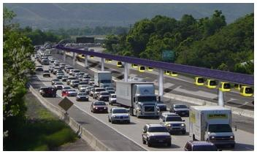
3.2.2. Faster. JPods networks are quicker than any other mode of urban transport:
- No waiting. Machines wait for people, not people waiting for buses.
- Non-stop from origin to destination. Only you and your party travel in a vehicle with no stops between where you started and where you wish to go.
- Grade separation preempts the congestion on the ground.
- As of 2012, congestion costs the average worker 38 hours per year (source: TTI’s 2012 URBAN MOBILITY REPORT); a work-week per year drained from the person and economy. This number is only expected to increase as the economy improves. This drain equates to a 2% tax on working people that benefits no one. In large metropolitan areas such as Washington DC, Los Angeles, and San Francisco the cost is nearly double.
- Commuting to work by bus takes about twice as long as by car. Delays are a tax on time. JPods combine the personal service of a chauffeured car with the process controls and automation of the Internet. JPods provide the personal mobility of a car without the requirement to park, maintain, or operate it.
3.2.3. Safer. Safety is enhanced by:
- Grade separation: The Personal Rapid Transit network in Morgantown, WV has been injury-free since it opened in 1975. Compliance with the ASTM F24 has a safety record of 4.5 injuries per million versus Departments of Transportation with 106 deaths per million.
- People do not have to wait for vehicles on a schedule, reducing crime risks.
- Women and children can travel anytime of day safely.
- Life requires energy. Bengaluru’s economy’s dependence on foreign oil is a risk preempted by JPods solar-powered mobility networks.
3.2.4. More affordable. Cutting energy requirements 90% reduces makes horizontal mobility as simple as riding an elevator. As the infrastructure is paid off, the cost of mobility will drop in price.
3.3. JPods networks build on well proven existing solutions.
JPods networks combine the efficiency of freight railroads with the safety of theme parks and the on-demand service of the Internet to create the Physical Internet®:
- The 140,000 miles of freight railroads in the US average 476 ton-miles per gallon.
- The Personal Rapid Transit network in Morgantown, WV has been injury-free for 42 years. The suspended train in Wuppertal, German has had one fatal incident since 1901. About 25 million people ride this each year.
- Theme parks regulated by the ASTM F24 have an injury-rate of 4.5 per million versus DOT’ 106 deaths per million. About 294 million people visit US theme parks each year.

3.3.1. What is Personal Rapid Transit (PRT) or podcar networks?
PRT stands for Personal Rapid Transit system. It consists of a light guideway infrastructure suspended some 5 -15 meters above the ground over city streets or along the curb side.
- Individual travel in automatic, car size vehicles.
- Vehicles are on-demand. There is no schedule.
- Vehicles move non-stop from origin to destination.
- Although greater speeds are possible, the networks are typically designed to average 50 to 80 km/hr.
- Compliance with the ASTM standards results in an average injury-rate of 4.5 per million. This compares to the 106 per million death rate of roads.
- The 42-year operation of Personal Rapid Transit network in Morgantown, WV has been injury-free.

- Efficiency and low mass combine to support private funding to build, maintain, and operate.
- Cameras, sensors, and robotics combine to support the network adapting to changes in load, weather, and other events.
- The networks operate 24 hour per day, 7 days per week.
- Anti-vandalism is built into the networks.
- Women and children can safely travel any time of day.

  - People do not travel with strangers.
  - Abnormal momentum shifts in vehicles engage the internal cameras and a request can be made to assure everyone is OK.
- Pods move in the congested area without being affected by ground traffic.
- Low energy consumption makes transport competitive with all other modes of transportation.
- No emission.
- Zero accidents –solve major traffic problem.
- Proven viable in Morgantown, WV for 42 years and in Wuppertal, Germany for 116 years.
JPods networks are the 21st century version of Personal Rapid Transit (PRT). In 2007, The New Jersey Legislature concluded PRT is an ``enduring idea that offers the unique and rare combination of potentially improving the quantity and quality of transit service while reducing costs, congestion, and environmental impact.’’
The efficiencies inherent in the network are the core of JPods competitive advantages. The ultra-light pod cars need only a simple electric motor powered by the solar panels mounted over the rail. This self-reliant system is durable against energy supply shocks. Relative to current passenger and cargo transit services, JPods recovers 90% of energy costs into savings, competitive advantage, and profit.
Part of the energy efficiency advantage surfaced from putting the JPod network on a separate plane. This grade separation allows JPod networks to travel unimpeded by ground pedestrian and vehicle traffic, making the network inherently safer and solving urban congestion. Grade separation also accounts for the JPods small footprint: pylons every 30 meters support the elegant rail, truss, and solar arrays.
Essentially, JPods networks have the convenience of a chauffeured automobile without the problems of oil, parking, traffic, and debt. Automated pod cars offer on-demand service for 1 to 6 travelling companions, a pallet of cargo, or any shipment less than 550 kg. The nonstop travel gets passengers and freight to their destination quickly and with less energy.
- Competitive Advantages of JPods Networks
3.4.1. Ergonomics: Vehicles hanging from overhead rails (wheels-up vs. wheels-down) employs superior physics to reduce pod mass, energy consumption, increase ride stability for the you as the passenger. QQQ In a wheels down roller coaster you experience “bobble head” wherein your head is at the end of a whip created by your center of mass being between the wheels on your head. JPods’ puts your head between the fulcrum of the wheels and your center of mass.
3.4.2. System Patent: Patent #6,810,817 was issued in 2004 and defines how independently computer controlled vehicles can talk to each other, make decisions together and behave intelligently to move physical packets (PodCars) in a distributed collaborative network. Currently, about 50 additional patents have been researched and identified by JPods.
3.4.3. Management Track Record: A strong team leads the company with an outstanding track record in leading manufacturing, logistics, process controls, power generation, and high-tech companies.
3.4.4. Scalability: Rapid deployment of the PRT networks would be achieved by a combination of the leadership, management expertise, and networks of JPods and our allies. In particular, JPods holds the patent and technology as well as the manufacturing knowledge and experience.
3.4.5. JPods System Benefits
Provides a Renewable Energy Transportation System & Reduces Oil Dependency: JPods can be a solar-powered PRT. Solar panels on the top of the track gather 50,000 vehicle-kms of power per km per day.
Increases Energy Efficiency: PRT networks use about 85% less energy than vehicles using fossil fuels because:
- Ultra-light and ergonomically designed vehicles need less energy to move.
- It is non-stop and eliminates repetitive applications of power in start-stop traffic.
- Average travel speed is higher and peak speeds are lower than other modes of transportation; therefore, less energy is expended combating wind resistance.
Creates Green Jobs: Engineers, designers, manufacturers and contractors will be needed to deploy the JPods networks.
Low Cost: JPods PRT networks are expected to cost on average $10M per mile to build for the network costs. The low vehicle weight radically cuts operating and maintenance costs ($0.06 per mile vs $0.56 per mile costs for cars). Per mile cost to build light rail are typically in excess of $40M.
Provides Economic Benefits: Increases disposable income by decreasing transportation costs for the general public. Reduces government subsidies via financially self sustaining networks, and increases system revenues by potentially moving freight and waste as well as people.
Better Performance: Without repetitive start-stops, PRT provides a faster and more efficient transportation system with average speeds of 30 mph for JPods, as compared to 24 mph for cars, 18 mph for trains, and 8-12 mph for buses for similar service requirements.
Reduces Congestion: The small real estate footprint, grade separation, rail stacking, separate and additional networks to existing infrastructure, and computerized route optimization minimize ground congestion issues.
Reduces Pollution: JPods PRT utilizes a solar renewable energy system that eliminates harmful CO2 emissions. Rubber tires on concrete or steel rails, as well as low weight and speed produce less noise and vibration.
Increases Safety & Time Savings: Existing networks have low injury rates primarily due to slower maximum speeds as well as one directional movement and limited opportunity for collisions. Morgantown PRT has delivered 110 million injury-free and onsite emissions-free passenger miles.
Provides Flexible Transportation: PRT guideways can be laid out in a network or grid (as well as point to point), and there is more than one route connecting an origin and destination. Therefore, service can be maintained when a single guideway is out of service. Stations and guideways can be above ground and mitigate ground transportation issues.
Provides High Quality Service: Provides high quality on-demand, customized service comparable to chauffeured cars (at a fraction of the cost). A high level/frequency of service addresses variable and distributed demands with vehicle utilization tailored to real-time demand. The system delivers service as-needed while maintaining service quality at reduced overall cost.
Increases the Value of Existing Transit Networks: PRT inexpensively connects the short gaps between existing transit infrastructure; connecting airports to trains, trains to buses, and many people to their ultimate destination. The Prime Law of Networks is that the value of the network increases exponentially based on the number of interconnected nodes.
- Components - The following technologies are used to create the JPods network”
- JPods Vehicles
3.5.1.1 Passenger pPods.
The Pod or JPod is the moving vehicle. It can accommodate 1 to 6 passengers, including handicapped persons. Inside the pod there is a touch screen so that anyone may redirect to another destination while en route. CCTV cameras are mounted inside the pod for safety and security. The JPods also houses the environmental control system for comfortable travel. IT also houses the backup battery, capable of transporting the JPod to the nearest station in the unlikely loss of power.
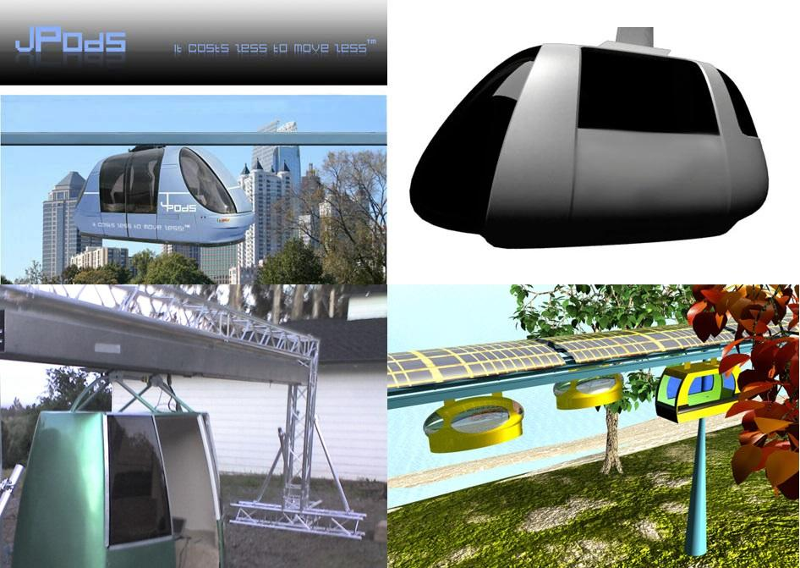
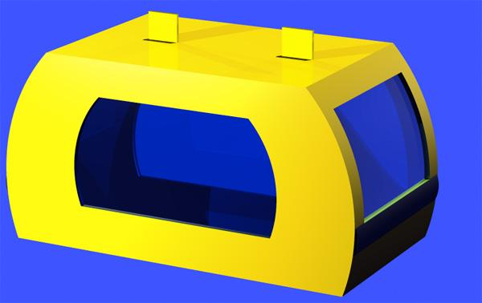
3.5.1.2. Cargo Pod
Cargo pods are similar to JPods, except they are configured to transport cargo instead of people. They lack some of the environmental controls and instead can accommodate more volume and weight than a JPod. Cargo Pods can be configured to transport pallets or carry loose material such as building materials or trash. They can be loaded and unloaded using a fork truck or a standard pallet lift.
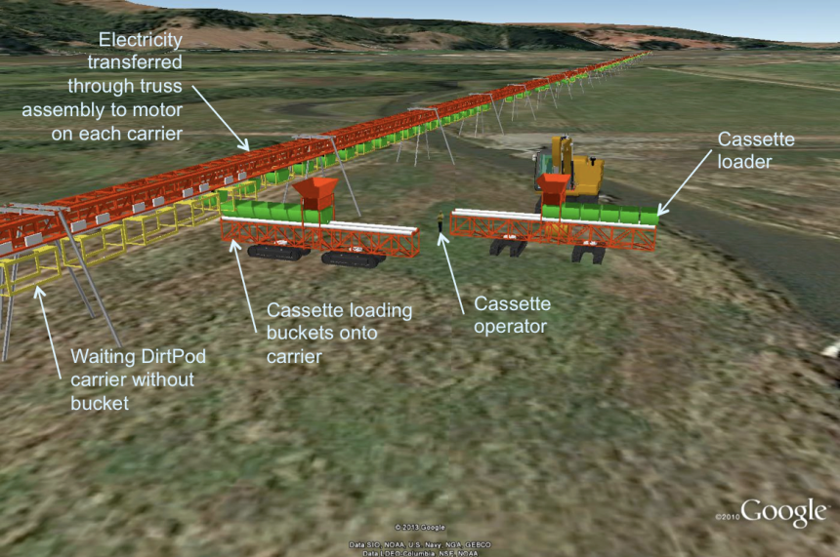
3.5.1.3. DirtPods™, FarmPods™, CNGPods™, WCPods™, H2OPods™, GurneyPods™, and many other specialty type of vehicles will deploy on the networks. The value will go far beyond just passengers. This is a circulatory system for an economic community.
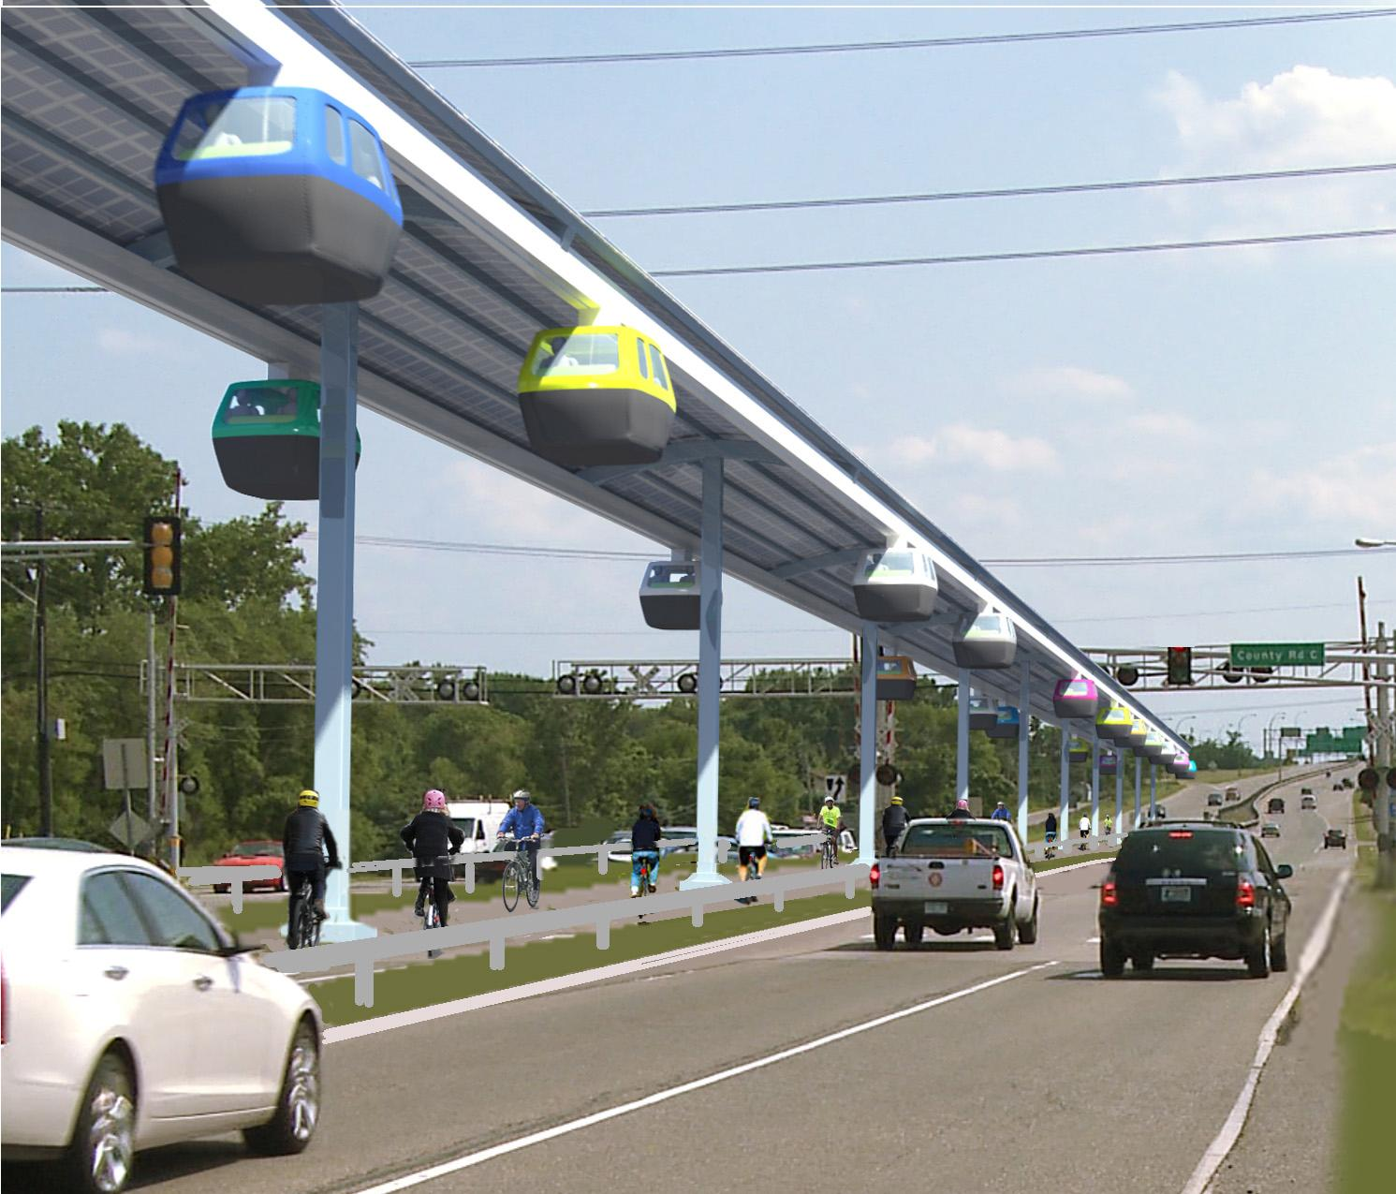
3.5.2. Guideway
The guideway is the rail system that the bogie and Jpod travel along. It is typically above ground, high enough so that as the JPod travels it will not come in contact with traffic below.
QQQ Space for construction: 1 diameter footpath curb-median. Top width of the system for a double rail is minimum of 3 meters. Top width of a single rail is 1.6 meters. Solar collectors over the rails would be 4 to 10 meters wide.
3.5.3. Stations
The JPods station consists of an elevated platform for the loading and unloading of passengers and cargo. Stairs or an elevator may be used to reach the platform. JPods arrive at the station be switching to a siding of guideway. This allows JPods not stopping at the station to continue along their path uninterrupted. A station can load and unload multiple JPods simultaneously. JPods not carrying passengers will place themselves at the station, waiting for passengers.
Unlike passenger trains, JPods vehicles do not stop at every station. They move directly from origin to destination, by passing stations on the “traveling rail.” If a vehicle needs to stop at a station, it exits the traveling rail on the “station bypass rail.”

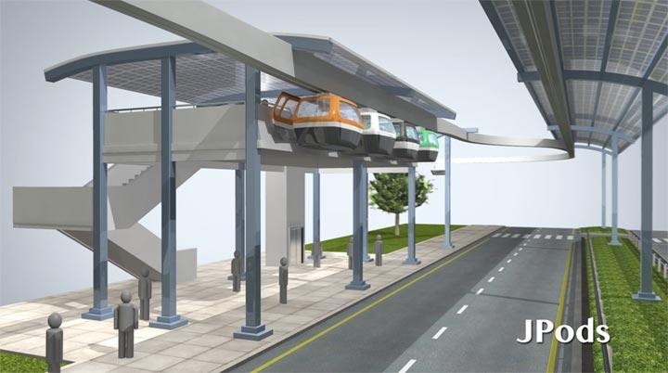

The station consists of an elevated platform for the loading and unloading of passengers and cargo. Stairs and elevator are provided to reach the platform. As the passenger carrying pods/cars arrive at the station, these shall be switching to a siding of guideway. This allows other vehicles non-destined to the station to continue along their path uninterrupted. A station can load and unload at multiple bays simultaneously. Those pods not carrying passengers will place themselves at the station, waiting for passengers. Depending on the location, the station can be either placed over the road, or stationed within a building complex or on the median. The location also decided the number of berths to be provided where the vehicles can berth and permit embarkation and disembarkation as well as the holding capacity needed for layoff pods.

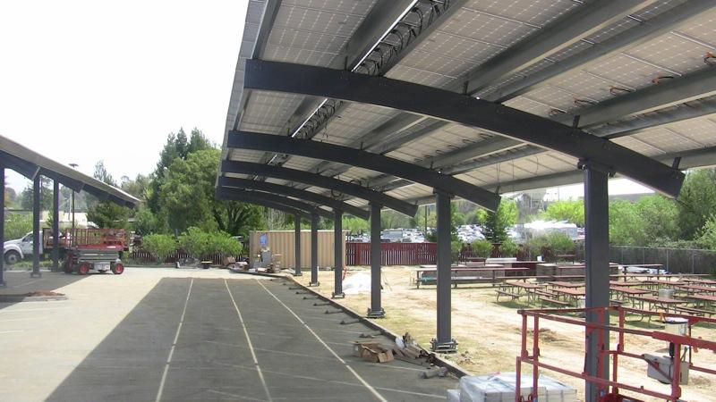
- Solar Power Canopy
Solar collectors mounted over JPods rails gather about 4 megawatt-hours per kilometer per day. This is sufficient to power 50,000 vehicles to travel that kilometer each day at 6 meters wide. It is practical to expand the collection from 6 to 10 meters wide.

The following chart shows the energy required per passenger-km.
According to US DOE, energy required per passenger-mile is:

Mode | Load (passenger/vehicle-km) | passenger-km/liter | Watt-hour/passenger-km
JPods | 1.57 | 112.3 | 79
Van Pool | 6.10 | 44.7 | 242
Motorcycle | 1.20 | 31.8 | 339
Rail, Commuter | 31.30 | 19.7 | 547
Air | 96.20 | 18.1 | 596
Cars | 1.57 | 16.8 | 642
Truck | 1.72 | 15.0 | 721
Bus | 8.80 | 13.9 | 774
Taxi | 1.00 | 4.1 | 2,614

3.5.7. Energy Storage: Excess energy gathered during the day is converted into chemical storage for use at night. Illustrated is the process for converting water and CO2 into methane and oxygen. The conversions to isopropanol and dimethyl ester are also very promising. More approaches will be disclosed as patents are filed.
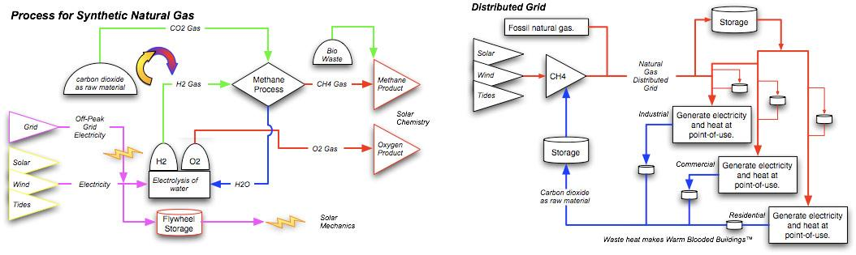

- Bogie
The bogie is the integrating component of the JPods system. It sits inside the guideway and supports the JPod. The bogie consists of a small electric motor that powers the traction wheels, used for moving the bogie along the guideway. Guide wheels are mounted horizontally on each side of the bogie, keeping it centered within the guideway. The top of the bogie has boss that moves right or left and is used for switching. The bogie also has a electric brush that allows for the transfer of electrical power from the solar collectors above the guideway to the electric motor, the network control system, and the environmental control system via the onboard battery.
Different bogies, tuned to different configurations, for different needs, have been built:
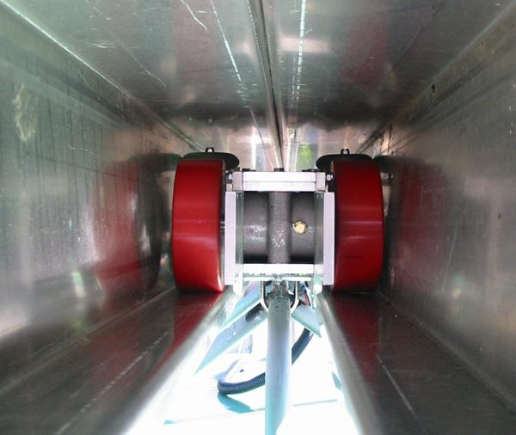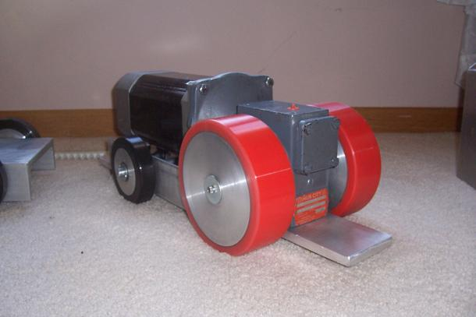
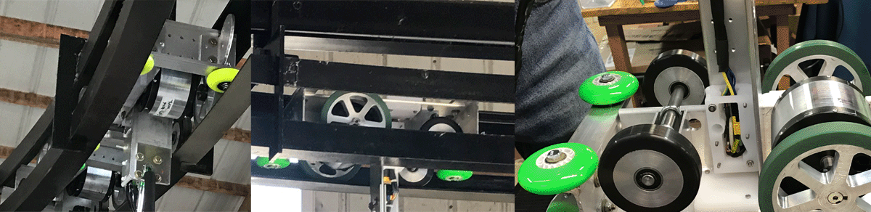

- Switches
Switches are used to direct the bogie and JPod to the appropriate guideway that results in the fastest route to the passenger’s destination. A boss mounted above the bogie switches left or right into a guide. The guide then routes the bogie to the planned guideway. Switches are also used at station sidings. This allows JPods to arrive at the station without other JPods having to wait while it unloads.
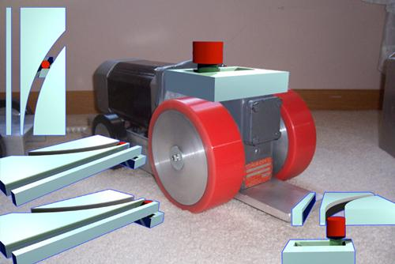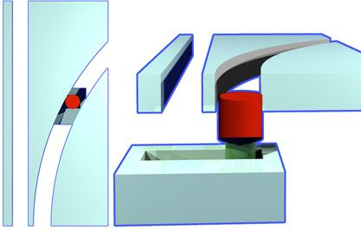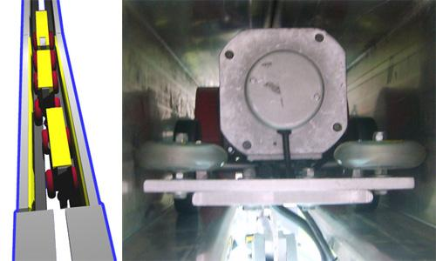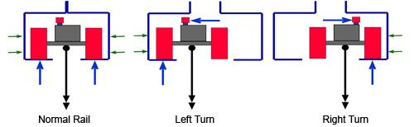
JPods will publish documents on additional patented switching mechanisms as the market opens and they are deployed.
- Vehicle Control System
The Vehicle Control System utilizes proprietary software to control the movement of JPods within the network. It controls speed and switch direction of each JPod to avoid collisions at merge points along the guideway.
Concepts in the control system can be seen in Route-Time™ software and JPods Robotics.
- Collision Avoidance System
JPods Collision Avoidance System is based on separate system from the Vehicle Control System. It will override commands from the Vehicle Control System. Under normal operations the Vehicle Control System will prevent any collision between JPods, however during abnormal conditions the Collision Avoidance System may be needed. Circumstances that may activate the Collision Avoidance System would be an obstruction in the guideway or a malfunctioning JPod.
Below are links to testing the avoidance system on a test track at SkyRide. Software is critical to the Physical Internet®:
- Suspended battery packs
- Bike vehicles

- Control System
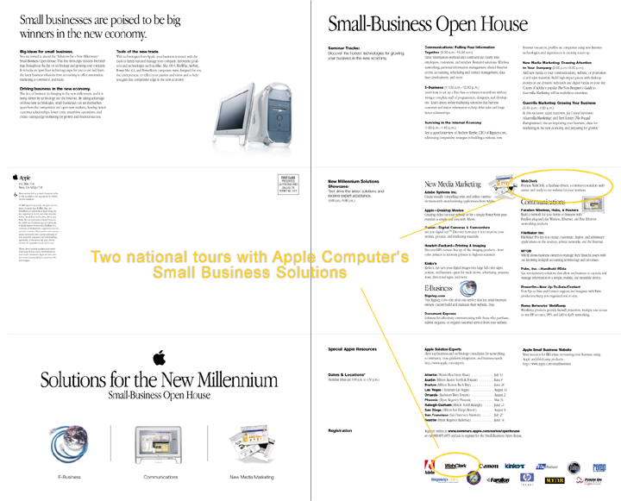
An Environmental Control System is used to keep the JPod comfortable for passengers. It consists of a small air conditioning/heating unit that regulates temperature within the JPod.
- Ticketing System
JPods business software systems are based on WebClerk. This software was featured in two US national tours with Apple Computers in 1999.

The ticketing system will be similar to current modern transit fare systems. It can interact with cell phones and pass cards.
Once inside, the JPod, the passenger enters their destination using the onboard navigation interface.

Technologies such as, Near Field Communication (NFC) enable customers to pay their fare with one time use tickets bought at the station, a personal transit card, or their NFC enabled smart phone.

- Cleaner, faster, safer, more affordable
- Cleaner
Put this power in personal experience. Walking barefoot on sun-baked asphalt, you quickly get an idea sunshine is a potent and widespread energy source. Harnessing this power to make oil independent transportation requires three actions:
- Convert the distributed nature of transportation network into solar collectors.
- Drive Parasitic Mass towards zero. Current transportation, where we pay for moving a ton to move a person, is too wasteful to take advantage of solar power.
- Deregulate transportation so it is open to innovation. Current regulations mandate delays, more highways, more oil dependence and other restrictions beyond the ability of most innovators to navigate.
The 140,000 miles (224 km) average 476 ton-miles per gallon. This is 140 times the efficiency of moving a person in a car on a road. This efficiency is accomplished by moving non-stop across the nation.
JPods networks approach the efficiency of freight railroads by:
- Removing vehicle parasitic mass (a 200 kg vehicle carries a payload of 500 kg).
- Moving non-stop from origin to destination.
The Parasitic Energy Ratio was created to illustrate the huge losses of moving parasitic vehicle mass in repetitive start-stop traffic. It is calculated by dividing the moving mass (vehicle and passenger) by the mass of the passenger and then multiplying the result by the number of start-stops (applications of power).

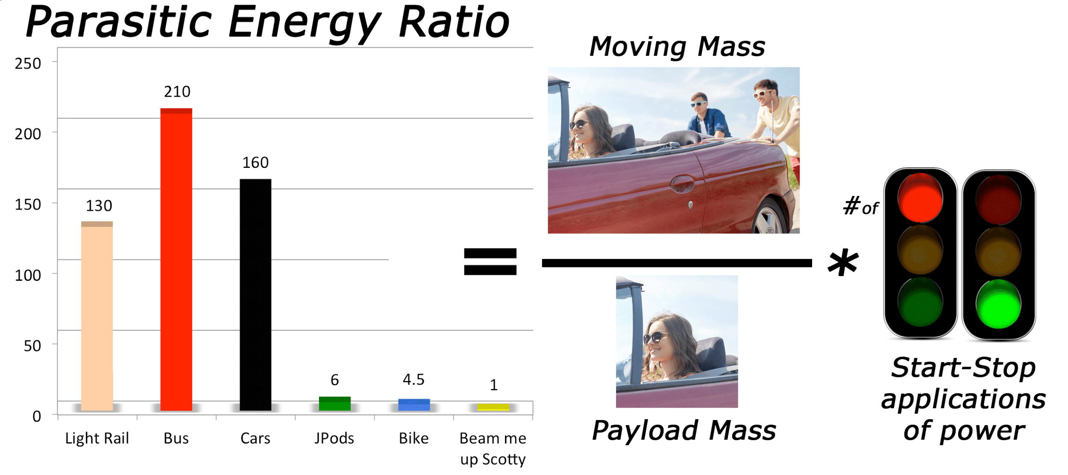

By removing the Parasitic vehicle mass, congestion can also be solved.
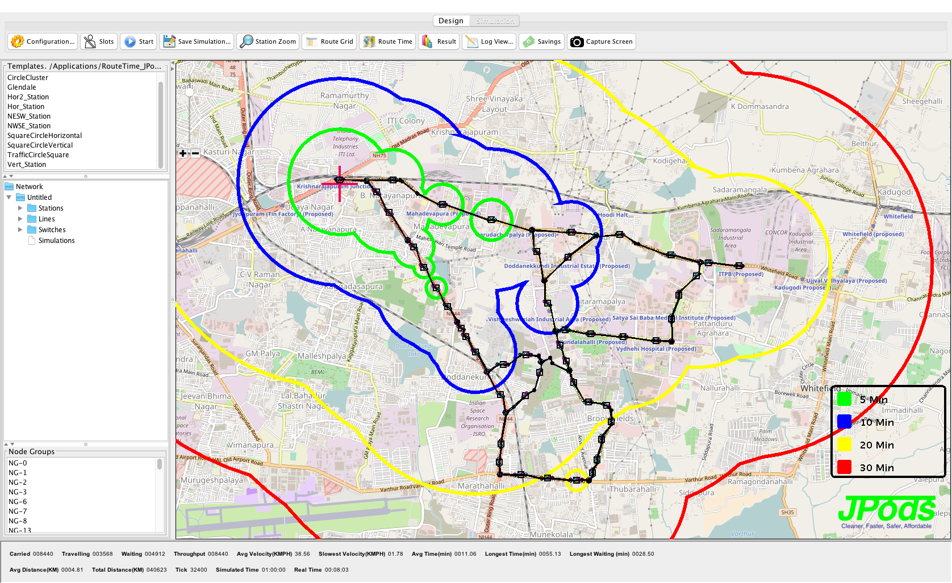
- Faster
Cars are the right answer: personal, on-demand access to work, economic and educational opportunities. Cars are just the wrong mass and randomness of behavior for highly repetitive travel.

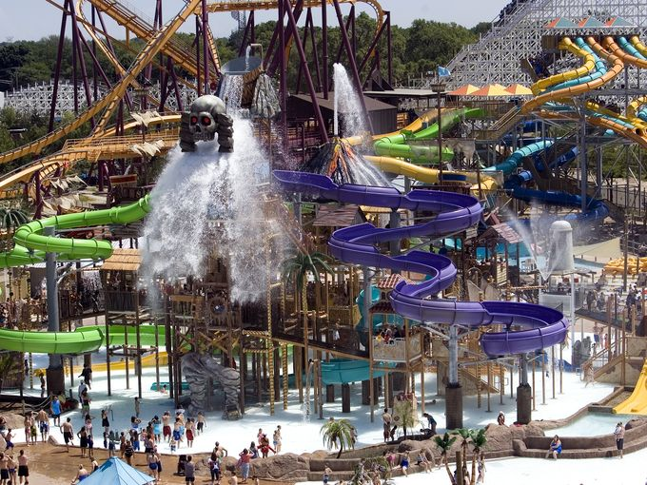
- Safer –Safety certificate
JPods uses safety standards from ASTM International Technical Committee F24. These standards resulted in the innovative spirit, care for customers, and extraordinary safety record of the theme park industry.
ASTM International, formerly known as the American Society for Testing and Materials (ASTM),
They set the standard. We certify compliance of the design and build to that standard. The insurance company that provides the insurance confirms that we are in compliance. There are multiple checks with risks of lawsuit to anyone trying to avoid compliance. Personal Rapid Transit developed under ASTM leadership
JPod Systems Codes and Standards

The following codes and standards apply to the design and construction of the JPod chassis:
Issuing Organization | Code / Standard | Title
ASTM International | ASTM F2291 | Standard Practice for Design of Amusement Rides and Devices
National Fire Protection Association | NFPA 70 | National Electrical Code
ASCE | ANSI/ASCE/T&DI 21-05 | Automated People Mover Standards

- Affordable
Cutting the cost of energy by 90% will, as networks are paid off, result in radically lower transportation costs.

3.6.4.1 Family Costs
The following graph shows yearly transportation costs for US families based on access to alternative networks to highways. The New York City subway systems saves families in that city the equivalent of a car payment per month over the typical American city.
There will be similar metrics in Bengaluru. Life requires energy. By shifting way from foreign oil, the costs of energy will be saved by those using JPods networks.
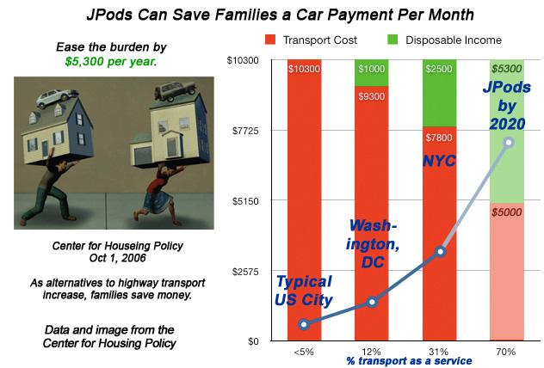In Cities with less than 5% public transportation, a typical working family ($20-50,000 income per year) spends $10,300 on transportation. In cities averaging 12% public transportation, that cost drops to $9,300; fewer car payments, insurance, gas and parking results in an extra $1,000 per year of disposable income.
It is practical to privately finance a 20% displacement of oil-based transportation in the next three to six years, increasing a working family's disposable income by $2,000.
In 10-12 years, it is possible to cut transportation cost by $5,000 by displacing 70% of oil-based transport; about a $5,000 increase in disposable income.
Construction, manufacturing and operations jobs will be created.
Driving Parasitic Mass, the mass we pay to move that is not cargo or passengers, towards zero results in dramatic cost reductions.

- Capital Costs
The typical cost per km of commuter rail ($70 million per km) is ten times the cost of a typical km of JPods network ($7 million per km).

- Operational Costs

The cost per passenger-km is linked directly to the energy per passenger-km. The following graph is based on Massachusetts DOT data for cost and US DOE data for pollution per passenger-mile.

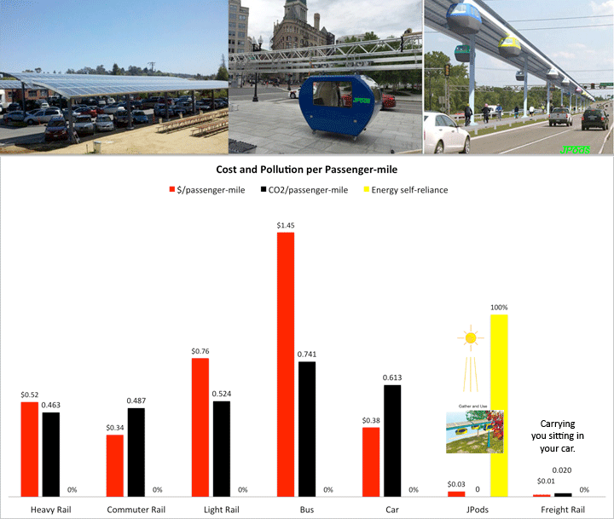

- Maintenance Costs
Maintenance increases as a 4th power of axle weight. Using lighter vehicles, such as JPods, can greatly decrease the cost associated with maintaining our transportation infrastructure.
- Rescue-Rail networks
Solution: Deploy temporary Jpods networks to provide cleanup. Disaster relief. Food. water and medical support
Rescue-Rail: JPODS networks tailored to be deployed over broken heavy infrastructure and to mitigate congestion and energy use in times of emergency
Uses of Rescue-Rail: Pre-position Rescue-Rail to deploy while infrastructure is unavailable and/or being repaired.
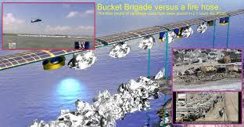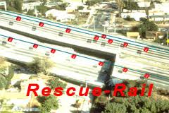

- The uniqueness of the JPODS-ACTIS PERSONAL RAPID TRANSIT SYSTEM:
- Exceed 120 passenger-miles per gallon (51 km/liter).
- Pay 5% of gross revenues to the aggregate rights of way holders (ROW holders are mostly city and other governments).
- Exceed the safety of existing modes operating in the ROW.
- Comply with ASTM International F24 Technical Committee Theme parks safety standards: This standard has a track record about 80,000 times better than DOTs and a well-established insurance and inspection industry to enforce compliance.
- Built under solar-powered mobility with people and cargo.
- Build with private capital.
- No emission and no accidents, solving major traffic problems.
- Anti-vandalism on a 24/7 transport system.
- Women/children safety with round-the-clock video monitoring.
- Cheap mode of transportation requiring less construction cost compared to metro and monorail and with an average speed that is 50 to 70km/hr and can be increased to 100km/hr.
- Less space needed for construction, which will take approximately 6-8 months.

- Deep Understanding of What is Required to Drive a Paradigm Shift

The book Outliers provides many case examples of how 10-years of determined effort (the “10,000 hour rule”) is required for humans to master a skill. The JPods team members have spent more than 10,000 hours in the effort for developing solar-powered mobility networks.
- Liberty is an essential requirement for human societies. JPods mission is to provide the on-demand mobility of people and cargo that is the physical manifestation of Liberty. The Solar Mobility Act standard using the ASTM F24 standards is a result of JPods teams understand. Liberty is the source of the “general welfare.”

- Underst the need. Congestion, pollution, Climate Change, rising gasoline prices, road deaths, and so on underscore that transportation needs are not being met.


Actis/JPods team created the key technology metrics and regulatory framework for driving the shift to sustainable infrastructure:
- Performance Standards Law- establishes Rights of Way access based on exceeding the safety, efficiency, and environmental standards of highways and paying 5% of gross revenues. Attached as filed in the Massachusetts Legislature and as noted in the ASTM F24 requirements of this EOI.
Metrics are required to measure progress to sustainable infrastructure:
- Parasitic Energy Ratio – Measuring the relative energy waste of transportation modes based on the number of power applications and the mass of the vehicle relative to the mass of the payload. Link to explanation.
- Economic Work – Measuring economic value per unit of energy consumed. Link to explanation.
- Disposable Energy – Metric of how much energy people can afford with their Disposable Income, or how much energy people can afford to power their pursuit of happiness. Link to explanation.
- Understanding the unfolding crisis in oil costs. Link to explanation.
- Understanding the need to shift energy systems from “Just-in-Time” to “Just-in-Case.”

- Capacity
The reason Just-in-Time/Six Sigma manufacturing replaced mass production is because the larger the batch, the harder it is to maintain quality.
Tailoring the trip to the traveler (cargo) people and goods move on-demand. By automating the vehicles with robotics, vehicles can move, communicate, and adapt to optimize spreading the load across all possible routes. Automate sensors and motor controls allow vehicles to travel in close proximity. The capacity of a rail is 21 times that of a freeway lane at recommended safe following distances.

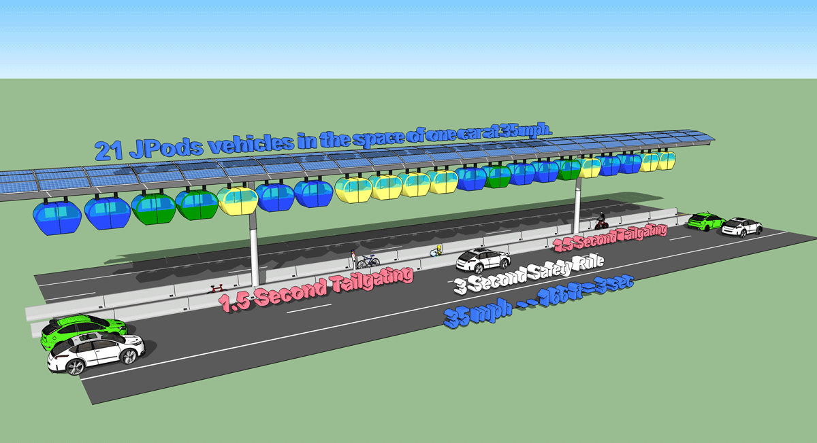

Comparison of seats per hour
 | Seats per Vehicle | Seats per Hour |  | Headway
Bus | 50 | 600 |  | 5 mins
Light Rail | 200 | 1200 |  | 10 mins
JPods, Ultra and other PRT | 4 | 28,800 |  | .5 secs
Automobiles | 4 | 4800 |  | - secs

- QQQ JPods are the Catalyst for Changing Energy Systems. Net Energy to transportation as the catalyst

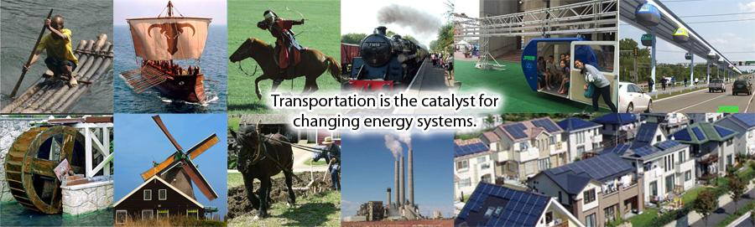

- Durability
Oil and coal have very long and fragile supply chains. JPods has a very simple supply chain. Solar collectors mounted over JPods rails gather 50,000 vehicle-km of power per km per day. Urban mobility can be powered within a solar budget,
Communities adopting JPods become Economic Lifeboats, durable against oil supply shocks.
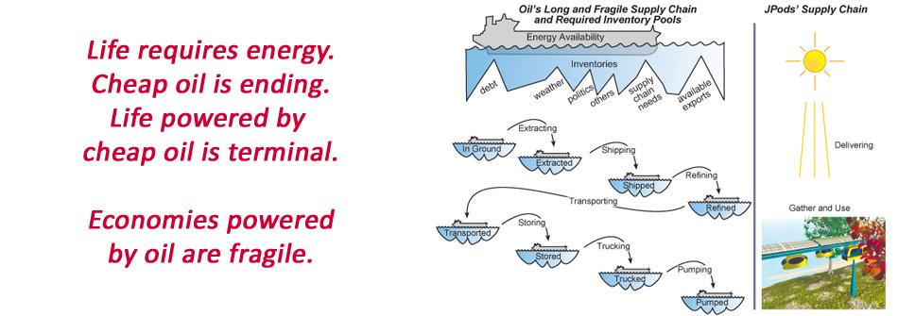
Oil prices ratchet higher. Since US Peak Oil in 1970, on average gasoline prices have increased 7.33% per year, 14.1% per year since China and India began importing substantial oil in 1998. These prices will continue to rise in the future. JPods networks provide an alternative to expensive and high-risk energy.
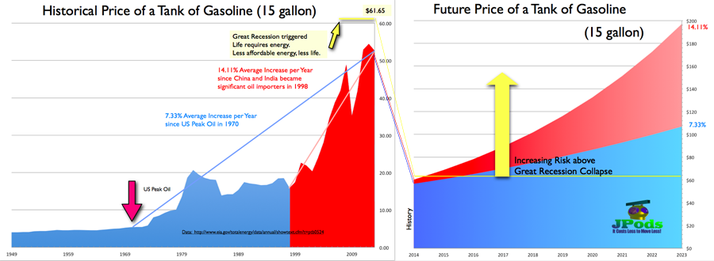
- Intellectual Property. JPods patents and trademarks are for the Physical Internet® and the use of distributed collaborative computer networks to move physical packets. The concept of no single-point-of-failure supports networks scaling in size easily.

4. The experience in INTERNATIONAL PROJECTS –JPODS US LLC

No one has solved traffic congestion in cities. So no one has two years of experience in ending the problems of urban traffic. More of what is failing will fail.
To find solutions requires turning to those who will not repeat the defects which account for the current problems.
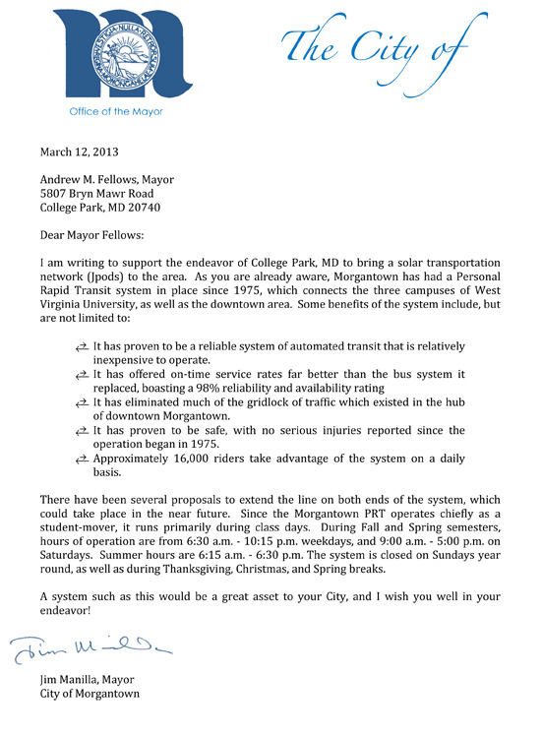
The Actis/JPods team signed a contract in 2012 to change the lifeblood of India from oil to ingenuity. To that end we have defined a solution based on the success of the Morgantown, WV Personal Rapid Transit network. Attached is a 2013 letter from the Mayor of Morgantown on the efficacy of PRT.

JPods modernize and patented improvements to PRT to create the Physical Internet®.

4.1. Software. The Physical Internet® is about applying software and robotics to create a new
mobility network. JPods has delivered large components of the software suite required to build the Physical Internet®:

- CommerceExpert/WebClerk™ software to manage the enterprises, ticketing, contracts, purchasing, inventories, serialization, bills of material, web serving, and other business components. This product was recognized by being invited by Apple Computers to participate in two US national tours.
- RouteTime™ software to tinker and model networks flows. It estimates costs, numbers of vehicles, choke points, and travel times. (video link) See RouteTime maps provided in this proposal.
- JPods3D™ software to visualize networks in Google Earth.

4.2. JPods Demonstrations of PodCars. JPods has created a customer interface and engaged with thousands of people who have take rides in our small mobile units since 2006.

Here is an image in front of Parliament, Ottawa, Canada, City Hall, Oakland, CA, and City Hall, Boston, MA. Adding up the number of times these have been setup, run, and moved, we have already built more than a kilometer.
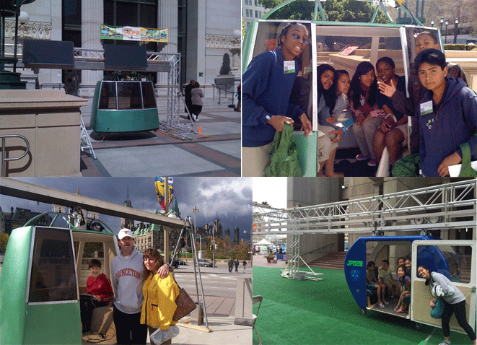

Commercially, JPods teamed up with SkyRide Technology to apply our robotics and computer networks to their human powered systems. We will deploy such a system into Bengaluru very quickly if we have access to Right of Way. It is very important for people to personally experience the energy required to move on rails.
- SkyRide
JPods systems provide SkyRide installations greater throughput. The vehicles can be peddle to sense the energy required. Robotics assure minimum and maximum speed with collision avoidance.

SkyRide's 'elevated mono-rail fitness machines' provide guests the exhilaration of flight through any environment. Innovating thrill with the benefit of exercise. As YOU pedal, YOU become part of the ride. Sit back, cruise, or race on the 2-lane SkyTrack. Crowning the top of the Carnival Vista, the 800 foot SkyTrack allows riders to soar 150 feet above sea level. SkyRide Technology and Carnival Cruise Lines have seamlessly integrated fitness and amusement

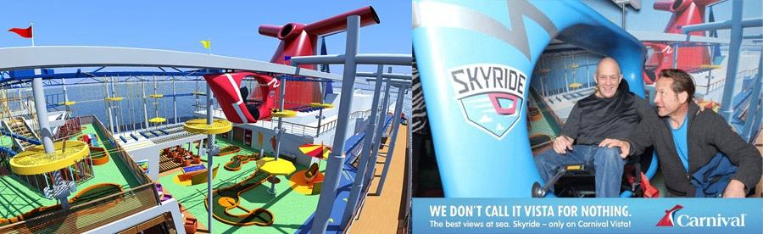

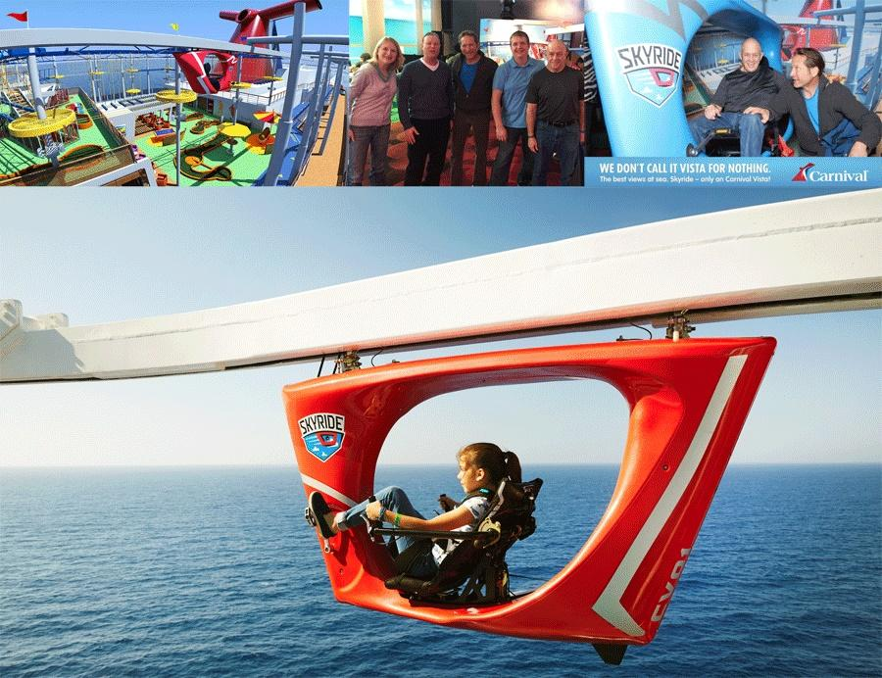

4.4 Within a Solar Budget: Energy Collection

In collaboration with Swenson Solar, collection systems have been designed and deployed for JPods networks for 5 years. Three arrays 80 meters long and 10 meters wide gather the equivalent of 4.1 megawatt-hours per day.

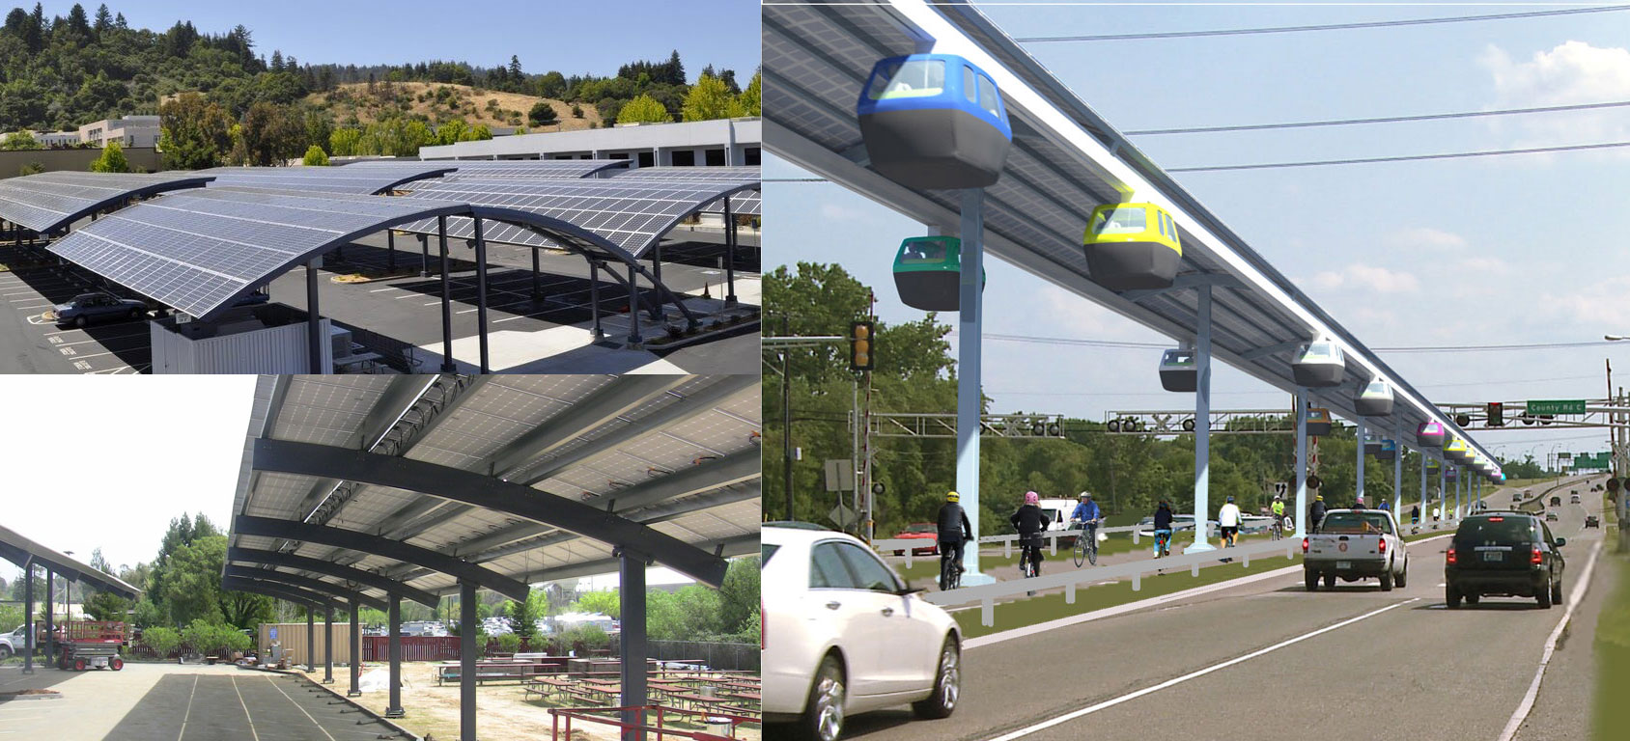

The following links and data update about every 15 minutes based on Plantronics 375 units:
- This is an installation of 3 arrays, 10 meters wide, and 80 meters long. in the field for several years.
  - Link to the summary page
  - Link to yearly output
  - Link to the monthly output
  - Link to the daily output for the last 30 days
JPods have been designed and tailored to power urban community within a solar budget.

- Proposed Initial Plan and Schedule
Until the projects are defined and the regulatory environment is fixed, capital will not invest and traffic congestion and other defects will remain unaddressed. More of what is failing will likely continue to fail. Without leadership from the government to define specific projects, with specific legal access to Rights of Way, nothing will happen.

Once the Rule of Law is defined, within two months the initial SkyRide and example of solar collection can be installed. Demo units, such as those displayed in Boston, can be available in about 2 months. It will take time to build the tooling for localization of manufacturing.

Depending on the availability of truss manufacturing, geotech efforts, utility shifting, ROW for stations, yards and pillars, and compliance issues, the first commercial networks could become operational within 8–12 months from the date of receipt of all statutory approvals. Deployment will speed up as the manufacturing base expands and crew skills increase.

- Capital Plan and Annual Turnover

Cost are fairly well known (see Paragraph 7) but the capital plan and commitments require the Rule of Law.

Capital will not invest without the Rule of Law. There was nearly a century of rotary telephones under the unconstitutional Federal communications monopoly; and the world followed America’s infrastructure lead. After that monopoly was declared unconstitutional in 1982, millions of jobs were created delivering better services at lower costs.

India’s economy leap-frogged ahead after becoming a center for software development in the late 1990s.
India’s economy may again leap-frog the oil-powered economy by creating a Rule of Law that supports deploying the Physical Internet®. Granting Rights of Way based on ASTM F24 is essential.

Federalist #62, Madison
"What prudent merchant will hazard his fortunes in any new branch of commerce when he knows not but that his plans may be rendered unlawful before they can be executed? What farmer or manufacturer will lay himself out for the encouragement given to any particular cultivation or establishment, when he can have no assurance that his preparatory labors and advances will not render him a victim to an inconstant government? In a word, no great improvement or laudable enterprise can go forward which requires the auspices of a steady system of national policy."
Capital will not invest without known routes being issued Rights of Way. The Solar Mobility Act (as adopted by this EOI) defines the Rule of Law that will allow private capital to invest. To provide a specific capital plan requires:
- Specific routes.
- Specific locations of stations
Until the regulatory framework is established, capital plans cannot be defined nor congestion solved. Recommend reading the books:
- Nothing Like It in the World for how the Transcontinental Railroads were capitalized and built in the US in the 1860s.
  - Railroad Act of 1862, was required to start capitalization.
  - Railroad Act of 1864, was required to actually attract capital to build.
- Why Nations Fail, the Origins of Power, Prosperity, and Poverty. This book highlights the barriers governments employ to keep their people poor by stifling innovation and how inclusive institutions unleash the capacity to create wealth.
- Review the history of the Internet’s deployment. Capital will not invest without the Rule of Law respecting the rights to innovate.
Once specific Rights of Way have been granted, capital and balance sheets will be provided each project.
- Estimated Cost Towards Capital Expenditure and Maintenance

7.1. Capital Costs

- Capital costs are about 46.9 crore per km ($7 million US).
- A preliminary analysis the project is self-sustainable and may provide a return of 18 %. BBMP SPV will raise the required finance and carry out the project on its own without any financial burden on the Government
- According to the 2010 Independent Audit of the Morgantown Personal Rapid Transit network, the network pays for itself about every 5 years compared with buses (link to audit document).

- Estimated Costs, Maintenance & Operation

Until specific routes and configuration of those routes are agreed to, only general costs can be estimated:
- Transport energy is about 79 watt-hours per vehicle-km (link, 7.5 mile trip)
- Electrical collection is about 4.1 megawatt-hours per km per day (link).
- As trips are converted to JPods networks current costs for:
  - Pollution decrease more than 90%.
  - Accident decrease more than 90%.

- Request to Government/BBMP

This proposal may be considered favorably by the government as it shall help to ease out the traffic congestion along the route without any financial commitment or burden from the part of the government, and the same can be replicated in other parts of the city as well as the state successfully.

- Additional information
The Actis Infrastructure Private Limited representing on behalf of JPODS US LLC. ACTIS, JPODS, financial partners, and industrial allies will collaborate on a project by project basis, first come, first served, to build solar-powered mobility networks in India. These entities will found the Bengaluru Mobility Company to implement this scope of work. As experience and needs evolve, these partners will create the India Master Mobility Company to fund and coordinate projects across India.

Actius is representing this consortium in providing this proposal.
- Declaration
Herewith we confirm that we are interested in competing for this Personal Rapid Transit project and all the information provided herewith is genuine and accurate.

Date of Signature: 22nd May 2017
For Actis Infrastructure Pvt Ltd
Authorized Person signature:

Name and Position: Mr Rajashekar B N .Chief Executive Officer

