PROPOSAL REQUESTS
Create a regulatory framework for deploying solar-powered and sustainable transportation infrastructure that exceeds 120 passenger-miles per gallon:
- Lead in passing the Performance Standards Law in New York:
  - Link to Secaucus Ordinance 2014-23.
  - Link to Massachusetts Senate Bill #1837.
- Grant Rights of Way access to privately fund the constution of JPods solar-powered mobility networks in a document similar to the Franchase Law.

JPods will pay the $60 million to build from LaGuardia to the train stations:
- 90 second summary of JPods solar-powered mobility networks.
- 15 minute summary of the business case using New Jersey as an example.

As with the near century of rotary telephones under Federal monopoly, the barrier to transportation innovation, to building the Physical Internet® is regulatory. If NYSERDA helps the Governing remove the regulatory barriers, private capital will build the networks based on converting current costs into value.

OPPORTUNITY

To develop personal rapid transit (PRT) systems within in New York City and New York State to demonstrate and prove the ability to cost effectively and efficiently move people, cargo, and waste by utilizing a low carbon footprint and creating green and sustainable jobs.

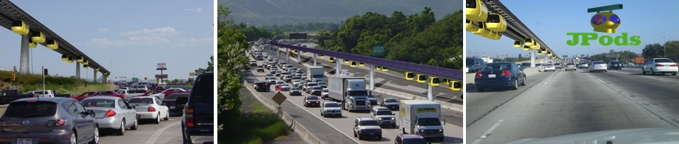

PRT DEFINITION

PRT provides transportation services that are on-demand, customized and automated that use about 90% less energy than other forms of current transportation and can be solar powered.

The Advanced Transit Association (ATRA) definition of PRT is:
- Direct origin-to-destination service with no need to transfer or stop at intermediate stations.
- Small vehicles available for the exclusive use of an individual or small group traveling together by choice.
- Service available on demand by the user rather than on fixed schedules.
- Fully automated vehicles (no human drivers) which can be available for use 24 hours a day, 7 days a week.
- Vehicles captive to a guideway that is reserved for their exclusive use.
- Small (narrow and light) guideways are usually elevated but also can be at or near ground level or underground.
- Vehicles able to use all guideways and stations on a fully connected PRT network.

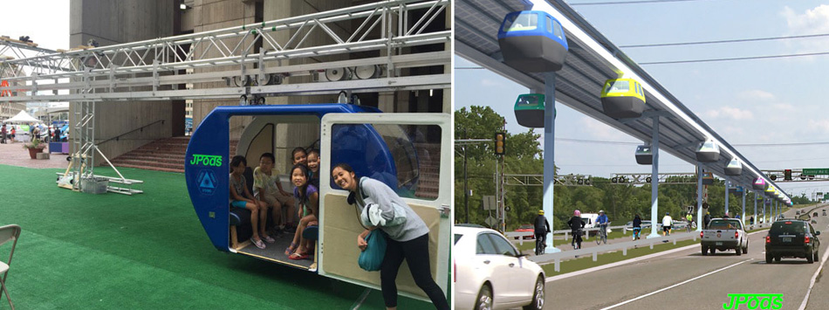

PRT BACKGROUND & COSTS

In response to the 1973 Oil Embargo, the Congressional Office of Technology Assessment study PB-244854 identified Personal Rapid Transit as the solution to make US cities independent of oil. The study specifically identified "institutional barriers" that "neglected near-term ... simpler approaches to correct transit problems." Regulatory barriers have continued to persist even though eight successive US Presidents have declared dependence on imported oil a threat to national security, the volume of oil imported increased from 20% in 1973 to 65% today of total oil consumption .

After the 1973 Oil Embargo, a PRT system was built by Boeing and the Federal Government in Morgantown, WV. The system currently is operated by West Virginia University. Operating costs for this system are higher than current systems due to oversized vehicles/pods (8-18 people), archaic computer and networking technologies, nonexistent robotics, and heavy system materials.

With the current oil concerns, PRT has become popular once again over the past few years. Heathrow Airport in London is in the process of opening a PRT system that was built by Advanced Transport Systems, Ltd (ATS), which is partially owned by British Airways. There are about ten companies active in the PRT sector and most are outside of the US in such countries as the UK, Germany, Japan, Korea, Netherlands, Russia, and Poland. The US active companies are JPods (Las Vegas, NV), SkyTran (Los Angeles, CA), Skyweb Express (Minneapolis, MN), and CyberTran International (Oakland, CA).
PRT Costs:
- Construction costs for JPods PRT networks are estimated to be $5-12 million per mile for network costs depending on the number of vehicles and stations. Right of Way (ROW) costs are estimated on a project by project basis.
- Operating costs (power and operation) are estimated to be $0.04 per vehicle mile versus $0.56 per vehicle mile for cars.

MAJOR BENEFITS OF PRT

- Provides a Renewable Energy Transportation System & Reduces Oil Dependency: JPods can be a solar-powered PRT. Solar panels on the top of the overhead track provide electricity to the rail and backup battery in the pods. JPods estimates that solar collectors four meters wide will gather 5,000-20,000 vehicle-miles of power per mile per day in most areas.

- Increases Energy Efficiency: PRT networks use about 85% less energy than vehicles using fossil fuels because: 1) ultra-light and ergonomically designed vehicles need less energy to move, 2) it is non-stop and eliminates repetitive applications of power in start-stop traffic, and 3) with non-stop travel, average travel speed is higher and peak speeds are lower than other modes of transportation; therefore, less energy is expended combating wind resistance. JPods PRT design is estimated to utilize about 127 watt-hours per passenger mile versus 900Wh for trains, 1,033Wh for cars, and 1,246Wh for buses.

- Creates Green Jobs: Engineers, designers, manufacturers and contractors will be needed to deploy the JPods networks.

- Low Cost: JPods PRT networks are expected to cost on average $10M per mile to build for the network costs. The low vehicle weight radically cuts operating and maintenance costs ($0.04 per mile vs. $0.56 per mile costs for cars). Per mile cost to build light rail are typically in excess of $40M.

- Provides Economic Benefits: Increases disposable income by decreasing transportation costs for the general public, reduces government subsidies via financially self sustaining networks, and increases system revenues by potentially moving freight and waste as well as people.

- Better Performance: Without repetitive start-stops, PRT provides a faster and more efficient transportation system with average speeds of 30 mph for JPods, as compared to 24mph for cars, 18mph for trains, and 8-12mph for buses for similar service requirements.

- Reduces Congestion: The small real estate footprint, grade separation, rail stacking, separate and additional networks to existing infrastructure, and computerized route optimization minimize ground congestion issues.

- Reduces Pollution: JPods PRT utilizes a solar renewable energy system that eliminates harmful CO₂ emissions. Rubber tires on concrete or steel rails, as well as low weight and speed produce less noise and vibration.

- Increases Safety & Time Savings: Existing networks have low injury rates primarily due to slower maximum speeds as well as one directional movement and limited opportunity for collisions. Morgantown PRT has delivered 110 million injury-free and onsite emissions-free passenger miles.

- Provides Flexible Transportation: PRT guideways can be laid out in a network or grid (as well as point to point), and there is more than one route connecting an origin and destination. Therefore, service can be maintained when a single guideway is out of service. Stations and guideways can be above ground and mitigate ground transportation issues.

- Provides High Quality Service: Provides high quality on-demand, customized service comparable to chauffeured cars (at a fraction of the cost). A high level/frequency of service addresses variable and distributed demands with vehicle utilization tailored to real time demand. The system delivers service as-needed while maintaining service quality at reduced overall cost.

- Increases the Value of Existing Transit Networks: PRT inexpensively connects the short gaps between existing transit infrastructure; connecting airports to trains, trains to buses, and many people to their ultimate destination. The Prime Law of Networks is that the value of the network increases exponentially based on the number of interconnected nodes.

SAMPLE PROEJCT: LA GUARDIA AIRPORT - SHEA STADIUM SUBWAY/TRAIN CONNECTION

A particularly appealing first project is about a 2.3 mile connection between LaGuardia Airport and the NYCTA Subway / Long Island Railroad at Shea Stadium since the route simplifies right of way or complex constituency issues by going over airport parking lots as well as following alongside a freeway and Long Island Sound. Additionally, it is a high volume route and connection that would be in high demand.

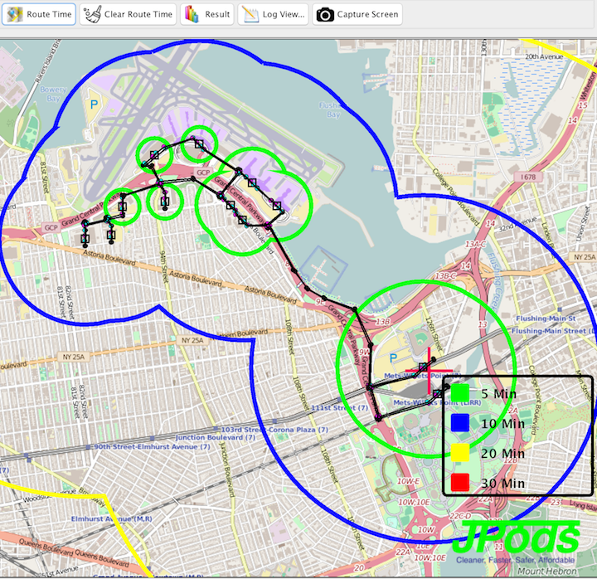
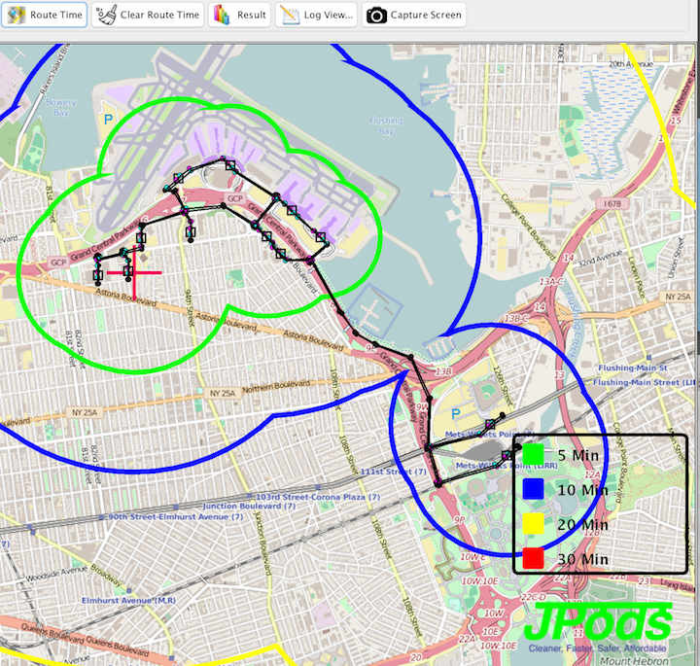
After the airport, hotels, parking, and car rental are attached to LaGuardia terminals, the network can be extended to Jamica Station.

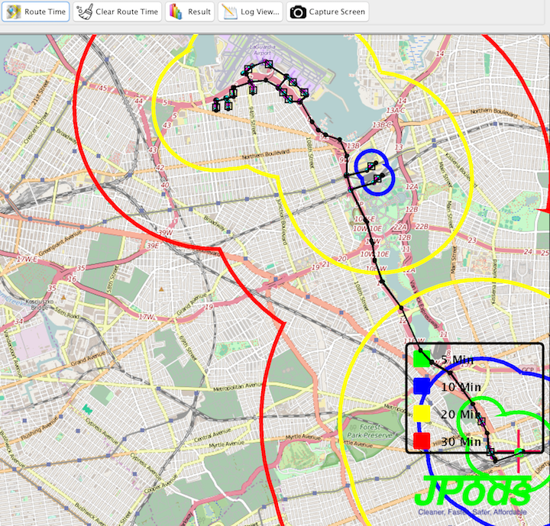
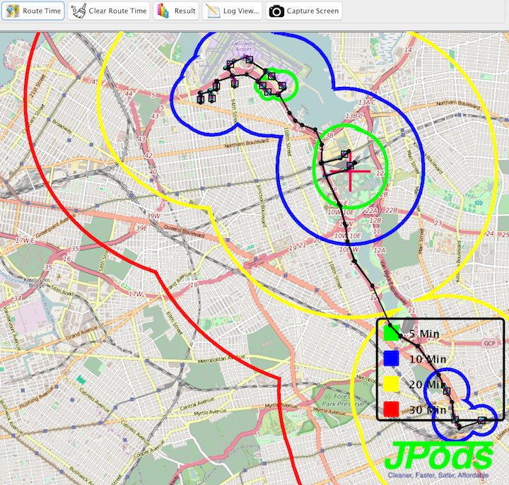

TECHNOLOGY, BUILDERS & OPERATORS

JPods, Inc. (“JPods”) supplies the technology and operating concept for PRT networks. JPods supplies the mechanical/electrical, manufacturing, and software expertise.

About JPods, Inc. (www.jpods.com)

JPod’s concept is to design, build and operate on-demand and computerized PRT networks that can be solar-powered. The company plans to deploy networks of Horizontal-ElevatorsTM that provide short to medium range travel using ultra-light, computer controlled vehicles that are suspended from rail mounted on elevated structures. The system is electrically powered. Solar collectors mounted on the overhead rails and positioned to absorb maximum sunlight make the networks durable against power outages and emit no CO₂ gases. The JPod vehicle (PodCar) has the capacity to hold about 4-6 people or a cargo pallet, yet uses about 12% of the energy per passenger mile that is required by current modes of urban transport such as light or heavy rail, buses, and cars.

The company was started in 1999, and currently has 12 active employees (2 full-time and 10 part-time). Current ownership is private. The development of JPod’s baseline technology was completed in 1999 and patent #6,810,817 was issued in 2004 for the use of distributed, collaborative computer networks that move physical packets. In 2006, a 20 foot operational demonstration was deployed in San Jose, CA. JPods is looking to build its first commercial and permitted PRT network, and has many existing Letters of Interest for potential PRT networks. To build such networks governments must pass the Performance Standard Law that establishes the ASTM Theme Park standards. Theme parks are communities designed specifically to cater to pedestrians of all age and commerce. The existing ASTM standards have and existing insurance industry, enforcement industry, and safety record thousands of times better than Departments of Transportations. The Town of Secaucus, NJ Ordinance 2014-23 and Massachusetts Senate Bill #1837 are this law.

JPODS VALUE PROPOSITION / COMPETITIVE ADVANTAGES

- Product Design: Vehicles hanging from overhead rails (wheels-up vs. wheels-down) employs superior physics to reduce pod weight and energy consumption, increase ride stability and safety, and solve congestion issues in cities.
- System Patent: Patent #6,810,817 was issued in 2004 for the use of distributed, collaborative computer networks that move physical packets. Currently, about 50 additional patents have been researched and identified by JPods.
- Management Track Record: A strong team leads the company with an outstanding track record in leading manufacturing, logistics, process controls, power generation and high tech companies.
- Scalability: Rapid deployment of the PRT networks would be achieved by a combination of the leadership, management expertise and networks of JPods and our allies. In particular, JPods holds the patent/technology and manufacturing knowledge/experience.

PRT ENERGY STATISTICS

PRT Energy Conservation / Savings
Reduce energy by 85% per passenger mile from existing forms of transportation.that use fossil fuels. JPods PRT is estimated to consume 127Wh per passenger mile versus 1,246Wh for buses, 1,033Wh for cars, and 900Wh for trains.

PRT Energy Collection
Use the distributed nature of the JPods transportation infrastructure to mount 1MW of solar collectors per mile of rail. The 2.3 mile solar network is expected to produce a 2MW facility capable of powering 50,000 vehicle-miles of transportation per day.

PRT Energy Storage (currently being developed as a concept and can be offered as an option to the PRT system)
Store excess electricity in a natural gas “battery” in the PRT infrastructure via a chemical process involving electrolyzed water and carbon dioxide (patent pending) that is driven by spare system electricity.

PRT Energy Distribution (currently being developed as a concept and can be offered as an option to the PRT system)
Deploy natural gas, oxygen, and carbon dioxide pipelines in rail superstructure to distribute stored energy to points of need.

PRT MANUFACTURING

System Components to be Made

Civil Engineering Components:
- trusses & rail
- footings
- survey
- interface to existing civil structures
.
Vehicle/Pod Components:
- frame
- doors
- windows
- seats
- ceilings
- air control
- safety equipment
- bogeys
- electric motors
- mechanical lifts, stations

Intelligence Components:
- computer networks
- computers
- robotics
- sensors
- communications (wireless & wired)
- software

Power System Components:
- mechanical leaves
- pipelines
- wiring
- lighting
- vehicle power pickups
- batteries and ultra capacitors
- chemical processing plants

Manufacturing Functions / Skills

- machining & casting
- sheet metal fabrication
- electric motor design and fabrication
- electro-mechanical switching, locks and controls
- sensor and switches
- welding
- composite design and fabrication
- buckyballs industrialization
- welding
- plastic molding and other fabrications
- statistical process controls and preemptive maintenance practices to achieve zero in-service failures
- truss fabrication
- footings design and fabrication
- integration with existing infrastructure
- survey and route design
- painting
- fiber glassing
- glasswork
- purchasing/component sourcing
- upholstery
- safety equipment
- inspectors & testers
- documentation
- engineering: civil, mechanical, electrical, chemical, and software
- energy storage and distribution (optional)

ESTIMATED JOBS FROM LA GUARDIA / SHEA STADIUM 2.3 MILE PRT PROJECT

For the first PRT projects, many of the components will have to be initially purchased because the skills and facilities for producing small quantities have atrophied in the US. As the PRT systems grow, manufacturing jobs will incrementally increase.

On the LaGuardia/Shea Stadium project, it is estimated that small assembly and testing facilities will create about 20 local jobs as Just-In-Time manufacturing concepts develop. As experience develops and projects expand the assembly/testing facilities will grow to micro-manufacturing facilities. The intent is to develop micro-manufacturing facilities in urban environments that develop and hold the manufacturing “intelligence” locally. Some of the manufacturing talent should be able to be borrowed from existing manufacturing companies in the New York Metropolitan area. The micro-manufacturing facilities will scale as demand expands either within the cities where talent and resources reside or outside the cities where costs are lower. If PRT re-tools the transportation and power infrastructure, the job growth would be exponential and similar to the growth of the re-tooling of the communications infrastructure after 1984.

Employment During Construction
Estimate 50-60 manufacturing, engineering (design, planning & project management), and construction jobs for 4 months to build the 2.3 mile system with 6 stations based upon production of 20 foot prototype. Assuming 4 stations at LaGuardia Airport, 1 station at Shea Stadium subway station, and 1 station at Long Island Railroad station.

Employment After Operations
Estimate 37 full-time employment positions to operate a 2.3 mile PRT system with 6 stations
- 2 management positions
- 2 administrative positions
- 1 financial position
- 10 diagnostic/maintenance positions
- 20 station operators
- 2 general support positions

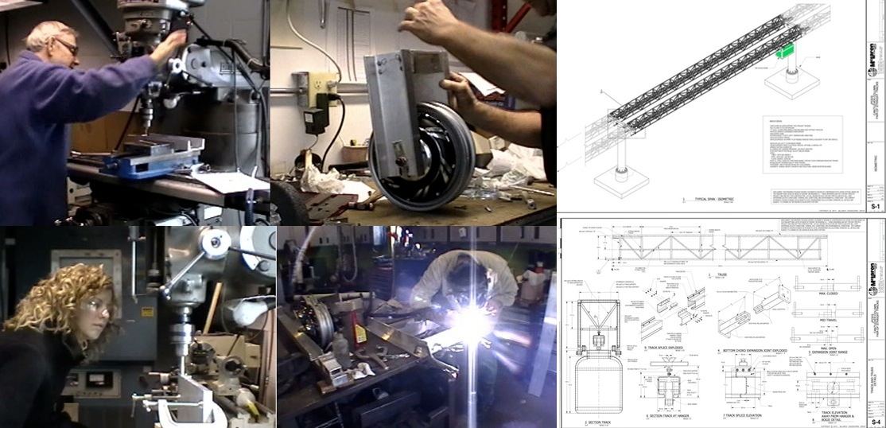
People building the JPods demonstration units and creating the civil engineering documents to deploy the PRT networks.

ESTIMATED PAYBACK FROM LA GUARDIA / SHEA STADIUM 2.3 MILE PRT PROJECT

Due to the small and ultra light vehicles used in PRT, the cost structure to build and operate these networks is much lower than current forms of transportation. Because this is the first network to be constructed, expenses are assumed to be higher than the estimated average system expense of about $10 million per mile for the network and exclusive of ROW costs. Additional allowance is needed for the first project to cover first time planning and implementation costs. Therefore for initial thoughts on costs, this network is estimated to cost about $41 million to build the 2.3 mile network and $5 million per year to operate including labor and O&M expenses.

Estimated Payback Calculation
Revenue
$5 per ride (same as cost for AirTrain to JFK airport excluding $2.25 additional fee for subway)
23.6M travelers per year at LaGuardia
Airport travelers (20% of LaGuardia travelers) = 4.6M per year
Novelty riders (10% of Airport travelers) = 460K per year
About 5M PRT travelers per year
- $25M revenue per year

Operational Expenses
- $5M for labor and O&M costs per year
Construction Expenses
- $41M

Payback
- within 2 years

