Implementing the JPOD at the United States Military Academy at West Point

By

CDT PATRICK HASTINGS
CDT PATRICK ROBERTS
CDT JONATHAN TRACZYK
CDT TANNER VAN ESSEN

Table of Contents
Executive Summary 3
Introduction 4
Background 4
Situation 4
Stakeholders 5
The System 5
Desired Outputs 6
Scope and Bounds 6
Underlying Need 7
Recommendation 7
Method/Technical Approach 7
System Goals 7
System Criteria 8
System Assumptions 8
System Alternatives 8
Analysis 9
Alternatives Performance 9
Summary Results 10
Sensitivity Analysis 11
Implementation 11
Future Work 11
Implementation Plan 12
Conclusion 12
Findings 13
Further analysis 13
Bibliography 14
Appendix A 15
Appendix B 16
Appendix C 17
Appendix D 18
Appendix E 19
Appendix F 20
Appendix G 21
Appendix H 23
Appendix I 26
Appendix J 27
Appendix K 29
Appendix L 30
Appendix M 31
Appendix N 33

Executive Summary
The task for this report is to explain how our team recommended the best way to implement the JPOD system at West Point. The team used the systems decision process to accomplish this task, starting with stakeholder analysis. The main stakeholders, COL LaChance gave us criteria he wanted to see as they system operated at West Point. The team also looked at the Military Police and what they would like to see out of the JPOD system. The team then compiled the information the information to be used to make functions for the implementation of the JPOD system that would please the stakeholders, this information was then used to make the following re-defined problem statement: “what is the best way to implement the JPOD system at West Point that is aesthetically pleasing and supports the West Point net zero Initiative while minimizing wait time and maximizing quality stops and transport capacity.” The team will now continue this forward and create candidate solutions to find the best way to implement the JPOD system at West Point that will accomplish this NetZero goal.
After conducting our research and modeling we determined that the best route that meets the Academy’s needs is route Spartans. Route Spartans has a total value of 78 and will cost approximately $425,371,872 throughout a lifespan of twenty years. Route Spartans has the highest total value of our other routes that we created which includes Route Hoosiers (45 value), Route Wolverines (45 value) and Route Cornhuskers (49 value). Route Spartans has five residential stops, a maximum wait time of two minutes, four historical stops, stops n the cadet area, and stops at Michie Stadium thus meeting and maximizing nearly all of the requirements given by our key stakeholder, COL LaChance.
The Big Ten conducted stakeholder analysis, data analysis, Qualitative Value Modeling which includes value functions and a Swing Weight Matrix), Solution Design (including Feasibility Screening Matrix , and a Life Cycle Costing Model), and Decision Making which includes Solution Scoring , Sensitivity Analysis, Improvements and Tradeoff Analysis. After all of this research the Big Ten suggests that the United States Military Academy implement Route Spartans. Finally the Big Ten looked into how to implement the JPOD system and specifically Route Spartans as well where future analysis will be needed in determining how to use Route Spartans and the JPOD system in the future.

1.0 Introduction
The purpose of this report is to explain the reasoning behind the Big Ten’s objectives for the remaining portions of the project. The report consists of the heading stated in the table of contents.
The background will describe the JPOD implementation situation in its entirety. The Big Ten will describe the problem and identify the stakeholders and their wants from the JPOD system implementation. The Big Ten will then describe the JPOD system in terms of component, function, hierarchy, and state. We will also describe the desired outputs of the system as well as the scope and bounds of the system as well as the underlying need of the system in the background.

2.0 Background
The background consists of the situation, stakeholders, the system itself, desired outcomes, scope and bounds, and the underlying need.
2.1 Situation
The United States Military Academy at West Point decided to implement the JPODs system to aid the academy’s and the Army’s Net Zero initiative. The army intends to be “net zero” energy consumption by 2030. (Lopez, 2010) Net Zero is “a holistic approach addressing energy, water, and waste. The Net Zero approach consists of five interrelated steps: reduction, re-purpose, recycling and composting, energy recovery and disposal. Katherine Hammoack, the Assistant Secretary of the Army for Installation Energy and Environment states that “The goal is net zero: net zero energy, net zero water and net zero waste, all striving towards sustainable installations” (Asmccall, 2011). In April 2011, five instillations, including West Point, will begin the net zero campaign with the goal of being self-sufficient by 2020. The JPOD system is a personal rapid transport (PRT), powered by a battery, and eventually by solar panels. The JPOD system offers the same privacy that cars provide. The JPOD System is a public transportation system that is faster than commuting by car. A computer directs the JPOD system. Therefore, a traffic jam is theoretically unlikely (personalrapidtransit.com). This would save the commuter hours of time throughout the year. The JPOD and other PRT systems alike have two times the passenger capacity of freeway lanes, and four times the capacity of a street lane with traffic lights. These systems will also help us towards our goal of having a net zero mode of transportation. The JPOD is a solar powered transportation system that uses no fuel, thus lowering pollution and energy consumption that people face today. However, much of the information found on the JPOD and PRT are theories, as they are not widely used in major cities throughout the world at this time.
Many complications go along with the JPOD system. For example, there are few forms of public transportation that will get a directly to where that person needs to go. A person will either have to transfer from one train to another multiple times, or spend a lot of time walking. A recent increase in the distance that people have to commute causes this complication. People walk further because they chose to live further from the city. A JPOD system would negate this issue. The JPOD is capable to go just about anywhere that the supporting track is set up and has more flexibility than a train. A JPOD runs by a computer, easily operated by a child and will find the quickest route to the desired destination, offering the convenience of a car, and the speed that no other form of public transportation provides.
The JPOD system offers a cleaner solution to the current West Point transportation situation and will help satisfy West Point’s initiative of becoming completely self sufficient by 2020. The Big Ten, tasked with finding the best way to implement the JPOD system at West Point, and more specifically, the best way to implement the JPOD system at West Point.

2.2 Stakeholders
The stakeholders for this project are, COL LaChance, Mr. Bill James, the Military Police (MP’s), the Corps of Cadets, and the staff and faculty of West Point. Each stakeholder brings different needs to the project, which we then used as our value measures based on stakeholder input. COL LaChance’s main concern is the route that the system will take and the number of stops and location along with the cost benefit of installing in the system at West Point. The Corps of Cadets, staff, and faculty are concerned with locations of the routes and stops that will be most beneficial (football stadium, parking lots, residential areas, etc.). The MP’s concerns deal with the security issues that come along with the installing of the JPOD system at West Point. A matrix of stakeholder analysis can be found in Appendix E . The survey questions were created based on the various interviews that the team conducted with COL LaChance. COL LaChance expressed his criteria for the JPOD system, which the team then took and got the opinions of the Corps of Cadets in order to better serve the stakeholders wants and needs. Based on the results from the surveys the team formed routes and along with the input from COL Lachance found the best possible route to use at West Point.

2.3 The System
The JPODs system is a physical, non living, manmade system. The system is one that you can touch and physically use. The visibility of the system is a grey box. If implemented, people will know how to use the JPODs, and generally how the JPOD system works (type in your destination and you travel to said destination), but most people probably will not know anything beyond that, such as the average person will probably not know how the destination that is typed into the JPOD system is processed and the calculations taken to travel to their desired destination.
The functions of the JPODs system at West Point are to transport goods, utilize self productive energy, and to plan the transportation route. The Meta System that the implementation of the JPODs fits into is the Army NetZero Initiative. The JPODs is a clean energy, self sufficient system that will cut down on fuel costs and help to reach the goal of West Point becoming a NetZero post.
To make a functional hierarchy for this system the team set up a functional flow diagram listed in Appendix A. Once we had an understanding of what functions the system would need we were able to transform this into a functional hierarchy listed in Appendix F.
2.4 Desired Outputs
The desired output for implementing the JPOD system is a fuel efficient, safe, and convenient rapid transport system that will take users where they will want to go in a relatively short time. The system will cut down on West Point’s fuel consumption to help the establishment meet its net zero requirement. The system will also help cadets and faculty get from place to place fast and cut down on congestion from vehicles entering West Point. The system will also transport waste efficiently from West Point to help save on fuel from garbage trucks.

2.6 Scope and Bounds
The scope and bound of the system is shown in Figure 1 below.

Figure 1: Scope and Bounds of the System
The scope of this problem is very complex, the system needed to be aesthetically pleasing, but still accomplish the deed to get people from place to place and help West Point accomplish its net zero goals. To do this, Big Ten formed figure 1 to help define the system boundary. Defining the system boundary helps us scope the problem. The creation of the boundary diagram helped us understand the components and feedback of the system. The internal feedback we needed to look at was the maintenance and the scheduling of the JPODs and how the team will create the effective alternatives to accomplish the stakeholder goals. The team also looked at the external feedback consisting of the amount of vehicles in the cadet area and feedback from the military personnel and the civilians that will use the system. The inputs, outputs, components and feedback of the JPOD system establishes the scope at an effective system will rapidly transport people and cut down on West Point’s energy usage. Another effective method of modeling this problem was using IDEF0, level 0 and level 1 diagrams to get a good grasp on the inputs and outputs of the system. These figures are listed in Appendix C and Appendix D respectively.

2.7 Underlying Need
The true underlying need of the JPOD system is several-fold. The JPOD system will greatly improve West Point’s chances of reaching its goal of being a fully self sufficient post by 2020. The elimination of cars from the cadet area will also open up the Academy for more space to build new buildings to aid the Corps of Cadets and staff and faculty alike. Finally, the JPOD system will be more convenient for the Corps and staff. After conducting stakeholder analysis, the Big Ten developed a re-defined problem statement. We determined that we will implement a JPOD system at West Point that is aesthetically pleasing and supports the West Point net zero initiative while minimizing wait time at maximizing quality stops and increasing transport capacity.

3.0 Recommendation
The Big Ten recommends that the United States Military Academy implement Route Spartans for the JPOD System. Route Spartans has a total value of 78 and will cost approximately $425,371,872 throughout a lifespan of twenty years. Route Spartans has the highest total value of our other routes that we created which includes Route Hoosiers (45 value), Route Wolverines (45 value) and Route Cornhuskers (49 value). Route Spartans has five residential stops, a maximum wait time of two minutes, four historical stops, stops n the cadet area, and stops at Michie Stadium thus meeting and maxing nearly all of the requirements given by our key stakeholder, COL LaChance.

4.0 Method/Technical Approach
The methods and technical approach consists of the system goals, system criteria, system assumptions, and system alternatives.
4.1 System Goals
The goals for the implementation of the JPod system are derived from why the JPod system would be emplaced. In order to meet the goals of the Net Zero Initiative set forth by the Department of Defense, as well as the stakeholder’s needs on the West Point installation, the JPOD system will need to meet certain criteria. This criterion was modeled in the qualitative value model, listed in Appendix B. It must be able to transport goods, provide its own energy source, and have effective transportation stops. Based on stakeholder wants, The JPOD must have to objective functions that minimize waiting time, provide stops near residential neighborhoods, provide stops near historical places around West Point, maximize solar efficiency, transport waste, maximize amount of people on the system at rush hour, and maximize the rate of personal transported. These objective functions were then turned into value measures listed in Figure 3. With the exception of maximize solar power which was cut out of the project due to lack of an effective equation to model this number.
4.2 System Criteria
Specifically, the implementation needed the following screening criteria when implemented: Time waiting at the station must be equal to or below two minutes, there must be three residential stops, there must be two historical stops (i.e. Trophy Point, Cemetery, Cadet Chapel etc.), the route must have a stop in the cadet area, and finally the route must stop at Michie Stadium.

4.3 System Assumptions
The Big Ten made several assumptions during the decision making process. We first assumed that the solar panels used were based off the gen uniform function in Excel. We assumed that we could pick any panel we wanted for the JPOD system. There was no limit to our choices. Mr. Bill James informed us that it will cost $20 million per mile. It will also cost 18 cents per vehicle per mile for maintenance. This maintenance cost also cover special weekends such as football weekends, class weekends, and graduation where we expect more traffic and the possibility of more maintenance issues. We also assumed that each empty car will transport waste from station sites.
4.4 System Alternatives
We developed eight alternative routes for the JPOD implementation. All of the routes are named after teams in the Big Ten Conference. The names of the routes are as follows: Fighting Illini, Hoosiers, Hawkeyes, Wolverines, Spartans, Buckeyes, Cornhuskers and Wildcats. These alternative routes were developed to meet the requirements of our stakeholders and our redefined problem statement. These requirements are as follows and are also shown in the Feasibility Screening Matrix in Figure 2: Time waiting at the station must be equal to or below two minutes, there must be three residential stops, there must be two historical stops (i.e. Trophy Point, Cemetary, Cadet Chapel etc.), the route must have a stop in the cadet area, and finally the route must stop at Michie Stadium. If an alternative route did not meet one of the screening criteria it received an overall NO GO and was eliminated from contention. If a route received all GOs it earned an overall GO. If a route earned an overall GO it was considered a candidate solution and we ran further analysis on these routes which will be explained later in the report. The candidate solutions are as follows: Hoosiers, Wolverines, Spartans and Cornhuskers.

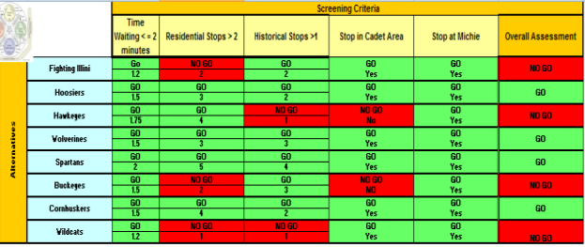
Figure 2: Feasibility Screening Matrix

5.0 Analysis
Eight different possible alternative solutions were devised based off of the system criteria set forth by various stakeholders. These different solutions were then put through a simulation program named Hermes PRT Network Simulator Version 2.63. The Hermes PRT Network Simulator was made in order to model and simulate any proposed JPod systems. In order for each alternative solution to be on an equal level, each alternative solution was run through the simulator for a 2 hour time period. There are several assumptions while using the Hermes PRT Network Simulator. First, in each alternative solution all routes have the same amount of capacitors, which is set at 6. A capacitor is a place where a JPod vehicle could sit and wait while waiting to be called by a rider. This is due to the fact that all alternatives are on an equal playing ground in regards for possible places they could draw a JPod vehicle from. Second, although some alternative solutions may have different amounts of stations, each station has the same amount of demand upon it. Therefore, a possible situation such as a football game or rush hour traffic could not be simulated. At any given period there are empty cars on the network. Through running the simulation, there was an assumption made that each empty car could be better utilized by using them as waste transporters. During each alternative solution simulation, only 4x4 cars were used

5.1 Alternatives performance
Eight different alternative solutions were devised and ran through the Hermes PRT Network Simulator. Through the simulation, various figures were computed. Specifically, waiting time, empty cars, amount of people in the system per hour, as well as the amount of people on the system at one time was calculated. The figures that the Hermes PRT Network Simulator calculated are listed in the table below.
Name | Maximum Waiting Time  (Minutes) | Empty Cars for Waste Transport | Amount of People in the System Per Hour | Amount of People on the System at One Time
Hoosiers | 1.5 | 572 | 715 | 2858
Wolverine | 1.5 | 583 | 798 | 3190
Spartans | 1.5 | 923 | 1117 | 4468
Cornhuskers | 2.0 | 653 | 808 | 3232
Fighting Illini | 1.5 | 446 | 590 | 2360
Hawkeyes | 2.0 | 577 | 712 | 2846
Buckeyes | 2.1 | 536 | 699 | 2794
Wildcats | 2.1 | 310 | 394 | 1576
Table 1: Figures computed by the Hermes PRT Network Simulator for alternative solutions.
. The data for each route regarding the various stops is listed below.
Name | Residential Stops | Historical Stops | Stops in Cadet Area | Stop at Michie Stadium
Fighting Illini | 2 | 2 | Yes | Yes
Hoosiers | 3 | 2 | Yes | Yes
Hawkeyes | 4 | 1 | No | Yes
Wolverines | 3 | 3 | Yes | Yes
Spartans | 5 | 4 | Yes | Yes
Buckeyes | 2 | 3 | No | Yes
Cornhuskers | 4 | 2 | Yes | Yes
Wildcats | 1 | 1 | Yes | Yes
Table 2: Data on Areas of Station Stops.

5.2 Summary Results
Based off of all the information construed by the Hermes PRT Network Simulator along with route plans, the following routes passed the screening criteria set forth by the stakeholders and thus become the candidate solutions: Hoosiers, Wolverines, Spartans, and Cornhuskers. Each of the candidate solution route maps is located in Appendix G.

Also these candidate solutions were scored. Values were given to each candidate solution based on how well they scored via the value functions we created (found in Appendix H) and the Swing Weight Matrix (found in Appendix I). The value functions allow for different metrics to be measured as one metric or value. For example a wait time of less than one minute earned 100 value points, whereas six stops near historical sites earned 100 value points in another value function. The Swing Weight Matrix breaks down each value into what is very important, what is important and what is less important. Minutes waiting was deemed extremely important to the Big Ten; whereas the amount of people on the system at one time was not seen as that important to COL LaChance. How each candidate solution was scored is explained in Appendix J.

We then looked at cost. We first assumed that the lifespan of the JPOD system will be 20 years. Cost is broken down into seven components: acquisition, fixed, variable, recurring, none recurring, direct, and indirect. In this case all cost estimations were made thanks to some helpful information from Mr. Bill James. The acquisition costs of the JPOD system are those costs that are required to start up the project. In this case it will take $20 million per mile of track to build the JPODs. Fixed cost includes taxes, insurance, and security costs. Variable costs include labor. Recurring costs include maintenance which happens all the time, whereas nonrecurring costs include things that only happen once. Direct costs include labor, and indirect costs includes security. The total cost of the Spartans Route is approximately $425,371,872 . The Life Cycle Cost Model can be found in Appendix K.

We then created a Cost vs. Value Chart which displays our results. This chart can be found in Appendix L.

5.3 Sensitivity Analysis
To determine how sensitive our value measures were due to stakeholder input, the team put together a sensitivity analysis using excel to create a sensitivity graph. The sensitivity of a parameter is determined fairly easily, the team used the excel program. This data analysis program changed a parameter over a range of different values. The team plotted on a graph the change in swing weight values over a certain interval, in this case every 0 to 100 with 25 weight intervals. The excel program kept all other weights constant while changing the specified weight. The graph included all candidate solutions and is in Appendix M. The team looked at the +/- 10 range of the original value measure to see if it was sensitive. The data showed that neither of the top two solutions was sensitive to change at this interval, giving the team confidence that the stakeholder’s assumptions on the swing weight where correct. There were two value measures tested for sensitivity, the maximum wait time and the amount of people on the system per hour, these values where the values tested in our sensitivity analysis.

6.0 Implementation
The implementation consists of the Future work to be done on the JPOD System and the implementation plan.
6.1 Future Work on Design
At this point the system is still in the planning phase, this phase consists of problem definition, solution design and decision making. The ending of the planning phase is that implementation phase. This process still has a long way to go, the team recommended the Spartans as the top candidate to move forward with implementation. The accomplishment of this project depends on more work, and research on the JPOD system at West Point. Spartan requires a large allocation of money, this means that it will have to pass and become incorporated into the West Point budget to initially start this project. Once the incorporation of the project into the budget; the next step is the acquisition of building and zoning permits. This will help move the process along although bureaucratic red tape consistently stalls the process of implementation. There is also a need for environmental planners as well as historians that will help keep the aesthetic look of West Point while keeping the functionality of the JPOD system. Subordinate plans help in the organization and implementation of the problems listed above.

6.2 Implementation Plan
The creation of these plans is critical to the team’s success in the implementation. The creation of a cost plan will help the project pass the budget and stay within the cost parameters defined by the team in the cost analysis. The team should also consider setting up a schedule to ensure the project’s completion in a timely manner. The schedule will help in the reduction of cost due to incomplete deadlines. The creation of a risk management plan is the last and most important step to complete the planning phase. The team needs to realize different risks and stop them before they happen such as building risk and technological problems with the JPOD itself.
A linear responsibility chart will help in the creation the subordinate plans. The work breakdown structure the team created is the bases of the linear responsibility chart. This chart will lay out all the responsibilities of the team and help to make the project implementation run smoothly. This chart will included cost factors, plan layouts and testing requirements among other things that will help the implementation process run smoothly. After the completion of the initiation and planning processes, the implementation plan then class for the execution of implementation of the JPOD. The Work Breakdown Structure can be found in Appendix N.
Execution phase of implementation is a key factor in project completion and implementation. Here the project becomes increasingly more difficult. The team has to find a way to keep communication lines open as the execution of plans in the linear responsibility chart become enacted. This portion has a critical element; as soon as one part of the plan is completed the rest of the group must instantly know about it. This is to facilitate the timely completion of other aspects of the plan and ensure a smooth transition from one part of the plan to another. For instance the plan clearing of the budget allows the members to start looking at building contractors to find the lowest bidder in the implementation of the JPOD
The accomplishment of all these tasks depends on important monitoring and controlling. This process monitors all other project processes. The accomplishment of this task depends on the team’s ability to create a continuous monitoring system. This monitoring system will look at the schedule and cost of the system along with the value. All of these variables on the chart make three axis’s that allow the team the ability to see if the JPOD project is on schedule. Each subordinate plan will have its own monitoring and controlling graph to ensure smooth implementation. If the one of the subordinate plans such as building permits is behind schedule a monitoring and controlling system will help provide this information. At this time the team can use additional money and personal to get the project on schedule (Parnell 459).
The final step of implementing the JPOD system will involve closing the system. The closing phase involves the JPOD system being fully operational and build on West Point’s campus. The completion of all subordinate plans will conclude this phase and allow the project to move into the operational phase. In the operational phase of implementation, the process restarts. All plans at this stage start from scratch with the new goal of operation. The team has to accomplish more research to keep the JPOD up and running, we need to recalculate risk and other factors that play into the operation of the JPOD.

7.0 Conclusion
The Big 10 concludes that Route Spartan should be implemented at West Point. In order to make this a reality we have some findings and further analysis that must be conducted.

7.1 Findings
After careful engineering assessment the group has concluded that Spartan should be the JPOD system West Point uses to create an efficient NetZero PRT on the campus. The team created this decision through consideration of the variables based on what the stakeholder’s needs where. The team was effective in finding the most important values along with giving them the proper weights that created a value and finding that meets the stakeholder’s satisfaction. Spartan hits all the major points and is just a few total value points away from the ideal solution. Although this solution is the most costly of the candidate solutions we as a team feel that it is worth the value.
The NetZero project at West Point is a top priority at the Academy; this will require money, time and backing to accomplish the goals of reducing carbon emissions on post. The JPOD system can accomplish the goals of NetZero; the product the team created will emit almost no carbon emissions and will help reduce traffic on post which means less carbon emissions by vehicles. The system the team created also has another large contribution to the NetZero initiative; this system is capable of reducing waste disposal emissions and has the ability to make West Point cleaner, by faster waste disposal.

7.2 Further Analysis
Implementation of this system is the next step in the process. Talked about earlier in the report, the team created a work breakdown structure that has the potential to keep this project on track. The team will do everything it can to keep the project on budget and on time for the successful implementation of the JPOD at West Point. Although once the project is implanted the next step is the conduction of further study. This is to find out if the models created where as applicable as the Team predicted. This will help to see if the project has the potential, which we believe it does, to be a milestone in West Points NetZero initiative.
Further analysis on the technological aspect of this project is critical to the success of West Points NetZero initiative. There are many variables in the project such as solar panel efficacy and waste disposal that have the potential to have a greater impact on West Point’s NetZero initiative. The team, through research, has found some of the most efficient solar panels on the market today. The project satisfaction should not stop with these panels; there are new developments in the near future that could have a vast impact on the efficiency of the solar panels.

Bibliography
ASHMCCAL. “Army’s Net Zero Initiative.” Army – Live: The Official Blog of the United States Army 10 February. 2011. Accessed 14 September 2011. 2011.http://armylive.dodlive.mil/index.php/2011/02/ armys-net-zero-initiative/>.
Geiger, Warren and Bill James. Interview with the author, West Point, NY.
Lopez, C. Todd. “Army striving for ‘net-zero’ energy use.” WWW.ARMY.MIL – The Official Homepage of the United States Army 2 Nov. 2011.Accessed 12 September 2011 <http://www.army.mil/ article/ 47573/army-striving-for-net-zero-energy-use/>.
PersonalRapidTransit.com. Accessed 9 September 2011. http://www.personalrapidtransit.com/.
Parnell, Gregory S., P_atrick J. Driscoll, and Dale L. Henderson. Decision Making in Systems Engineering and Managment. 2nd ed. Hoboken: Wiley, 2011. Pri

Appendix A
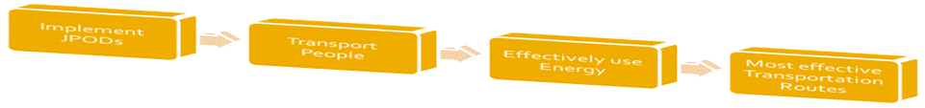

Figure 3: Functional Flow Diagram

Appendix B
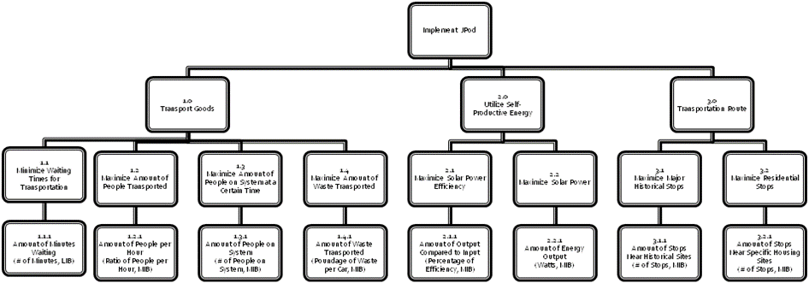
Figure 4 Qualitative Value Model

Appendix C

Figure 5 IDEF0 Level 0

The IDEF0 level 0 gives a description of what must go into the implementation of the JPOD system. It looks at the inputs, controls, and mechanisms that must be looked at to get the overall output of a rapid mass transport system at West Point.

Appendix D
IDEF0 Level 1

Figure 6 IDEF0 Level1
The IDEF0 level one gives a description of what must be done in order to implement the JPOD system at West Point. It gives a step by step process of the functions and what they consist of.

Appendix E
Stakeholder Matrix
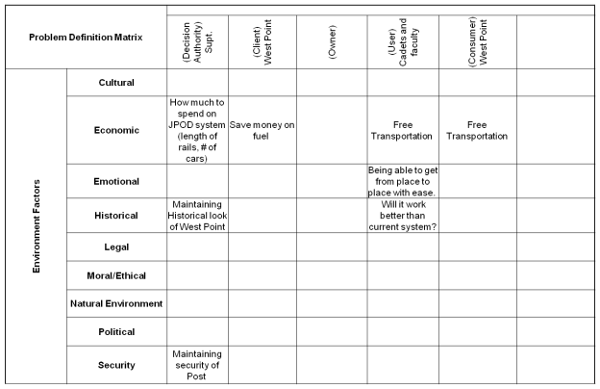
Figure 7 FCR Matrix

The stakeholder matrix describes the environmental factors that each stakeholder is concerned with when implementing the JPOD system at West Point.

Appendix F
Functional Hierarchy

Figure 8 Functional Heirarchy
The value hierarchy divides up the layer above into more detailed pieces. For implementing the JPOD at West Point, our subcategories are to transport goods, utilize self-productive energy, and to plan a transportation route. These functions are what must be looked at to be able to implement the JPOD at West Point.

Appendix G
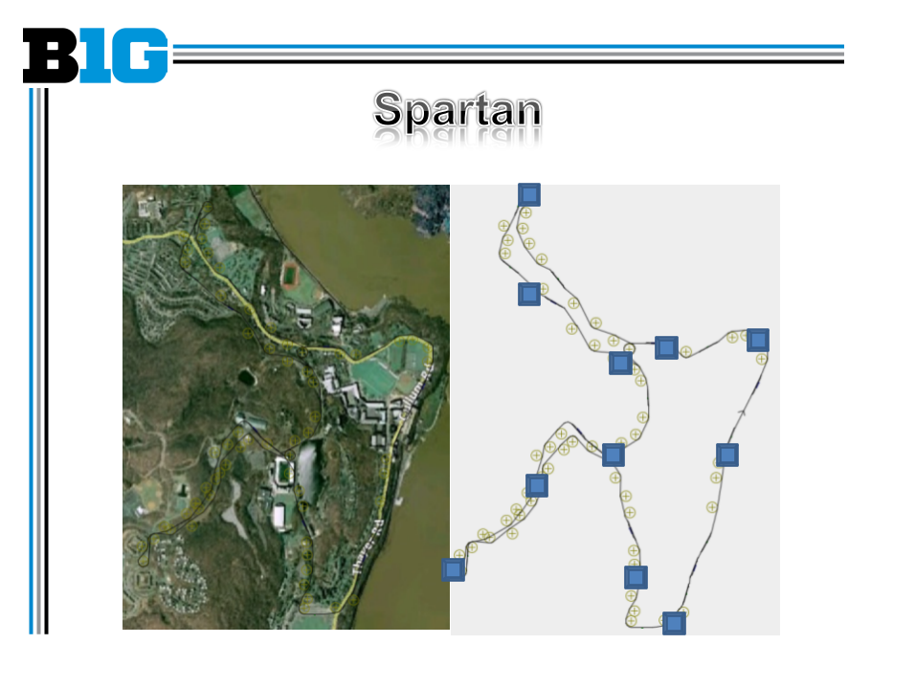
Figure 9: Spartan Track
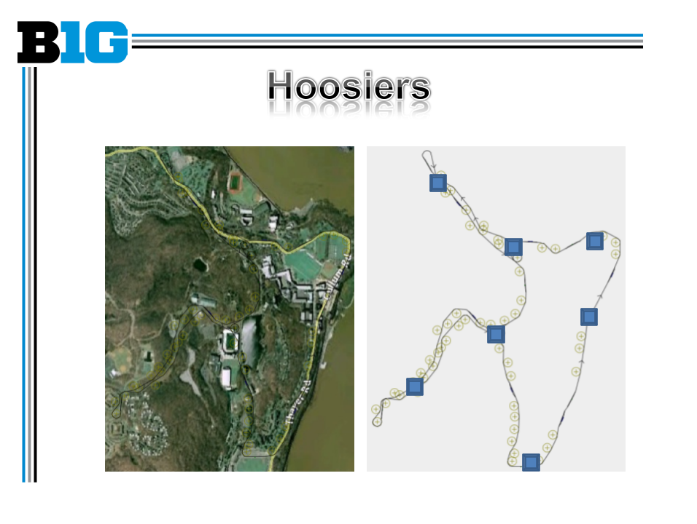
Figure 10: Hoosier Track
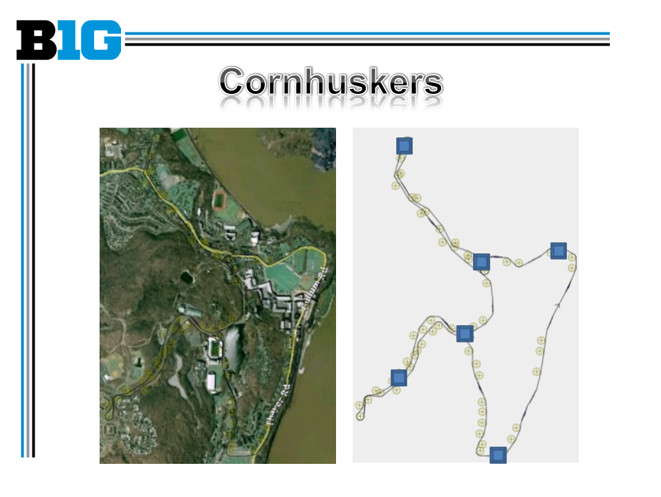
Figure 11: Cornhuskers Track
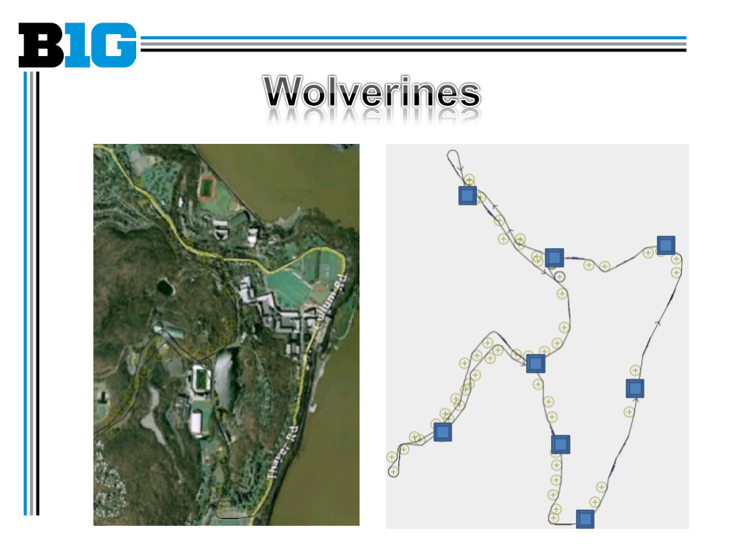
Figure 12: Wolverines Track
Each blue square represents a station and Stop
Appendix H
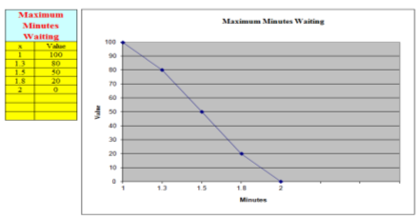
Figure 13: Maximum Minutes Waiting
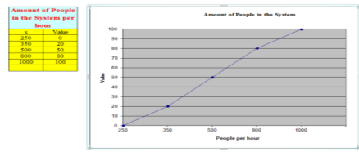
Figure 14: Amount of People in the System
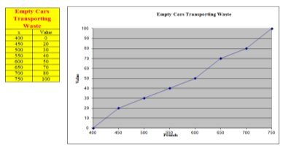
Figure 15: Empty Cars Transporting Waste
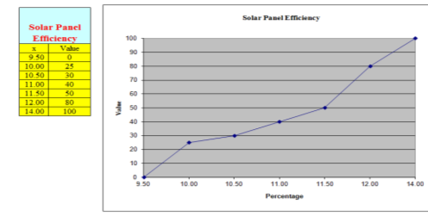
Figure 16: Solar Panel Efficiency
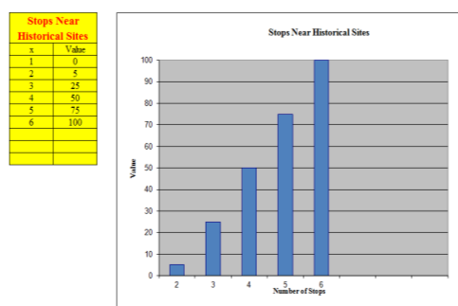
Figure 17: Stops Near Historical Sites
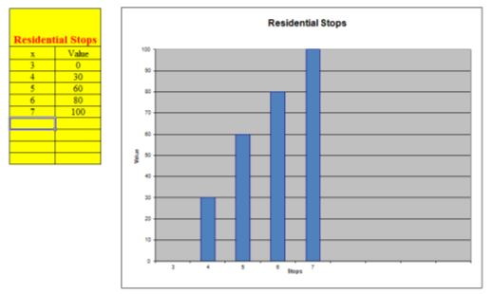
Figure 18: Residential Stops
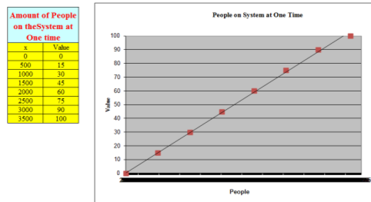
Figure 19: People on the System at One Time

Appendix I
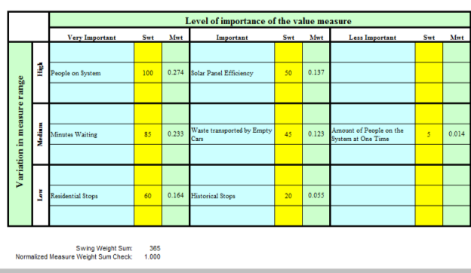
Figure 20: Swing Weight Matrix

Appendix J
Value Scoring
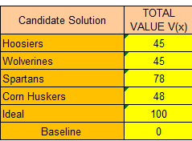
Figure 21: Final Value Scores
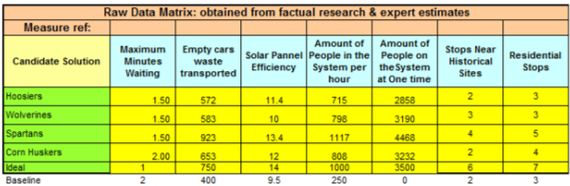
Figure 22: Raw Data Matrix
This is all the raw data collected from the Hermes Simulation
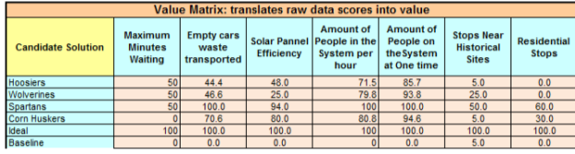
Figure 23: Value Matrix
The Value Matrix shows how each candidate solution scored for that particular measure. It converts the raw data into actual values.
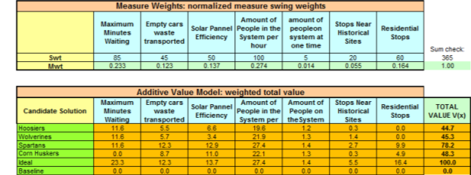
Figure 24: Additive Value Model
The Additive Value Model takes value scores from the Value Matrix and multiplies them by the measure weights (Mwt) and then sums up the total to get the total value V(x).
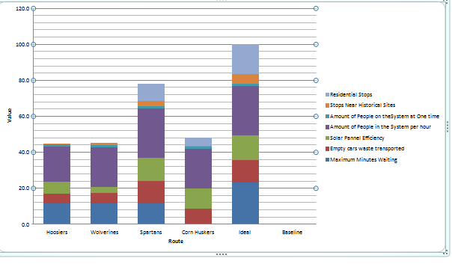
Figure 25: Stacked Bar Chart
This Chart shows the total values of all the candidate solutions. It also shows how each candidate solution did with each value measure. The Ideal solution has a value of 100 with every component meeting its highest potential.
Appendix K
Figure 26: Final Average Costs
These final Average Costs were determined by using a Monte Carlo Simulation 1000 times

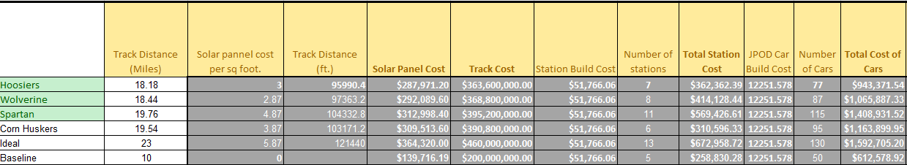
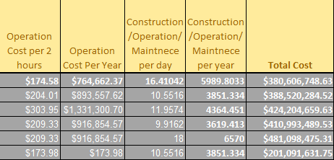
Figure 27: Cost Calculations
Each mile of track costs $20 million dollars to build. Uniform distribution was used to calculate both the station building cost and the cost to build the JPOD Cars, because Mr. James gave only a high and a low. The construction/ operation and maintenance costs were multiplied by 20 to hit our expected life span of the JPOD system at West Point.

Appendix L
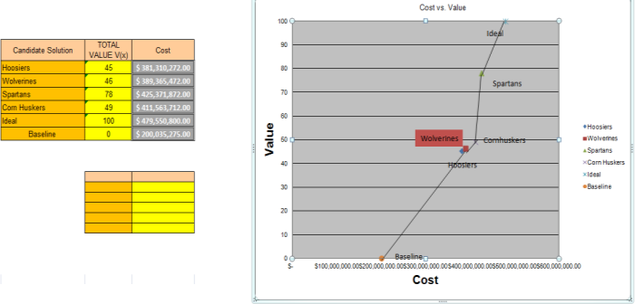
Figure 28: Cost vs. Value Model
No Candidate solutions were dominated. Route Spartans is the clear choice here.

Appendix M
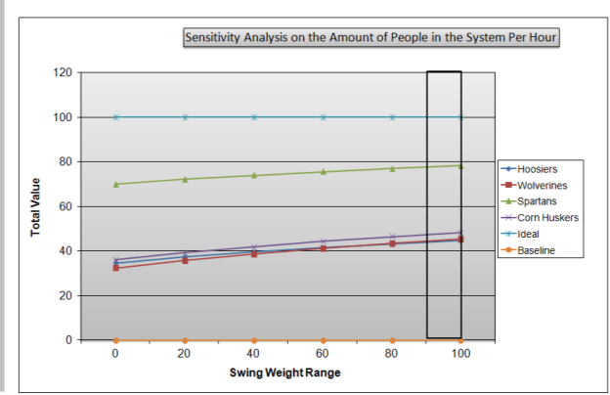
Figure 29: Sensitivity Analysis on the Amount of People in the System Per Hour
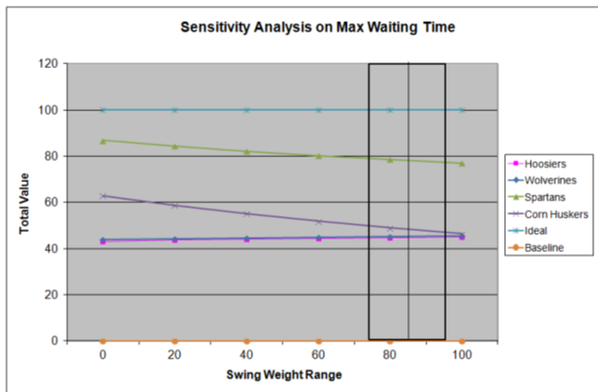
Figure 30: Sensitivity Analysis on Max Waiting Time
Both of these value functions are sensitive; Routes Wolverine and Hoosiers are sensitive for both Figure 29 and 30, they cross in between the +/-10. However since Route Spartans is not sensitive in either this fact does not matter. If Route Spartans were sensitive we would ask the stakeholders to relook at how much they value their value function.

Appendix N
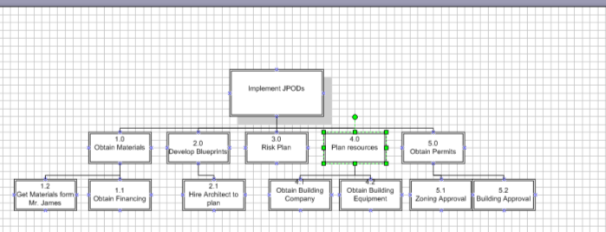
Figure 31: Work Breakdown Structure

