JPods Inc.
Executive Summary, Paradigm Shift to Solar Powered Mobility

Why
Life requires energy. Oil is finite. Survival depends on profitably providing mobility within a energy self-reliance – within a solar budget.
Mission
In the niche of highly repetitive urban transport, JPods move people and cargo on-demand while converting 90% of current costs into profit and customer saving. Powered within a solar budget, JPods builds on the success of the Morgantown Personal Rapid Transit (PRT) network. Networks trump devices.
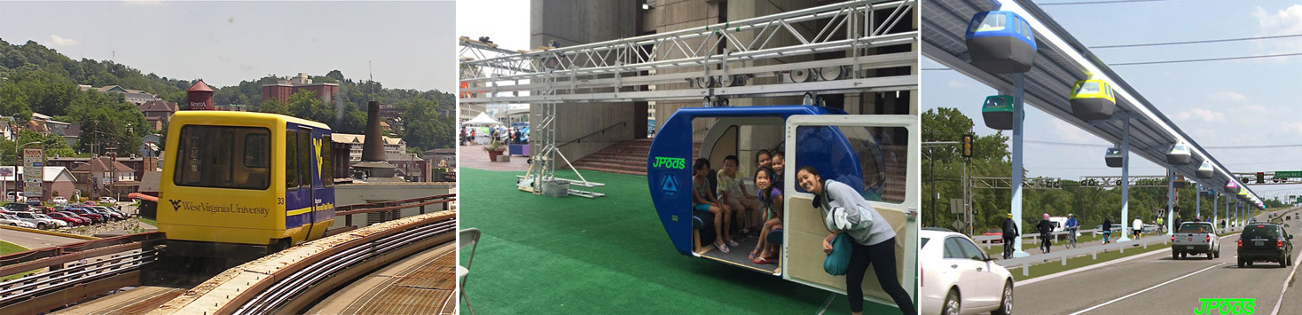
Objective
In 2016 JPods:
- Uses Route-Time software to create an understanding of the time-savings of JPods in at 60% of Boston metro area.
- Uses JPods 3D software to illustrate networks in at least 20 networks in the Boston metro area.
- Gets at least 9 more cities and Massachusetts to pass the Performance Standards Law (Rights of Way access granted based on exceeding 120 passenger-miles per gallon. Examples Secaucus 2014-23 and Massachusetts Senate Bill #1837.
- Build 3 Kitty Hawk Networks (300 meter commercial grade, revenue generating).
- Build in MA on the success of networks in Jaipur India and Anshan China.

Problem
In the mobilization to fight World War I, the US Federal government nationalized communication, power and transport infrastructures as “natural monopolies”. Until the Federal communications monopoly was declared unconstitutional in 1982, American had a century of rotary telephones. In transportation, the Federal monopoly removed efficiency and safety as market forces:
- We still have the gas mileage of the Model-T.
- Nearly half the railroads were driven into bankruptcy since The Federal-Aid Highway Act of 1956. The 140,000 miles of freight railroads in the US average 476 ton-miles per gallon, over 140 times greater efficiency.
- The Personal Rapid Transit (PRT) network in Morgantown, WV has delivered 110 million oil-free, injury-free passenger-miles in the same period that 1.6 million Americans died on the highway monopoly.

Metrics of these problems are Climate Change, oil-wars since 1991, oil-dollar funded terrorist attacks on America, US Peak Oil in 1970, 1.7 million highway deaths in the same period PRT has be injury-free, and more. Life requires energy. Oil is finite. Life powered by oil is terminal.

Solution
Restore liberty to the people to choose cleaner, faster, safer, and more affordable mobility networks. Build the Physical-Internet®. Repeat the success of restoring liberty to choose communications infrastructure to power and transport markets.

Uber is an example of how communications networks can radically improve mobility. Uber still requires oil and oil-powered highway networks. JPods networks displace highway networks, approaching freight rail efficiencies in urban mobility of people and cargo. As examples, the people of New Jersey spend $35.8 billion per year on traffic, Massachusetts $19.8 billion per year. More than half of this per year can be recovered by building a Digital Transportation Network™.

JPods are networks on which ultra-light, computer-controlled, robot-vehicles suspended from overhead rails move using 1/10th the energy of cars, buses and passenger-trains. Where practical, solar collectors mounted over the rails harvest about 40,000 vehicle-miles of power per mile of rail per day. JPods networks are Economic Lifeboats™, making communities durable against energy supply shocks. Solving congestion, JPods turns Cities into Theme Parks™:
- 10x Operating Savings: JPods vehicles operating costs are $0.04 per mile versus $0.56 per mile for cars.
- 10x Capital Savings: JPods networks cost about $10 million per mile versus $100 million per mile for light rail. First 20 miles will cost $20 million per mile.
- 1000x Safety Savings: Theme parks are typically 80,000 times safer than DOT.
- Scalability: Invent imagining a tapestry, execute following a thread. For several years JPods will follow the thread of building in niche economic communities where there are large numbers of shuttle vehicles such as between existing mass transit, at airports, from convention centers to surrounding hotels, on campuses, and at military bases and industrial complexes. Long-term we guess 70% of oil-powered urban transport will be displaced by the Physical-Internet™.
- No Government Cash: Construction capital costs are low enough, paybacks high enough and networks scalable enough so construction can be privately financed, bypassing political and budget delays.
- Cleaner, Faster, Safer and Affordable: Carbon neutral, non-stop mobility, preempts accidents, and no personal debt required. JPods provide on-demand mobility regardless of age, ability or wealth.
- Validated History: JPods is an ultra-light, suspended version of Personal Rapid Transit (PRT or PodCars). PRT was identified as the solution to the 1973 Oil Embargo in the Congressional Office of Technology Assessment Study PB-244854. The PRT network operating since 1975 at Morgantown, WV has delivered 110 million injury-free, oil-free passenger miles.

Execution
Start small, iterate relentlessly. Divide efforts between three types of single-purpose companies to focus divergent talents to delight the fare box payer:
- JPods creates and enforces technology.
- Master Mobility Companies® (MMCs) build networks within a regulatory jurisdiction. Each Thursday at 6 PM, they sells certified networks to Local Mobility Companies® (LMCs) to operate.
- LMCs are formed per 100,000 of population or special economic community to operate networks to delight the fare box payer. The LMC is the primary customer of JPods and MMCs.

Seed efforts to create a market for sustainability using:
- Software: RouteTime™, JPods3D and WebClerk to lower costs of opening markets and controlling deployment.
- Performance Standards Law (Secaucus 2014-23 and Massachusetts Senate Bill #1827).
- Patent 6,810,817 to provide intellectual foundation for JPods systems. Additional patents are to be filed.
- Kitty Hawk Networks™, Physical Internet®, Rescue-Rail™, and Economic Lifeboat™ concepts to seed networks.

Management Team and Board of Directors

- Bay State Sunway Master Mobility Company. Owen Toney, Judeth Van Hamm, Marc Older, Maru Colbert
- Bill James, founder and CTO. Experienced in manufacturing, statistical process control, sensors and computer software. BS - West Point, 1972.
- Frank Pao, Director. Principal Owner of Atlantis Energy, a solar manufacturing facility in Poughkeepsie, NY.
- Chuck Mahan, Director. Retired Lt General, expert in large-scale logistics, formerly the US Army G4 (logistics). BS - West Point, 1968.
- Steven Day, Chief of China Deployment. Securing contracts and financing in China.
- Chuck Bratton – Chief Intelligent Systems. BS University of Maryland. Experienced in multi-million dollar multi-national software developments in publishing, manufacturing and human interfaces.
- Bill Saylor – Chief of Distributed Power. BS –West Point 1972, MS MIT. Member of the IEEE P1547 standards committee for distributed resource grid interconnection standards. Designed and installed several distributed power projects using natural and fossil sources.
- Mike Teske, Director and Design Team. Independent consultant. Formerly Director of Construction and Engineering at Dollywood. Past President, Vekoma Rides USA (Vekoma is world’s largest in-house design and manufacturer of amusement rides). Past Technical Director for opening 5 major Theme Parks in the US and Europe, responsible for engineering, safety and opening 110 major attractions.
- Software team including Christina Eneroth, Mike Cassano, Sourish Chanda.
- Hardware and Civil team including HJ Schmidt, Denny Fox, Kory James, Travis James
- Allies:
  - Arizona Master Mobility Company. Nick Garzilli
  - JPods China
  - JPods India, Ravi Nagappa, Irwin Raja, Sourish Chanda, Puneet Kaur,
  - Allies such as San Jose State Spartan Superway team and advisors of Ron Swenson.
  - Others who have worked for years without paychecks to build solar-powered mobility networks.

Competitors
There are about 10 very small companies in the world building similar systems. They may grow to be significant but forecasting their success is difficult. Currently these are more allies in opening the market than competitors. There are large companies such as GE and Siemens that enter a $5 trillion US market, but it will take them time to abandon their train business. Key threats will come from companies such as Kiva Systems. Kiva received a $33 million investment from Bain Capital and recently sold themselves to Amazon for $775 million.

Market Size (US)
- The 140,000 miles of freight railroads in the US, averaging 476 ton-miles per gallon, are logistical arteries.
- The nearly 2 million lane-miles of urban road will find oil ever less affordable.
- Guess build 4x railroads and 25% of urban lane-miles to build logistical capillaries. In MA this is about 6,000 miles.

Market Driver - Energy
The graph on the left shows US Peak Oil in 1970, oil imports and national debt. An economy powered by debt will at some time collapse. The graph on the right shows the metric JPods created of Disposable Energy™, how much energy people can buy with their take-home-pay. Disposable Energy has been collapsing since 1998.
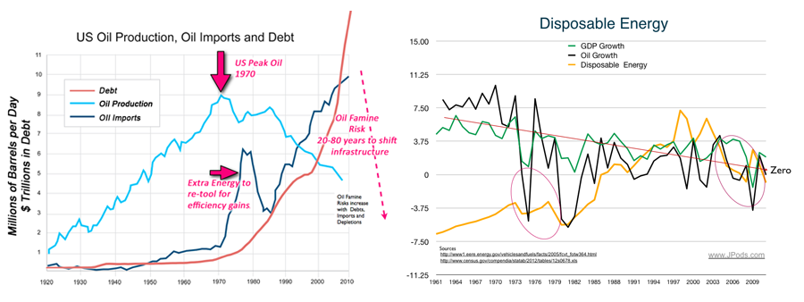

Logistics have mass and momentum. Graphs below show the history and likely future of gasoline prices. In March 2016 gasoline prices are very low because Frackers are producing 4 million barrels per day. But they are $200 billion in debt, bankrupt, stopped drilling, and have oil fields that deplete quickly.

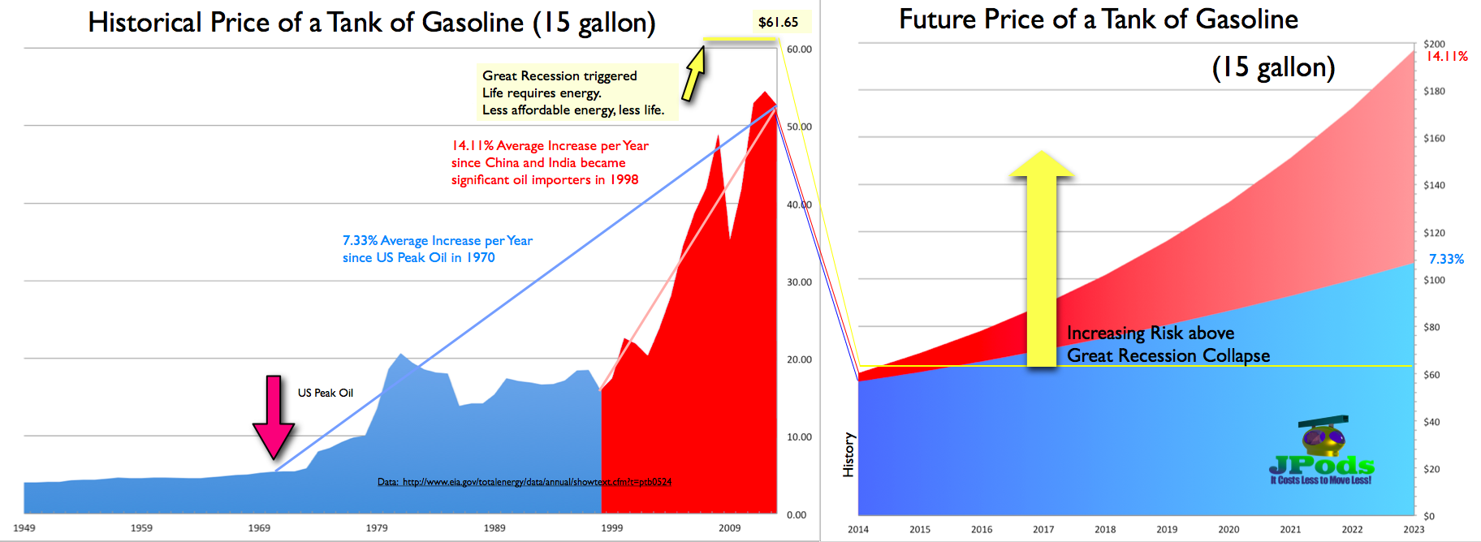

In contrast to oil, JPods networks are solar-powered. Amplifying the 10x gain in efficiency, JPods gain a 6x advantage over oil sources based on 20:1 versus 3:1 Net Energy. Review Energy Economics.

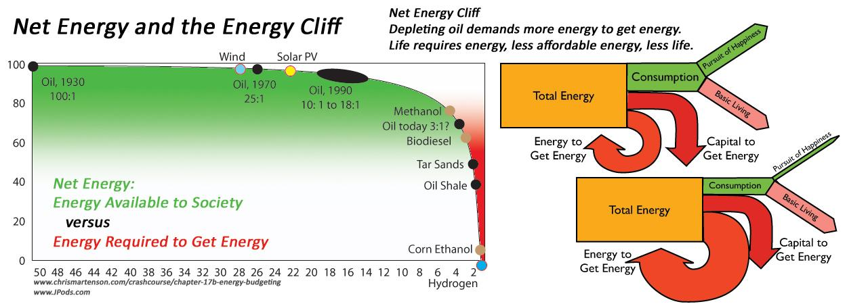

With Net Energy over 20:1, JPods will accomplish what Thomas Edison observed as practical in 1910:
"Sunshine is spread out thin and so is electricity. Perhaps they are the same, Sunshine is a form of energy, and the winds and the tides are manifestations of energy.”

“Do we use them? Oh, no! We burn up wood and coal, as renters burn up the front fence for fuel. We live like squatters, not as if we owned the property.

“There must surely come a time when heat and power will be stored in unlimited quantities in every community, all gathered by natural forces. Electricity ought to be as cheap as oxygen...."

Financing
JPods Inc. is currently privately funded by the officers of the company because of our belief in the importance of creating technology that is powered within a solar budget.

Contact
Owen Toney, 617.259.7593, Owen.Toney@jpods.com, Judeth Van Hamm, 718.635.7749, One@hullportside.net

