Appendix C (draft, 141222)

In the book, Good to Great, Jim Collins identifies the Stockdale Paradox as the first step to taking an organization from being good to great. Admiral Stockdale lead the US POWs in the Hanoi Hilton for 8 years. The full story behind the Stockdale Paradox is worth reading. It is:

“Unwavering faith that we will prevail while facing the most brutal facts of the current reality.”

Brutal Facts:
The following graph shows the correlation between resource depletion (light blue line, US Peak Oil was in 1970), oil imports (dark blue line), and national debt (red line). The image on the right shows the change in multi-year sea-ice since US Peak Oil in 1970. As nearly occurred in Sept 2008, the ability to buy 50% foreign oil with debt will collapse. The consequence to the food system is unthinkable.

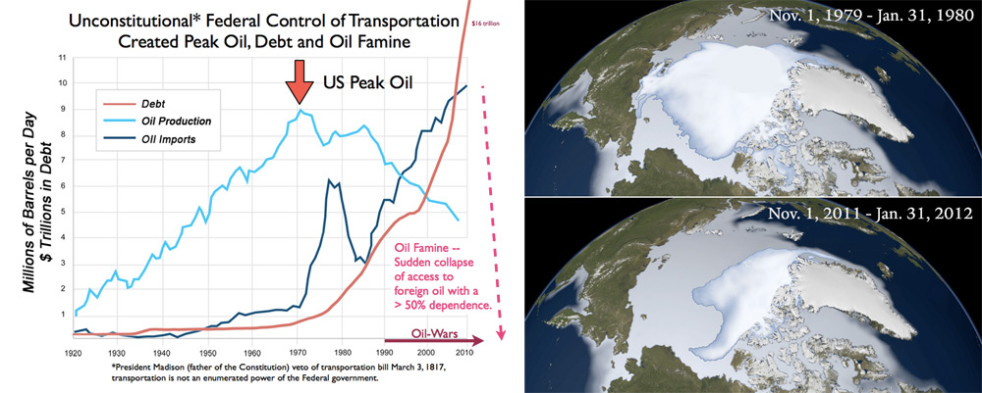

We face Civilization Killers created by our current infrastructure that provides a short-term benefit to a majority at the expense of Posterity.

- Climate Change. Pollution costs are pushed onto future consequences to be faced by children, a non-voting minority.
- Resource depletion, US Peak Oil was in 1970. The future cost of not having affordable oil is pushed onto children.
- $17 trillion in national debt. National debt increased in tandem with oil imports. Debt is the tax on future labor, the labor of children who cannot vote.
- Oil-wars since 1990 and senior military warning of much wider war. Instead of taxing to fund oil-wars, their costs have been socialized into $7 trillion of the $17 trillion national debt. A small minority, soldiers, carries the blood sacrifice of war.
- Funding of Al Qaeda terror attacks with oil-dollars.
- The abandonment of 600,000 windmills after 1935. Federal taxing to subsidize the electrical grid and coal removed self-reliance as a market force and socialized the cost of pollution and resource depletion. The minority that owned and worked for windmill companies were driven out of business
- The loss of 120,000 miles of freight railroads after 1960. Federal taxing to subsidize oil and highways removed efficiency as a market force. The minority that owned and worked for railroads were driven out of business

Thomas Edison noted we had an alternative choice in 1910:
"Sunshine is spread out thin and so is electricity. Perhaps they are the same, Sunshine is a form of energy, and the winds and the tides are manifestations of energy.”

“Do we use them? Oh, no! We burn up wood and coal, as renters burn up the front fence for fuel. We live like squatters, not as if we owned the property.

“There must surely come a time when heat and power will be stored in unlimited quantities in every community, all gathered by natural forces. Electricity ought to be as cheap as oxygen...."

Democracy, an Essential and Flawed Tool
There are two facets to democracy:
- Wisdom of the many.
- Tyranny of the majority.

The book, The Wisdom of Crowds provides excellent examples of the wisdom of the many. The aggregated wisdom of all of us, acting individually in our self-interest is wiser than the wisest of us at choosing between choices.

Who sets the choices becomes critically important. Before 1913, choices were set by the State as “laboratories of democracy”. The 17th Amendment removed this protection against Tyranny of the Majority and shifted power to set choices from the States to Special Interests capable of funding elections. The American Dream shifted from personal liberty, to borrowing money from a bank to buy a house, a car, and oil. Brutal fact: Special Interests, providing a benefit to the majority at the expense of children, harnessed the liberty of Americans via Federal infrastructure to buy their products.

The Founders express concern for Tyranny of the Majority:

Benjamin Franklin: "Democracy is two wolves and a lamb voting on what to have for lunch. Liberty is a well-armed lamb contesting the vote!"

Thomas Jefferson: "A democracy is nothing more than mob rule, where fifty-one percent of the people may take away the rights of the other forty-nine."

John Adams: "Remember, democracy never lasts long. It soon wastes, exhausts, and murders itself. There never was a democracy yet that did not commit suicide."

John Quincy Adams: “"Democracy has no forefathers, it looks to no posterity ; it is swallowed up in the present, and thinks of nothing but itself."

Federalist #10 (Madison ): “AMONG the numerous advantages promised by a well constructed Union, none deserves to be more accurately developed than its tendency to break and control the violence of faction.”

“Hence it is that democracies have ever been spectacles of turbulence and contention; have ever been found incompatible with personal security or the rights of property; and in general have been as short in their lives as they have been violent in their deaths... A republic, by which I mean a government in which a scheme of representation takes place, opens a different prospect and promises the cure for which we are seeking."

The two houses of the Federal government were structured to reflect these two facets:
- The House, elected for 2 years was to aggregate the wisdom of the many.
- The Senate, elected for 6 years by State Legislatures was to aggregate the wisdom of us governing ourselves with the diversity of each state contributing to frame national choices.

Divided Sovereignty, with the Federal government having unlimited taxing powers to “provide” for the defense of liberty, was restricted to only “promote” welfare. This is stated in the Federal mission statement, the Constitution’s Preamble and restated in the 9th and 10th Amendments to the Bill of Rights.

Further, the “post Roads” restriction was voted into the Constitution on Sept 14, 1787 specifically to prevent a Federal monopoly from repeating the defects of the King’s transportation monopoly and creating the Tyranny of the Majority we see today.

Further still, to change the written instructions of the People to the Governing, the Governing had to justify the change via the rigors of an Article 5 amendment so the concerns of minorities could to taken into account.

To win Constitution ratification Madison explains Divided Sovereignty and infrastructure in Federalist #45:
"The powers delegated by the proposed Constitution to the federal government are few and defined. Those which are to remain in the State governments are numerous and indefinite. The former will be exercised principally on external objects, as war, peace, negotiation, and foreign commerce; with which last the power of taxation will, for the most part, be connected. The powers reserved to the several States will extend to all the objects which, in the ordinary course of affairs, concern the lives, liberties, and properties of the people, and the internal order, improvement, and prosperity of the State."

President Madison affirmed the written Constitution when he vetoed a transportation bill on March 3, 1817.

"Having considered the bill this day presented to me entitled 'An act to set apart and pledge certain funds for internal improvements,' and which sets apart and pledges funds 'for constructing roads and canals, and improving the navigation of water courses' . . . I am constrained by the insuperable difficulty I feel in reconciling the bill with the Constitution of the United States to return it with that objection to the House of Representatives. The legislative powers vested in Congress are specified and enumerated in the eighth section of the first article of the Constitution, and it does not appear that the power proposed to be exercised by the bill is among the enumerated powers."

Illicit Energy
Federal support for Illicit Energy, energy outside of self-reliance it the path to war:
- The Constitution’s Framers accommodations to Tyranny of the Majority, in accommodating dependence on slave energy that cascaded into a war after festering for most of a century. Divided Sovereignty, as explained in Federalist #9 and #10, diverse State economies between free and slave labor in the western expansion that finally cascade into war to enforce the self-evident truth that “all men are created equal.”
- Federal monopoly control of the means of production in power and transportation infrastructure re-established a Tyranny of the Majority and again set us on the path to war.

In 2010 the Joint Forces Command warned all US military commands in the annual Joint Operating Environment:

By 2012, surplus oil production capacity could entirely disappear, and as early as 2015, the shortfall in output could reach nearly 10 million barrels per day.

A severe energy crunch is inevitable without a massive expansion of production and refining capacity. While it is difficult to predict precisely what economic, political, and strategic effects such a shortfall might produce, it surely would reduce the prospects for growth in both the developing and developed worlds. Such an economic slowdown would exacerbate other unresolved tensions, push fragile and failing states further down the path toward collapse, and perhaps have serious economic impact on both China and India. At best, it would lead to periods of harsh economic adjustment. To what extent conservation measures, investments in alternative energy production, and efforts to expand petroleum production from tar sands and shale would mitigate such a period of adjustment is difficult to predict. One should not forget that the Great Depression spawned a number of totalitarian regimes that sought economic prosperity for their nations by ruthless conquest.

Energy production and distribution infrastructure must see significant new investment if energy demand is to be satisfied at a cost compatible with economic growth and prosperity.

The discovery rate for new petroleum and gas fields over the past two decades (with the possible exception of Brazil) provides little reason for optimism that future efforts will find major new fields.

Forward by General James N Mattis

Fracking may have delayed the crisis a few years. But the instability in Russia and the Middle East underscores the crisis is not far way.

Had President Wilson, Roosevelt, and Eisenhower followed the Constitution and used Article 5 Amendments to expand control over communications, power, and transportation, those who understood the long-term consequences would have had a voice.

Specifically in transportation, Dr Hubert’s 1956 warnings that in about 1970 US oil production would peak 1970 and Admiral Rickover’s 1957 warnings of future oil wars would have received a more rigorous review. Those who understood the consequences of pollution would have been considered. But these minority opinions were not considered as auto, coal, mining, oil, and highway interests paid for elections in support of short-term gains by a Tyranny of the Majority at the expense of their children.

