WVU Personal Rapid Transit
Benefit Cost Analysis

Morgantown, West Virginia

Prepared For: West Virginia University



August 13, 2010

Table of Contents

Methodology
Key Findings
Demographic Trends - Walnut Station
Demographic Trends - Walnut Station
Demographic Trends - Beechurst Station
Demographic Trends - Beechurst Station
Demographic Trends - Engineering Station
Demographic Trends - Engineering Station
Demographic Trends - Towers Station
Demographic Trends - Towers Station
Demographic Trends - Medical Station
Demographic Trends - Medical Station
Demographic Data Summary
Travel Time Value
Travel Time Value - Assumptions
Travel Time Value – Scenarios
Travel Time Value - Results
Travel Time Value - Understanding Travel Time Costs
Travel Time Value - Understanding Travel Time Costs
Travel Time Value – Impacts on Local Businesses
Carbon Dioxide Emissions - Assumptions
Carbon Dioxide Emissions - Results
Economic Cost of Increased Congestion
General & Limiting Conditions

Methodology
A combination of qualitative and quantitative techniques suitable for assessing the impact of the WVU Personal Rapid Transit System (PRT) was employed for this analysis.

Demographic trends were analyzed for the area surrounding five stations on the PRT route. Demographic trend analysis was performed using U.S. Census data and proprietary demographic analysis software (ScanU.S.) and covered years 1990, 2000, 2010, and 2015 (projected). In addition, simple linear regression analysis was used to project trends out to year 2030. No change in Group Quarters Population when projecting trends was assumed.

Using data from the US Department of Transportation, a model was developed to estimate the value of travel time based on ridership, route timing, and method of travel. This model was used in conjunction with data provided by West Virginia University to estimate the quantitative value of travel time under a variety of scenarios.

Key Findings
Figure 1 below demonstrates the comparative operating costs of the PRT versus substitute buses. The PRT’s total present value savings is estimated to be $115.6 million over a 20-year period.

Figure 1: Comparative Operating Costs – PRT vs Substitute Buses
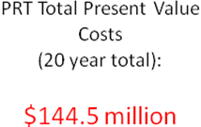
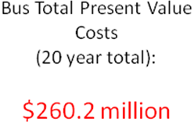
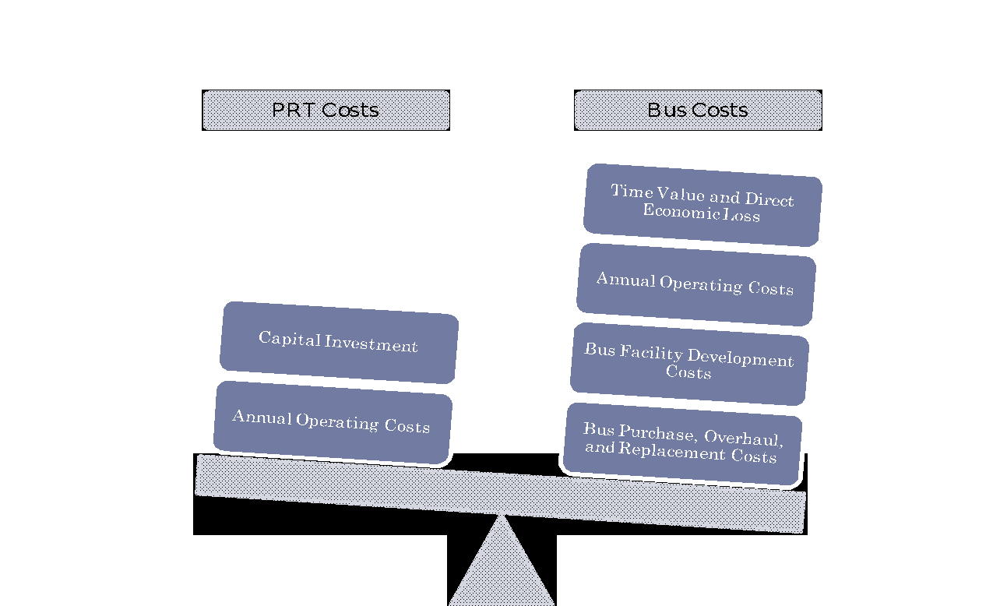
Improvements to the PRT would have the most significant impact in the areas surrounding Walnut, Beechurst, and Medical Stations, in terms of convenience and local business opportunity.

The PRT is a demonstrably faster system than a substitute bus route, even under an increased passenger load. Switching to a bus system would increase average time per rider by at least 11.2 minutes. Riders value travel time, and under current conditions, the PRT, in terms of time value, is worth an estimated $9.1 million per year.

Because the PRT is an electric-vehicle system, the PRT produces much less CO₂ than a substitute bus route. Over the course of a year, the PRT is estimated to produce 297 tons of CO₂ while a substitute bus route would produce 2,472 tons of CO₂ – 8.3 times the estimated CO₂ emissions of the PRT service.

The PRT also offers benefits in the way of congestion reduction. Assuming an average of 13,913 riders per day for 277 operating days per year on the PRT, this results in a savings of approximately $4.78 million per year.

Key findings are described in greater detail on the following pages.

Demographic Trends - Walnut Station

- The area surrounding Walnut Station has increased in population since 1990, albeit at a decreasing rate.
- The population in group quarters has shown the greatest increase since 1990, both in terms of actual population and rate of change.
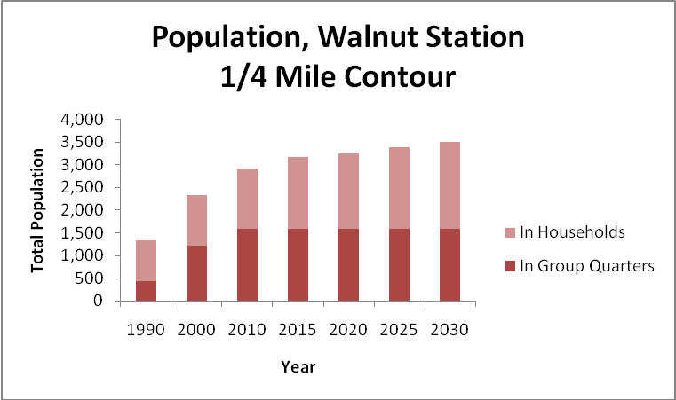
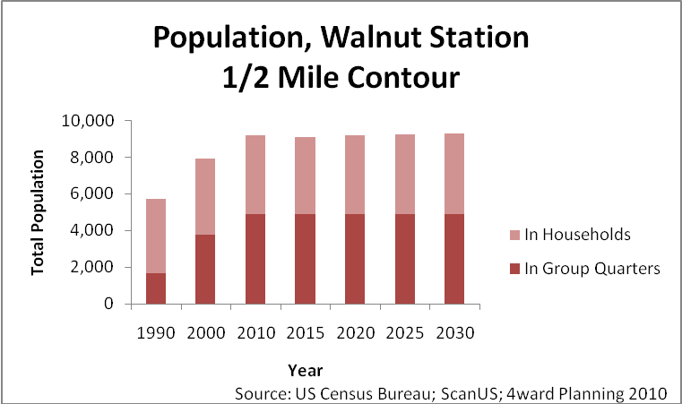

Demographic Trends - Walnut Station

- Total households near Walnut Station have increased over time, but are projected to have peaked in 2000, and to decrease slightly by 2010 and 2015.
- Median household incomes have stayed relatively stable within the 1/4 Mile Contour, but have increased by over $5,000 within the 1/2 Mile Contour.

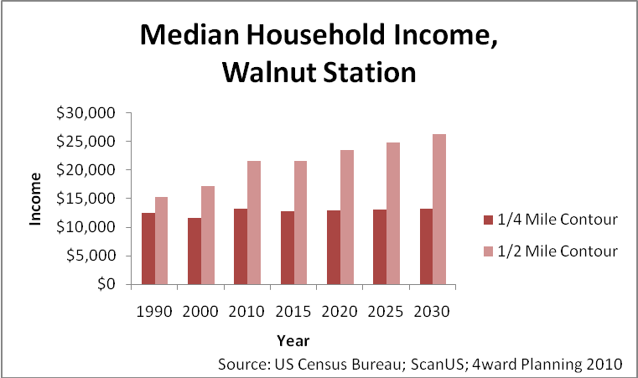
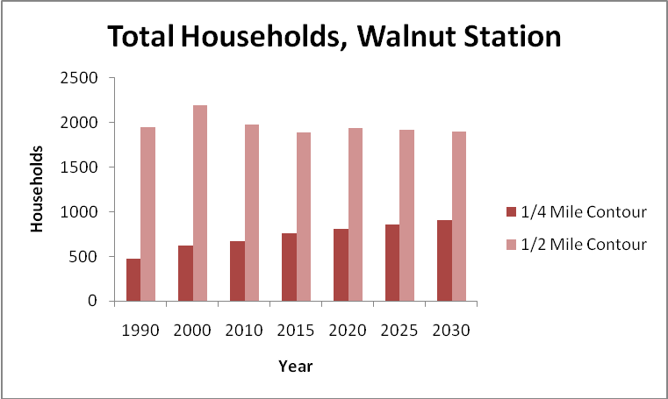

Demographic Trends - Beechurst Station

- The area surrounding Beechurst Station has increased in population since 1990, again at a decreasing rate.
- The population in group quarters is roughly equal to the population in households. The rate of change for both has fluctuated over time.

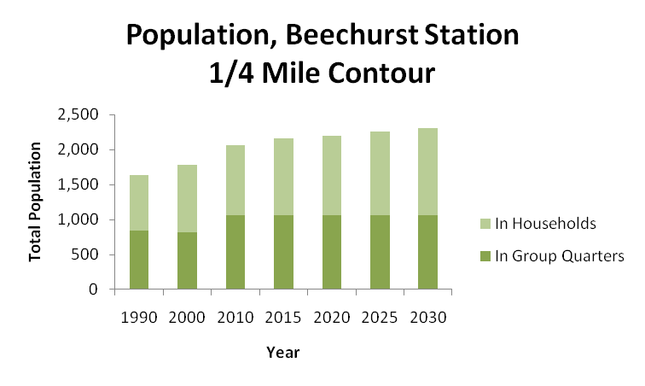

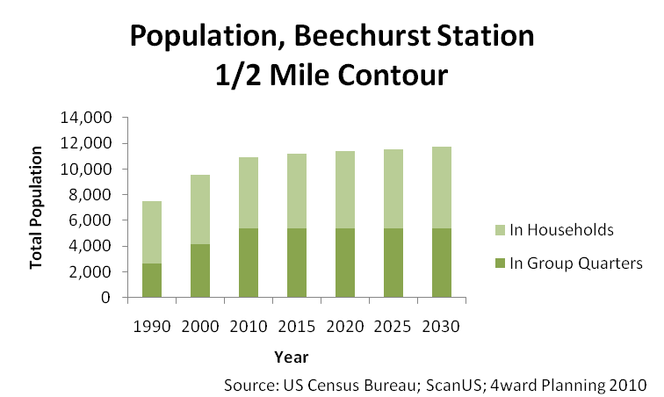

Demographic Trends - Beechurst Station

- There are significantly more households outside of the 1/4 Mile Contour than within it. Total households near Beechurst Station have fluctuated over time, but not greatly.
- After a decrease in 2000, median household incomes have increased slightly in the Beechurst Station region. Incomes within the 1/4 Mile Contour are slightly lower than incomes outside of the 1/4 Mile Contour.

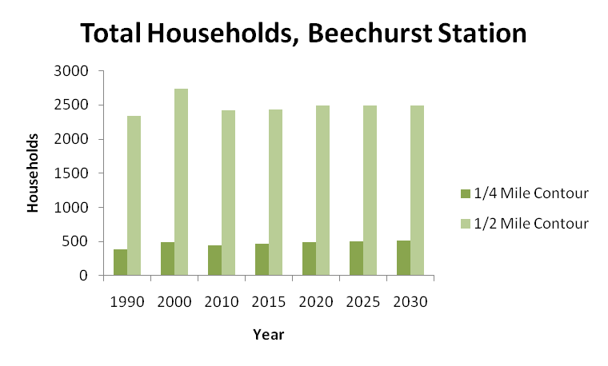

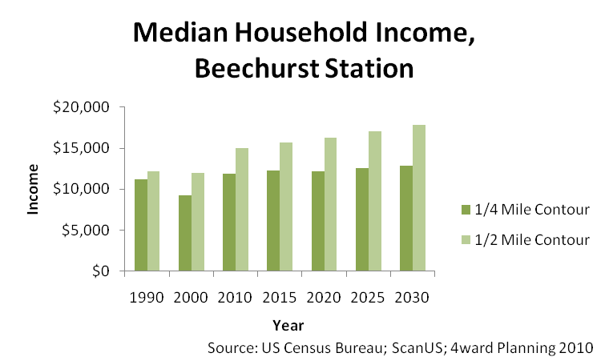

Demographic Trends - Engineering Station

- The population within the 1/4 Mile Contour surrounding Engineering Station is extremely small, and has remained virtually unchanged over time.
- No population in group quarters existed within the 1/2 Mile Contour after year 2000, and the population in households has decreased slightly over time. No population in group quarters has existed within 1/4 mile of Engineering Station since at least year 1990.

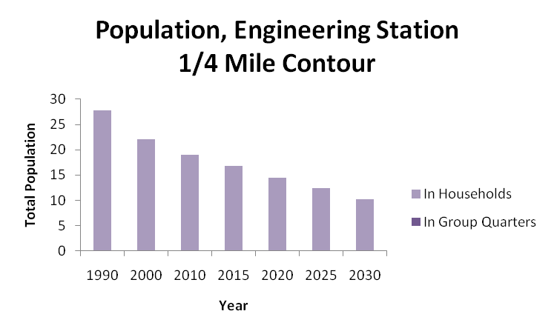

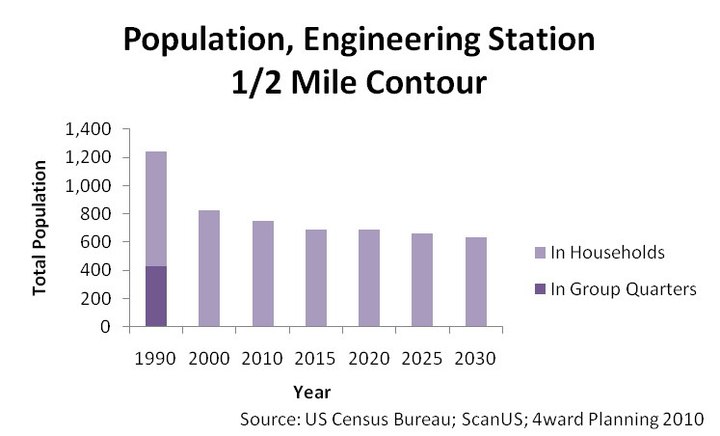

Demographic Trends - Engineering Station

- Total households within 1/2 mile of Engineering Station have decreased since 2000, as have the small number of households within 1/4 mile of the station.
- Median household incomes have risen greatly within the area surrounding Engineering Station, most significantly within the 1/4 Mile Contour. However, potential effects of the small number of households within the 1/4 Mile Contour should be noted.

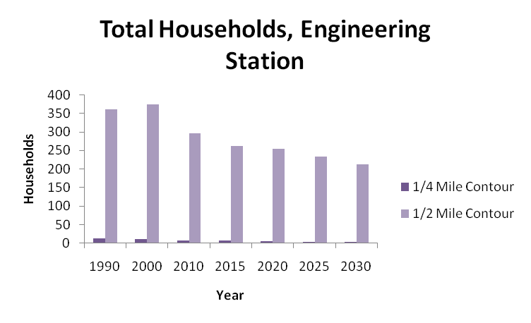

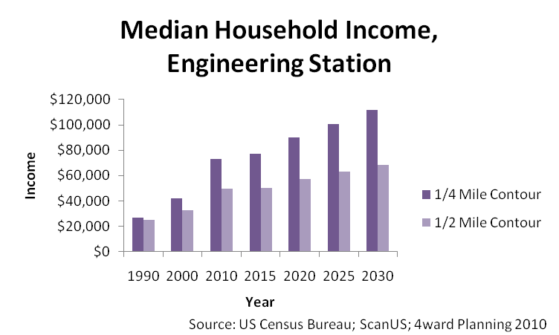

Demographic Trends - Towers Station

- After a decrease in year 2000, due to the loss of all population living in group quarters, the population within 1/4 mile and 1/2 mile of Towers Station has remained very stable.
- No population in group quarters existed within the 1/2 Mile or the 1/4 Mile Contour since at least year 2000. The population in households has decreased slightly over time.

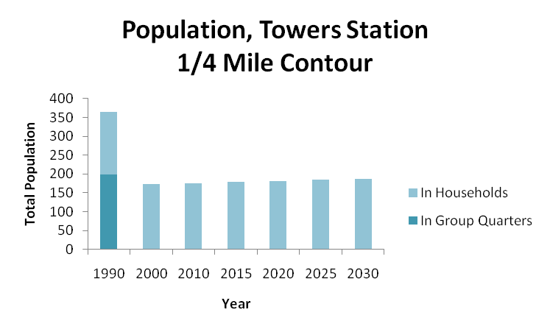

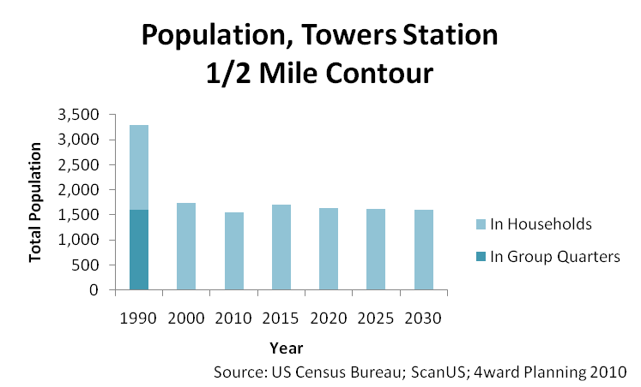

Demographic Trends - Towers Station

- Total households near Towers Station have remained stable within the 1/4 Mile Contour, but have fluctuated within the 1/2 Mile Contour.
- Median household incomes have increased, both in the 1/4 Mile and 1/2 Mile Contour. Household incomes are slightly greater within the 1/4 Mile Contour.

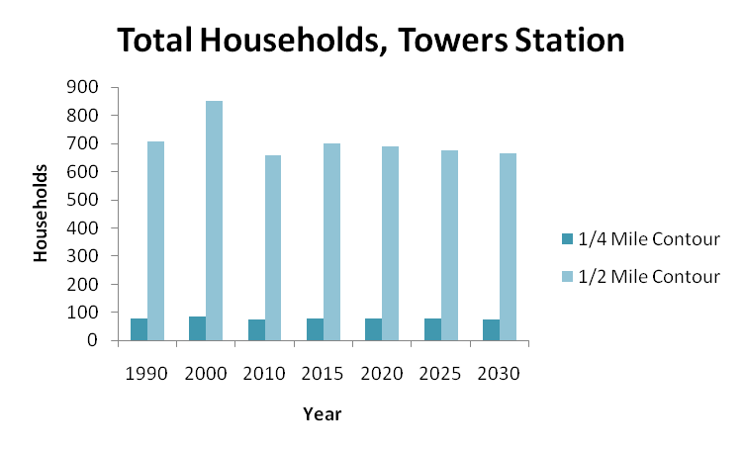

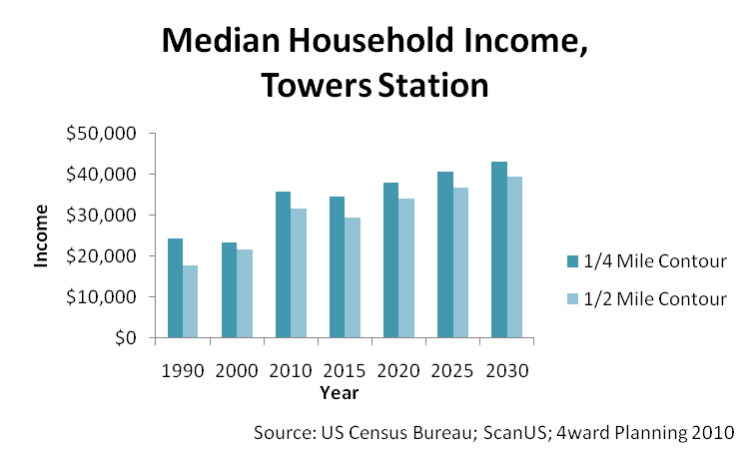

Demographic Trends - Medical Station

- The population surrounding Medical Station has fluctuated over time, though the population in group quarters has remained virtually unchanged since year 2000.
- The population in group quarters decreased sharply between 1990 and 2000, for both the 1/4 Mile and 1/2 Mile Contours.
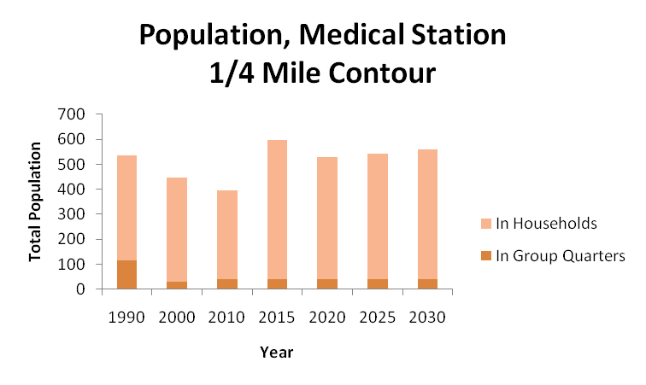

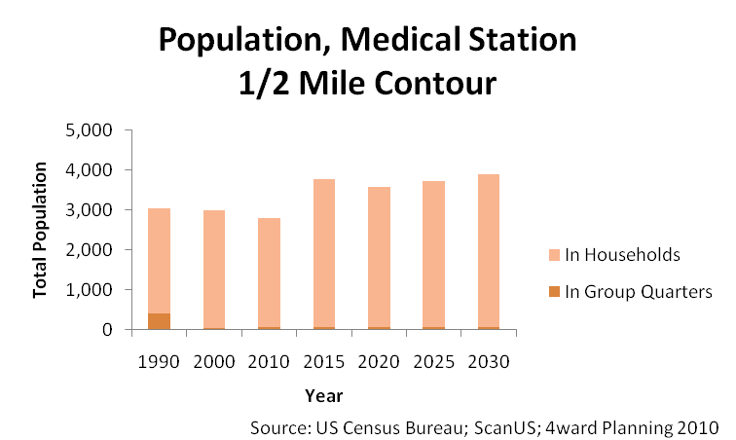

Demographic Trends - Medical Station

- Total households near Medical Station have fluctuated over time, but there has been an overall increasing trend within the 1/2 Mile Contour. There are significantly fewer households within 1/4 mile of Medical Station than within 1/2 mile.
- Median household incomes have increased steadily over time, more than doubling within the 1/4 Mile Contour, and nearly doubling within the 1/2 Mile Contour.
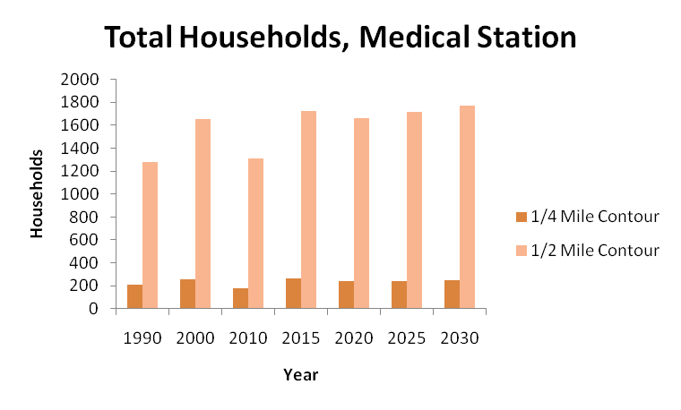

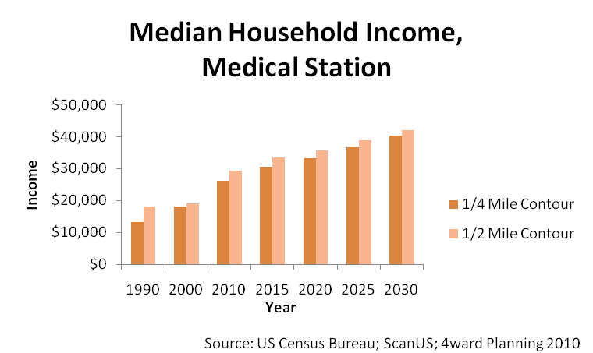

Demographic Data Summary

The populations within 1/2 mile of the Walnut, Beechurst, and Medical stations have increased over the last twenty years, and are projected to continue to increase. In addition, the greatest concentration of households falls within a half mile of Walnut, Beechurst, and Medical Stations.

Improvements to the PRT would have the greatest impact on convenience (time value) and local commerce (more time for consumers to spend money on goods and services) within the area surrounding these stations.

Household incomes for households within a half mile of all stations have increased over the last 20 years, and are projected to continue to increase – favorable for new business investment close-in to PRT station stops.

Travel Time Value

Figure 2: Travel Time Value Model User Interface
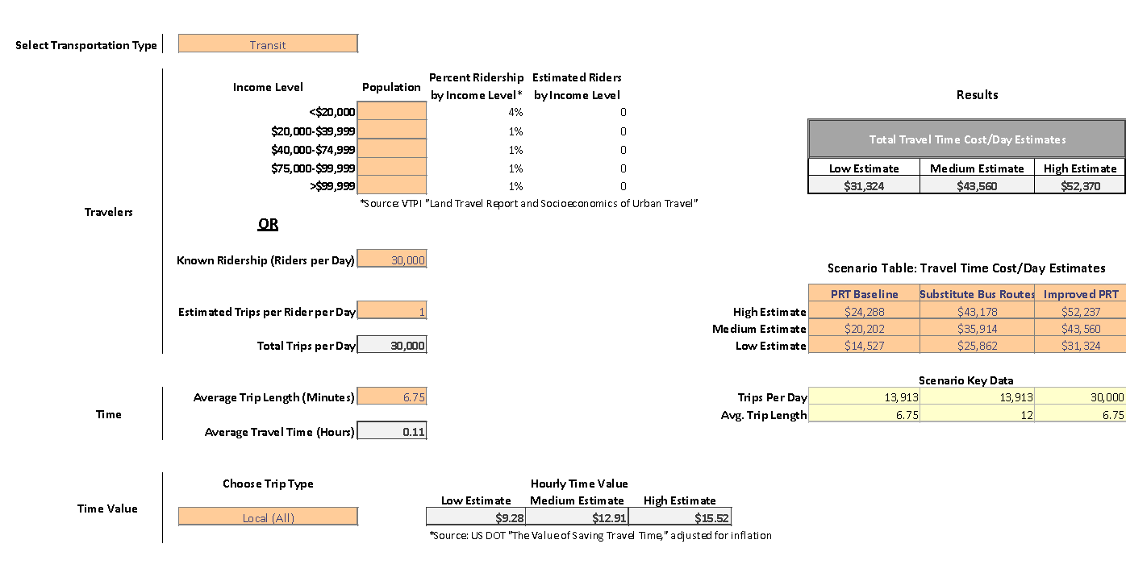

Travel Time Value - Assumptions

In modeling scenarios associated with PRT travel time, and travel time for a substitute bus route, the following assumptions were made:

  - All PRT riders will choose to use a bus system, it the PRT were shut down - This provides a conservative estimate for travel time value and CO₂ emissions.

  - Ridership is a function of student population - A vast majority of PRT users are students (nearly 94 percent, according to data from a recent survey). Increases in student population were projected and the resulting increases in ridership to model travel time.

  - Travel time increases proportionally with ridership for a bus system only. Additional riders require additional buses, and more riders cause congestion. Delays for the bus system, accordingly, result in increased travel time for passengers. Increased ridership does not affect travel time on the PRT.

  - Status-quo average travel time is 6.8 minutes for the PRT, and 18 minutes for a substitute bus route. These values are drawn from data provided by WVU.

Travel Time Value – Scenarios

Based on data provided by West Virginia University and the US DOT, several transit scenarios and estimated the travel time costs associated with each were modeled:

Figure 3: Travel Time Value by Transit Type
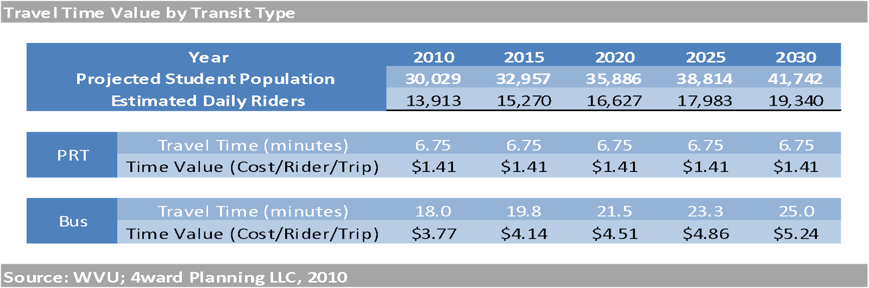

Travel Time Value - Results

By estimating the travel time costs per rider, per trip, an apples-to-apples comparison can be performed between the two transit systems. We conclude that, owing to the greater travel time from station to station, substituting a bus route for the existing PRT will increase travel time costs.

Figure 4: Travel Time Costs
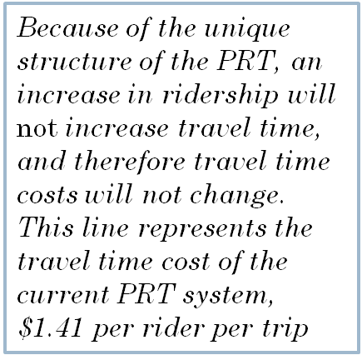
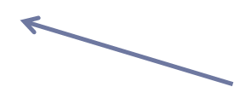
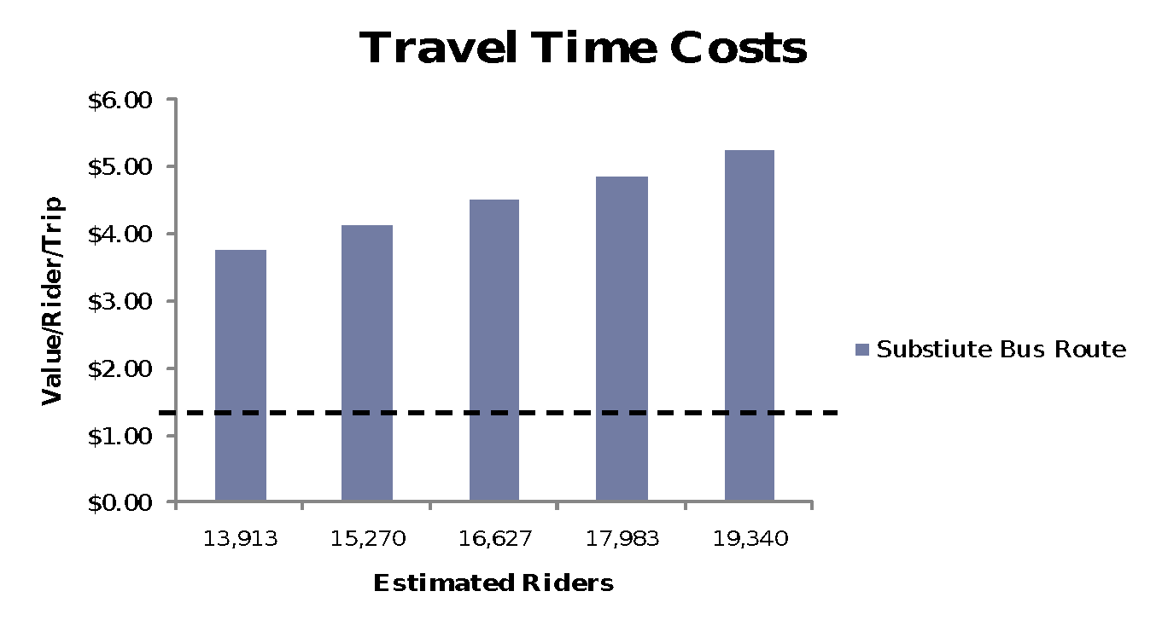

Travel Time Value - Understanding Travel Time Costs

Travel time, a non-market value, can be difficult to understand. One way to understand time value is to ask: “What if WVU had the PRT and a substitute bus system? Which would riders choose?”

A time value model demonstrates the following:
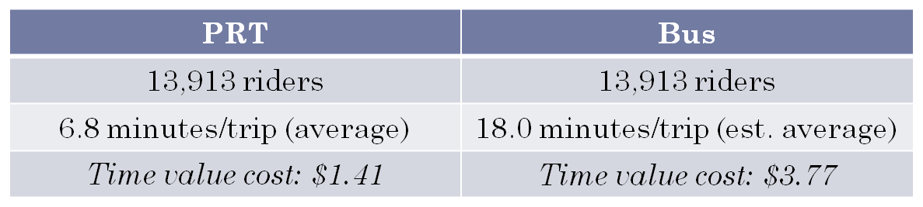

If given the choice between the PRT and a bus, and based on the above metrics, riders would likely be willing to pay an additional $2.36 to ride the PRT and save an average of 11.2 minutes on their trip – the additional time saved being available for either increased work or leisure activities.

Travel Time Value - Understanding Travel Time Costs

Why should riders be willing to pay to save time? Because people value time (a non-market valuation) the ability to save time represents increased value to the individual (to use for leisure or work or both); Aggregating time saved by riders over the course of a year demonstrates that a few minutes saved each day adds up:

Assuming 13,913 riders per day,
277 operating days per year, and
$2.36 in time value savings per rider per trip,
all riders together are saving an estimated
$9.1 million (non-market value) in time value per year.

The loss of the above time value would negatively impact local businesses.

Travel Time Value – Impacts on Local Businesses

Increases in travel time also limit the amount of time riders can spend shopping at local businesses. When traveling to a particular location becomes difficult or time-consuming, riders switch to shopping at other locations, resulting in economic losses to the local economy.

To model this effect, the following assumptions were made:

  - PRT riders, primarily students, have a disposable income of $21,417, 70 percent of the Morgantown median household income. (Source: www.City-Data.com)

  - People under the age of 34 (primary student age) spend 35% of their disposable income on consumer goods—in this case, approximately $7,474.60 per year.
(Source: Bureau of Labor Statistics, Consumer Expenditure Survey)

  - People spend an average of 0.5 hours per day (10,950 minutes per year) shopping for consumer goods. Dividing consumer goods expenditures by minutes spent shopping gives an average of $0.68 spent on consumer goods, per person, per minute, annually. (Source: Bureau of Labor Statistics, American Time Use Survey)

As travel time increases with increased ridership, “travel time” begins to cut into “shopping time.” It was assumed that every 10 minutes of additional travel time results in one minute less local “shopping time,” and modeled the resulting economic losses over a twenty-year period, selected years of which are shown below.

Figure 5: Additional Travel Time per Rider
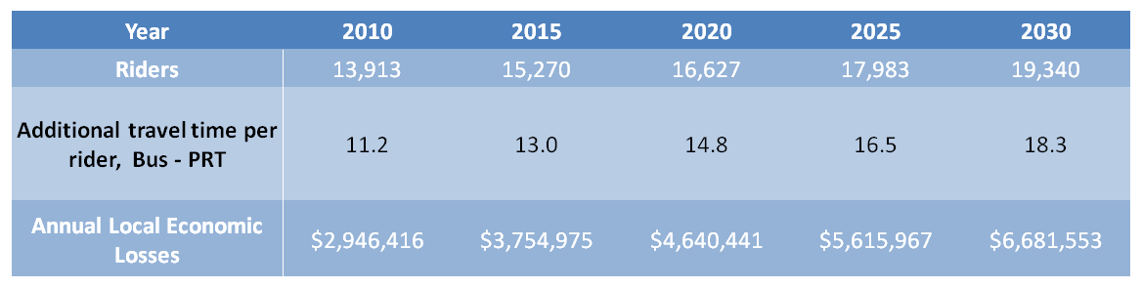

In total, travel time increases result in a local economic loss of over $92.2 million dollars over twenty years.

Carbon Dioxide Emissions - Assumptions

In modeling scenarios associated with CO₂ emissions from both the PRT and a substitute bus route, the following assumptions were made:

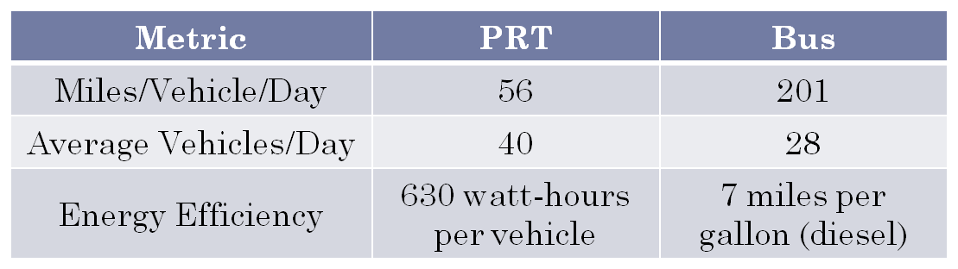

Assumptions for these calculations are based on data provided by WVU.
In addition, we used a metric provided by the EPA for “upstream CO₂” generated by electric vehicles, of 0.642 grams CO₂ per watt-hour. “Upstream CO₂” is generated by power plants producing the energy that powers electric vehicles like the PRT.

Also, it was assumed that 28 buses running constantly over a 16-hour period, averaging three one-way trips per hour (with an average trip length of 18 minutes) in order to calculate figures for miles/vehicle/day. Seven miles-per-gallon is an estimated average fuel efficiency for buses and other large diesel vehicles.

Carbon Dioxide Emissions - Results

As the figure below demonstrates, a substitute bus system will produce significantly more CO₂ per day than the PRT. Assuming 277 operating days per year, a bus system will produce over 2,472 tons of CO₂ annually, while the PRT will produce only 297 tons of CO₂, a difference of 2,174 tons of CO₂ a year.

The EPA’s Carbon Equivalency Calculator helps to put these figures into context: 2,174 tons of CO₂ is equivalent to:

  - removing 377 cars from the road,
  - powering 168 homes, or
  - preserving 18.7 acres of pine forest.

Figure 6: CO₂ Emissions, Pounds per Day
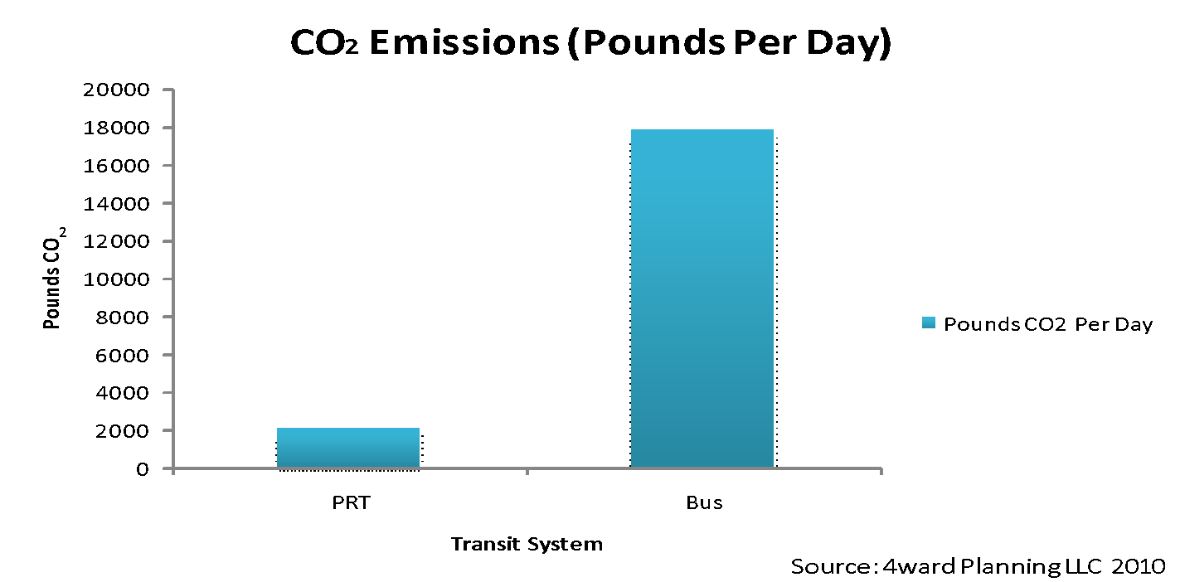

Economic Cost of Increased Congestion

If congestion from additional public (buses) and private (trucks, autos, motorcycles) vehicles were to increase the travel time on the existing affected roadways by 50 percent (quite reasonable given that the current Level of Service on area roadways is “D”), significant additional impacts and costs would be incurred.

The current time value cost of $12.50 per hour would be applied to the current bus trip time of 12 minutes and the future bus travel time of 18 minutes to yield an additional $1.24 in time value cost per trip, per rider. With 13,913 riders per day for 277 operating days per year for the PRT, this results in approximately $4.78 million per year at current levels. Over a 20-year period the Present Value of this delay would be $63.7 million.

An additional delay cost would be incurred by the vehicles that currently use area roadways on a daily basis which would further degrade the level of commercial activity in the area due to worker delays. According to the Morgantown Monongalia Metropolitan Planning Organization the existing traffic volume on the area roadway is anticipated to grow from 20,800 vehicles per day in 2005 to 23,400 vehicles per day in 2030. The delay cost to these persons results in approximately $7.36 million per year. Over a 20-year period the Present Value of this congestion delay would be $85.2 million

Economic Costs Summarized

As discussed in the above sections there a number of areas that economic costs associated with the closing of the PRT can be monetized. These areas include Operating Costs of the PRT Compared to a Replacement Bus Service and Economic Cost of Increased Congestion. The Operating Costs of the PRT Compared to a Replacement Bus Service has a present value cost of $260.2 million and includes time value and direct economic loss, annual operating costs, bus facility development and bus purchases, overhaul and replacement costs. Economic Costs of Congestion has a present value cost of $148.9 million and includes the time delay experienced by the riders of the replacement bus system as well as the time delay experienced by the vehicles currently using the roadway. The total present value of economic costs that can be monetized is $409.1 million. The present value of the PRT Improvements and operational costs is $144.5 million.

General & Limiting Conditions

All estimates, assumptions and extrapolations are based on methodological techniques employed and believed to be reliable. No responsibility for inaccuracies will be assumed in reporting by the client, its agents, representatives or any other third party data source used in the preparation of this report.

Further, this study may not be used for purposes other than that for which it is prepared or for which prior written consent has first been obtained. This study is qualified in its entirety by, and should be considered in light of, the above limitations, conditions and considerations.

